|  |
| --- |
| Name: W.A.D.N.N. Wijesuriya |
| Student Reference Number: 10674049 |



|  |  |  |
| --- | --- | --- |
| Module Code: PRCO303SL | Module Name: Computing Project (20/AY/AU/M) | |
| Coursework Title: Final Year Project | | |
| Deadline Date: 12 May 2021 | | Member of staff responsible for coursework: Dr. Rasika Ranaweera |
| Programme: BSc (Hons) Software Engineering (4872) | | |
| Please note that University Academic Regulations are available under Rules and Regulations on the University website [www.plymouth.ac.uk/studenthandbook](http://www.plymouth.ac.uk/studenthandbook). | | |
| Group work: please list all names of all participants formally associated with this work and state whether the work was undertaken alone or as part of a team. Please note you may be required to identify individual responsibility for component parts.  ***We confirm that we have read and understood the Plymouth University regulations relating to Assessment Offences and that we are aware of the possible penalties for any breach of these regulations. We confirm that this is the independent work of the group.***  Signed on behalf of the group: | | |
| Individual assignment: ***I confirm that I have read and understood the Plymouth University regulations relating to Assessment Offences and that I am aware of the possible penalties for any breach of these regulations. I confirm that this is my own independent work.***  Signed: Nidula Wijesuriya | | |
| Use of translation software: failure to declare that translation software or a similar writing aid has been used will be treated as an assessment offence.  I *have used/not used translation software.  If used, please state name of software………………………………………………………………… | | |
| **Overall mark _____% Assessors Initials ______ Date_________** | | |



School of Computing and Mathematics

PRCO303SL

Final Stage Computing Project

BSc (Hons) Software Engineering

W.A.D.N.N Wijesuriya (10674049)

Human Resource Information System

2020/2021

Acknowledgements

Firstly, I would like to express my sincere gratitude to my project supervisor, Dr. Rasika Ranaweera for his support and guidance throughout the span of the project, as well as being available to meet me for meetings during this tuff period. I am also grateful for all the undergraduates, graduates, and human resource managers in organizations for reviewing and providing me with suggestions for the project.

Abstract

This report provides information on a software development project for Web and mobile applications called the HRIS or also known as the Human resource information system. This project is done to identify the mundane tasks of the human resource managers and how to improve the communication and effectiveness of the HR managers and the employees. To identify functionality of the application a large amount of research was done from reading articles on HR management to collecting information from HR managers via questionnaires and interviews to identify the functionalities of the application. During the research process I came across multiple issues which this application could help to solve, the main issues was that there is no proper Human resource management system that handles all the main and mundane tasks of a HR managers and that the current software that are available are not user-friendly applications. To do this project incremental approach was followed and a clear scope for the project was made along with the project objectives, business objectives, quality plan, project plan, risk plan and much more to clearly understand and manage this project. The HRIS project was developed for the mobile and web to provide a solution to the mention problem while satisfying all the needs of the user and achieving the project objectives and quality plan set in the initial stages. A variety of technologies and languages were learnt and used in the development of the project while facing certain risk that occurred during the project which I managed and overcame in order make it into an effective and easy to use progressive web application for enterprise use.

Table of Contents

**1. Introduction** 9

**2. Business Case** 10

2.1 Business needs 10

2.1.1 Identification of the problem 10

2.2 Business objectives 10

**3. Project Objectives** 11

**4. Project scope** 11

**5. Languages and technologies utilized** 12

5.1 Initially planned technologies 12

5.2 The final technologies used 12

5.3 Background information on Languages used 12

**6. Research Results** 13

6.1 Research of the Project 13

6.1.1 Brief 13

6.1.2 Questioner 13

6.1.3 Interviews 13

6.1.4 Conclusion 13

6.2 Research on Existing Systems 14

6.3 Research Technologies & Languages 14

6.3.1 Currently used technologies 14

6.4 Reviews on the developing application 14

**7. Learning Undertaken** 14

**8.Architectural Diagrams** 15

8.1 Activity Diagram 15

8.2 Use Case Diagram 16

8.3 Context Diagram 17

8.4 Sequence Diagram 18

8.5 Tree representation of hierarchical modal of firebase database 20

**9. Project status** 20

9.1 Initial Progress 20

9.2 In the First Interim 20

9.2.1 Progress 20

9.3 In the Second Interim 20

9.3.1 Progress 20

9.3.2 Progress Tracker 21

9.3.3 Testing and Quality 21

9.3.4 Future Development 22

9.4 Final Progress 22

9.4.1 Progress 22

9.4.2 Testing of application 22

9.4.3 Quality of application 23

**10.The Application** 23

10.1 Screen shots & explanation of the application 23

10.1.1 HR Managers User Interface in Web View 23

10.1.2 Employees User Interface in Mobile View 32

10.1.3 Extra Information 34

10.2 Code Snippets from the application 34

10.2.1 Brief 34

10.2.2 Front-end code snippets 35

10.2.3 Back-end code Snippets 36

**11 Security & ethics of the application** 37

11.1 Security Of the application 37

11.2 Ethics followed for the application 37

**12. Risks** 37

12.1 Risk plan 37

12.2 Risk Encountered 38

12.3 Difficulties Faced During The Project 38

**13. Quality Plan** 39

13.1 Brief 39

13.2 Quality Plan 39

13.3 Changes Made Based On reviews 39

**14. Project Plan** 40

14.1 Brief 40

14.2 Initial Project Plan 40

14.3 Finalized Project plan 40

**15. Documentation Guide** 41

15.1 Technical Documentation 41

15.1.1 Web App 41

15.1.2 Android Mobile App 41

**16. Future Improvements** 42

**17. Conclusion** 43

**18. Appendices** 43

18.1 References 43

18.2 Proposal 44

18.3 Project Initiation Document (PID) 45

1. Introduction 45

2. Business case 45

3. Project Objectives 46

4. Initial scope 46

5. Method of approach 47

6. System Design 48

7. Project plan 49

8. Stage Management 49

9. Initial risk list 49

10. Initial quality plans 50

11. References 51

12. Appendix 51

18.4 Interim Report 1 53

1. Introduction 53

2. Research Results 53

3. Learning Undertaken 55

4.Architectural Diagrams 55

5. Project status 57

6. Risks Encountered 63

7. Changes to the project 63

8. Conclusion 64

9. Appendix 64

18.5 Interim Report 2 65

1. Introduction 65

2. Business Case 65

3. Project Objectives 66

4. Project scope 66

5. Languages and technologies utilized 67

6. Research Results 68

7. Learning Undertaken 69

8.Architectural Diagrams 71

9. Project status 76

10.The Application 78

10.2 Code Snippets from the application 85

11. Risks 88

12. Quality Plan 89

13. Changes to the project 89

14. Conclusion 90

14. Appendix 90

18.6 Questioner 91

18.7 Overall GitHub Commits 95

18.8 LinkedIn Courses Completed 96

18.9 Supervisor Meetings 98

List of Figures

Figure 8.1: Activity Diagram 17

Figure 8.2: Use Case Diagram 18

Figure 8.3 Context Diagram 19

Figure 8.4: Sequence Diagram 21

Figure 8.5 Hierarchical modal tree representation 22

Figure 10.1: Login page 26

Figure 10.2: Dashboard 26

Figure 10.3: Event Calendar 27

Figure 10.4: Chat lobby 27

Figure 10.5: Chat group for HR Managers 28

Figure 10.6: Add Notices 28

Figure 10.7: Recruitment 29

Figure 10.8: Employee Management 29

Figure 10.9: Salary Management 30

Figure 10.10: Document’s page 30

Figure 10.11: Add documents 31

Figure 10.12: Users Page 31

Figure 10.13: Add Policies 32

Figure 10.14: Attendance 33

Figure 10.15: Mark Attendance 33

Figure 10.16: User profile 34

Figure 10.17: Graph Data 35

Figure 10.18: Employee Dashboard 36

Figure 10.19: Employee Chat 37

Figure 10.20: Employee Attendance 37

Figure 10.21: Employee event Calendar 38

Figure 10.22: Firebase Firestore database 38

Figure 10.23: Firebase Real-Time Database 39

Figure 10.24: Update profile function 40

Figure 10.25: QR-code scanner 40

Figure 10.26: QR-code scanner 41

Figure 10.27: QR-code scanner 41

Figure 10.28: Update profile function 42

Figure 10.29: Add person function 42

Figure 15.1: Questioner Results 106

Figure 15.2: Questioner Results 106

Figure 15.3: Questioner Results 107

Figure 15.4: Questioner Results 107

Figure 15.5: Questioner Results 108

Figure 15.6: Questioner Results 108

Figure 15.7: Questioner Results 109

Figure 15.8: Questioner Results 109

Figure 15.9: Questioner Results 110

Figure 15.10: The dates on which commits were made to GitHub 110

Figure 15.11: Courses completed 111

Figure 15.12: Courses completed 112

List of Tables

Table 9.1: Progression table 23

Table 9.2: Test cases 24

Table 12.2: Risk Plan 43

Table 13.1: Quality Management Plan 45

Table 14.1: Initial project plan 46

Table 14. 2: Finalized project plan 47

Additional Details

Word Count: 10,434

GitHub Link: <https://github.com/nnwijesuriya/SE_Y03_PRCO303SL_Computing_Project>

Firebase Login Credentials

email: hrisproject0@gmail.com

Password: HRIS@developer123

# **1. Introduction**

The management of the human factor of an organization has been one of the main goals of organizations and to do so human resource managers are hired and they have the task of training employees, performance management, organization development, safety, wellness, benefits, employee motivation and more. These tasks can be time consuming and hard to manage so the Human Recourse management systems or also known as HRMS systems were introduced to the human resource managers. A research done by (Hussain, Wallace and Cornelius, 2020) states that the HRMS systems are used by human resource professionals to make strategic decisions no matter the size of the organization and says that this has added value to the organization and increased the status of the human resource profession. These HRMS systems are used to make the task of human resource managers easier and manageable. In addition, some HRMS systems have automated some of the tasks done by the human resource managers so that they could be more effective and focus on decision making for the betterment of the business.

The Project is to develop a HRIS system or also known as the Human resource information system, which is a type of human resource management system that has all the core functionalities of the standard HRMS systems and some more added functionalities for the Human resource managers to use. The application will be available as web app and as a mobile app, this is to improve the user experience and to make it convenient for the users to access the application even when they are not in the organization premises. This application will be mainly used by Human resource managers to manage the employees in the business in an effective and efficient manner. The HRIS systems main goal is to make the tasks of human resource manager easier and faster so that they can spend more time making strategic decisions to improve the business. Another main objective of this application is to improve the communication within the business. So, to do that this the application has an employee’s user interface. which allows employees to submit request forms, chat with others and much more.

# **2. Business Case**

## 2.1 Business needs

There are several factors that affect the organization it may be in a positive way or else a negative way but what decides this outcome depends on how the manages in the organization handle these factors. The employees of the business are one of the main factors that can have a huge impact on the organization, so they need to manage it in a proper manner. According to (Balyuk, 2020) Management of employees is important because the company is made up of people with different ages, customs and profiles and managing them is crucial to the success of the organization and she also states that if they are managed in a proper manner, it could provide benefits like good working environment, employee development, Increased productivity, motivation and finally business objective alignment. So, what the organization needs is a user friendly HRIS system that has the functionalities required for management of employees and reduce the mundane tasks of human resource managers. A good human resource management system does not just help the organization and human resource managers it also helps the employees that are working in the organization making them more motivated and providing them a good working environment and this will have a positive impact on the organization and may result in organizational growth or for it become more successful.

### 2.1.1 Identification of the problem

The problem this project is attempting to solve is the management of employees in a business and to make tasks easier for human resource managers by automating their task by developing a HRIS system. so that they can be more efficient in the decision-making process. There are multiple human resource management systems in the market but the problem with those systems is that they are either too complicated for user or they have less functionalities. So, with this project I will attempt to solve this problem by providing a user friendly HRIS system with the functionalities that are required by the HR managers.

## 2.2 Business objectives

The business may have multiple goals but one of the main goals of the business would be to have an effective human resource management department that manages employees to provide a good performance culture within the business. And To achieve this business goal the following business objectives should be accomplished.

* Automate some of the tasks done by employees to make them more efficient
* Provide human resource managers with informational data on the business to make important decisions for the betterment of the business
* To manage staff more efficiently and in an easy way
* To have a good communication between management and employees
* To motivate employees and provide a good working environment
* To ensure that organization resources are used efficiently
* To have accurate data within the business

# **3. Project Objectives**

At the end of this project, my goal is to provide a working user-friendly human resources information system that has the functionalities required to help the human resource managers and the objectives of this project are:

1. Identify what are the functionalities that the human managers need to manage task easily.
2. Identify what are the tasks done human resource managers that could be automated.
3. To provide a way to improve the communication between the employees and the management.
4. Create a good working environment for the employees with less arguments and fights within the organization.
5. To make the decision-making process of human resource managers easier using analytic data.
6. To keep the employees up to date on what is happening in the business and when it is happening.
7. To provide a way to manage employees effectively within the business.
8. To Provide self-service capabilities for employees in the business.

# **4. Project scope**

1. Identify what are the human recourses information systems in the current market and find what are the positives and negatives of these systems
2. Identify the human resource process what the human resource managers need to make decisions using questioners
3. The proposed system will allow:
   1. HR managers to get the attendance of each employee and find out the days the employee did not come.
   2. HR managers and employees should be able to mark attendance using this application
   3. HR managers to make decisions effectively by using the graphs provided by the application.
   4. HR managers to manage and change details about the current employees
   5. HR managers to add and remove the employees that are currently in the system.
   6. HR managers to send notifications to the employee in the organization
   7. HR managers and employees to talk to each other using the chat facilities
   8. Employees to request for a holidays and other requests
   9. Employees to see how many holidays they have left for the year
   10. Employees and HR managers should be able to change some of their personal details and their profile picture.
   11. HR managers to manage the hiring process
   12. Employees to review other employees in the same department
   13. HR managers should be able to add events to the calendar and employees can see them.
   14. HR managers should be able to add task to each other within the human resource management department
   15. HR managers will be able to fill and submit different kind of forms.
   16. HR mangers should be able to add new policies and edit existing policies
   17. HR managers should be able to accept and refuse forms submitted by employees.
   18. HR managers and employees should be able to change the passwords to their account in the system.
   19. HR managers should be able to add bonuses and increase salary of employees.
4. A mobile application will also be developed for the employees and the human resource managers
5. The system will use machine learning and provide a suggestion to human resource managers which employee should receive the raise and when they should receive it.

# **5. Languages and technologies utilized**

## 5.1 Initially planned technologies

In the beginning of the project the plan was to do a human resource management system which will be a desktop application and planned to use java as the programming language with firebase as the database but after doing some research and getting the plan revised from the supervisor, I came to know that most enterprise applications are web based and has a mobile app. So as a result, these technologies was not used to do the human resource management instead a new plan was formed to do a human resource information system as a web app and a mobile app for the user.

## 5.2 The final technologies used

When searching for programming languages to do a web and a mobile application I got to know the concept of PWA or also known as progressive web apps where the same code based is used to develop mobile and web applications which met my need to develop the human resource management system. So, after some more research I found out the best combination and the most recommended languages to do a progressive web app was by using Angular and ionic framework for the front end and then using node.js and express as the back end and mongoDB for the database which would form the MEAN stack. But I wanted to use firebase for its cloud functions and some of the other key functions. So, for this project I used Angular and ionic for the front end and node.js and express for the backend and finally the firebase as my database.

### 5.3 Background information on Languages used

* Ionic Framework: Ionic framework is an open-source hybrid mobile development SDK that is used to develop progressive web apps and native apps too. It makes use of typescript and is ideally build on top of angular to provide wonderful progressive web apps.
* Angular Framework: According to (Angular, 2021) Angular is a platform and framework for building single-page client applications using HTML and TypeScript. Angular framework is most known for its Single page application capabilities is one of the main reasons why angular is commonly used. The single page application is the process when only a single page is loaded initially and then the part of these page changes according to the change, we make rather than the entire HTML page been reloaded.
* Node.js: According to (Node.js - Introduction - Tutorialspoint, 2021) Node.js is an open source and a cross-platform runtime environment that is used for developing a server-side and networking applications. In addition, Node.js applications make use of the JavaScript language. Some features of node.js include no buffering and very fast since it is built on Google Chromes JavaScript engine.
* Firebase: Firebase is a platform that can be used for multiple functionalities rather than just the database. This platform is developed by google and provide multiple functionalities some of them include hosting, storage, real-time database and Firestore. But in this project, we will only be using a small amount its functionalities which storage, real-time database and the Firestore. Firebase is preferred by most people is because of its ability to scale and the functions it provides. Firebase also contains a full documentation on each of its functionalities which widely beneficial for software engineers when using firebase as their database or to do any other requirement.

# **6. Research Results**

## 6.1 Research of the Project

### 6.1.1 Brief

Research part of a project is crucial to a project success and its quality. Because of those reason and couple more an extent research was done in this project for over a course of three to four weeks to find each and important factor that may influence the project, to learn about the Human resource management, to identify existing systems and their issues, to identify the functionalities required by human resource managers and to find the perfect technologies and programming languages to be used to do this project. Some of the research methods are mention below along with what I learned with each research type and how they affected the project.

### 6.1.2 Questioner

One way the research was done was through questioners to identify whether the people know what a HRIS system is and to know whether they think it is useful to the organization. The Questions were aimed for HR mangers or undergraduates who are doing Human resource management, but the questioners were also distributed to the public to understand what they think about HRIS systems. The questioner was a success and received around 52 response and from those response 43 people had past working experience, 6 people were working and 3 had no working experience and due to these various responses, that was received a large amount of valuable information was gathered. One of those interesting results were that almost 31 of those responses said that having a good HRIM system can affect the working environment for employees. And another one was when asked what are things that is wrong with current HRIM systems the majority answers stated that the functionalities were not enough and there is no proper communication between employees and Human resource managers. Much more information such as those were gathered through the questioners.

### 6.1.3 Interviews

The other method used to gather information on Human resource management and the HRIS systems was using the interviews method. Even though substantial amount of information was gathered from questioner’s I could not ask questions which needed detailed answers so during the interviews this was possible. But an issue I ran into was because of the pandemic situation in the country the universities and business have been closed. so, I was not able to get interviews from industry professionals so the candidates I interviewed was mainly undergraduates who are in the final year and are doing human resource management as their degree. I was able to get 6 interviews done and gained a valuable information that was useful for the development of the application. Some of the main questions that were asked was what were the main documents that are submitted by human resource managers, what are the tasks that Human resource managers find boring or tiering. These were just some of the questions that was asked during the interview, the responses I got from them was greatly beneficial for the research.

### 6.1.4 Conclusion

Questioners and interviews were not the only methods used to do research on Human resource management and HRIS systems in addition to those methods online articles were also used to do the research for the project. Articles were mainly used to identify the tasks and responsibilities that the human resource managers have, and this was done so that I can understand and determine whether the functionalities specified in the interviews is a need to have functionality or want to have functionality and I then can assess on them. These different techniques of collecting information help me to get to know more about human resource managers responsibilities and to identify the functionalities they need in a human resource information system.

## 6.2 Research on Existing Systems

There are numerous existing human resource management systems and during my research I came to know their different types of human resources management systems. And they are HCM which means Human Capital management system, HRMS which means Human Resources management systems and finally the system type developed in this project which is HRIS Systems. HRMS systems only cover the payroll, time and labor and there are numerous systems available for this type and is the most common type of human resource management system used in low level business. Next is the HCM covers everything in HRMS and some additional functionalities like analytics and so on. Finally, HRIS systems cover everything and has additional functionalities. There are numerous HRIS systems and HCM systems but during the questioner and the interview I found out that they do not have enough functionalities to help Human resource managers. Furthermore, during the interviews, a common thing that was mentioned was that some more functionalities could be added to the existing HRIS systems that are used by businesses. In addition, in Sri Lanka only the high-level companies use HRIS systems, but the employees and the human resource managers believe use of HRIS systems can improve the working environment of a business.

## 6.3 Research Technologies & Languages

### 6.3.1 Currently used technologies

Since I will be using ionic and Angular frameworks for the front-end of the project and node.js and express for the backend of the project a thorough research was needed to be done to understand the limits, the advantages, and the disadvantages of using these languages. Because I wanted to avoid impactful surprises during the development of the project which could negatively affect the project. One of the main things that I looked into was the versions document of each framework and identified how much each version changes and what are things that will probably change in the next version of the framework because in the case of a version update my previous code wouldn’t work if that functionality is removed or changed. I did not do that much of a research for firebase because I have used Firestore before and new it was reliable and dramatic changes would not occur. This was done to ensure that project could be carried out smoothly without any issues

## 6.4 Reviews on the developing application

To identify whether my application is user friendly and has the key functions implemented in a manner that will be easy for the users a review session was done. The reviews were obtained from my supervisor, from some of my colleagues and from some human resource managers I personally knew. During these review sessions I was able to get a clear idea of the things they liked and disliked in my application and they even gave ideas on how to improve some functions and I also got to know the functionalities that I missed that should be implemented.

# **7. Learning Undertaken**

In this project there was large learning curve mainly due to the fact I did not know some of the languages that was used in the project because I have not used these languages before. During the research I found out using these languages were the best way to develop the system I planned for. So, to get the knowledge I had to be learn them from the beginning. In the database I did have some experience in using the fire store and NO SQL databases but not the real time database, so I had to learn about that section also. One of the greatest challenges were learning about machine learning and about how to implement them. Multiple machine learning courses were done in linked in learning and Udemy courses to get the basics of machine learning and understand the concepts. Next, I had to learn how to use machine learning in my project and once I came across tensorflow.js through research I started doing an online course on it as well.

In addition to that I also had to learn about node.js which was used for the backend. In the begging my plan was to use firebase API to do the backend part as well because since the tensorflow.js could be done in the front end itself and since there was firebase API a backend was not exactly planned. But during the development I learned that to do some firebase functions you need to use firebase admin SDK and the only way to implement admin SDK was by using a backend so because of that reason I had to learn node.js for the backend part of the application. So, like I did for tensorflow.js I followed multiple tutorials to learn about node.js since this would be my first time using it. During this learning process I learned how much node.js would improve my application and the numerous benefits it brings to my application.

These two were the largest and key things I had to learn for me to do this project to make it a successful project. In addition to those two major learning tasks there were minor learning also done one of them being the ionic framework. But since I had experience with angular, I did not have much of a learning curve there since it is kind of make use of the same logic. These were the learning undertaken for the project and learning these key things made the project much better and into a successful project.

# **8.Architectural Diagrams**

## 8.1 Activity Diagram

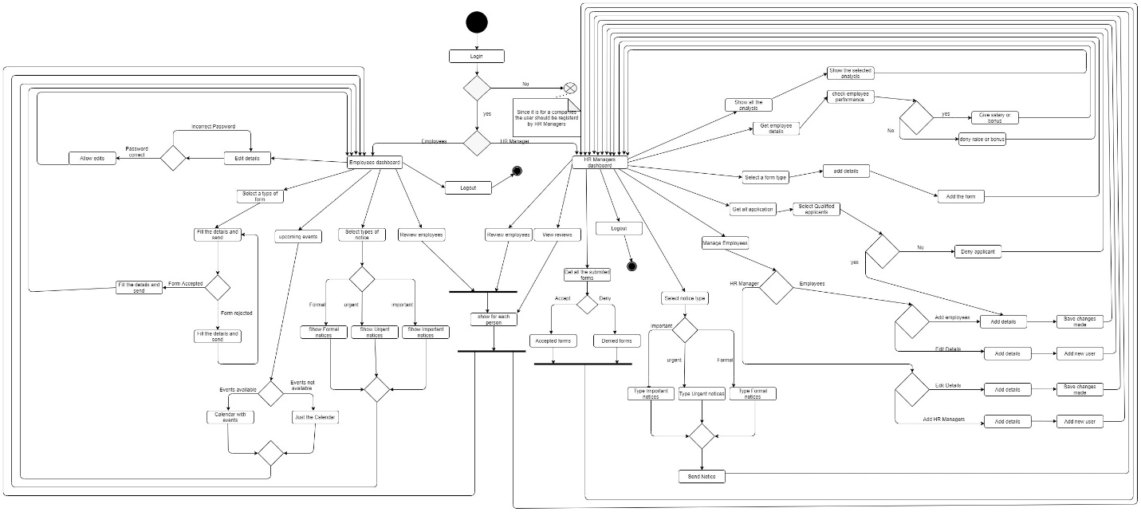

Figure 8.1: Activity Diagram

## 8.2 Use Case Diagram

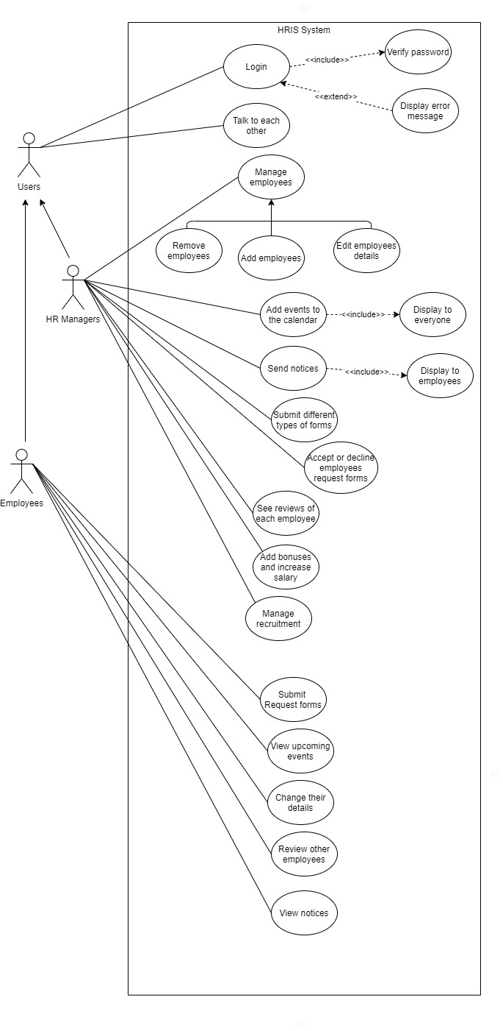

Figure 8.2: Use Case Diagram

## 8.3 Context Diagram

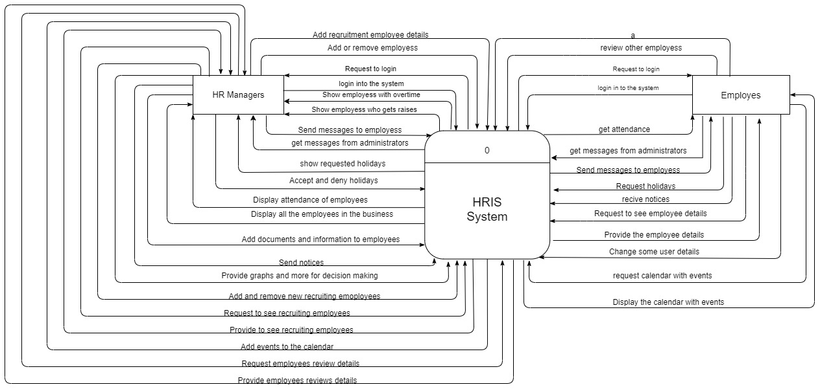

Figure 8.3 Context Diagram

## 8.4 Sequence Diagram

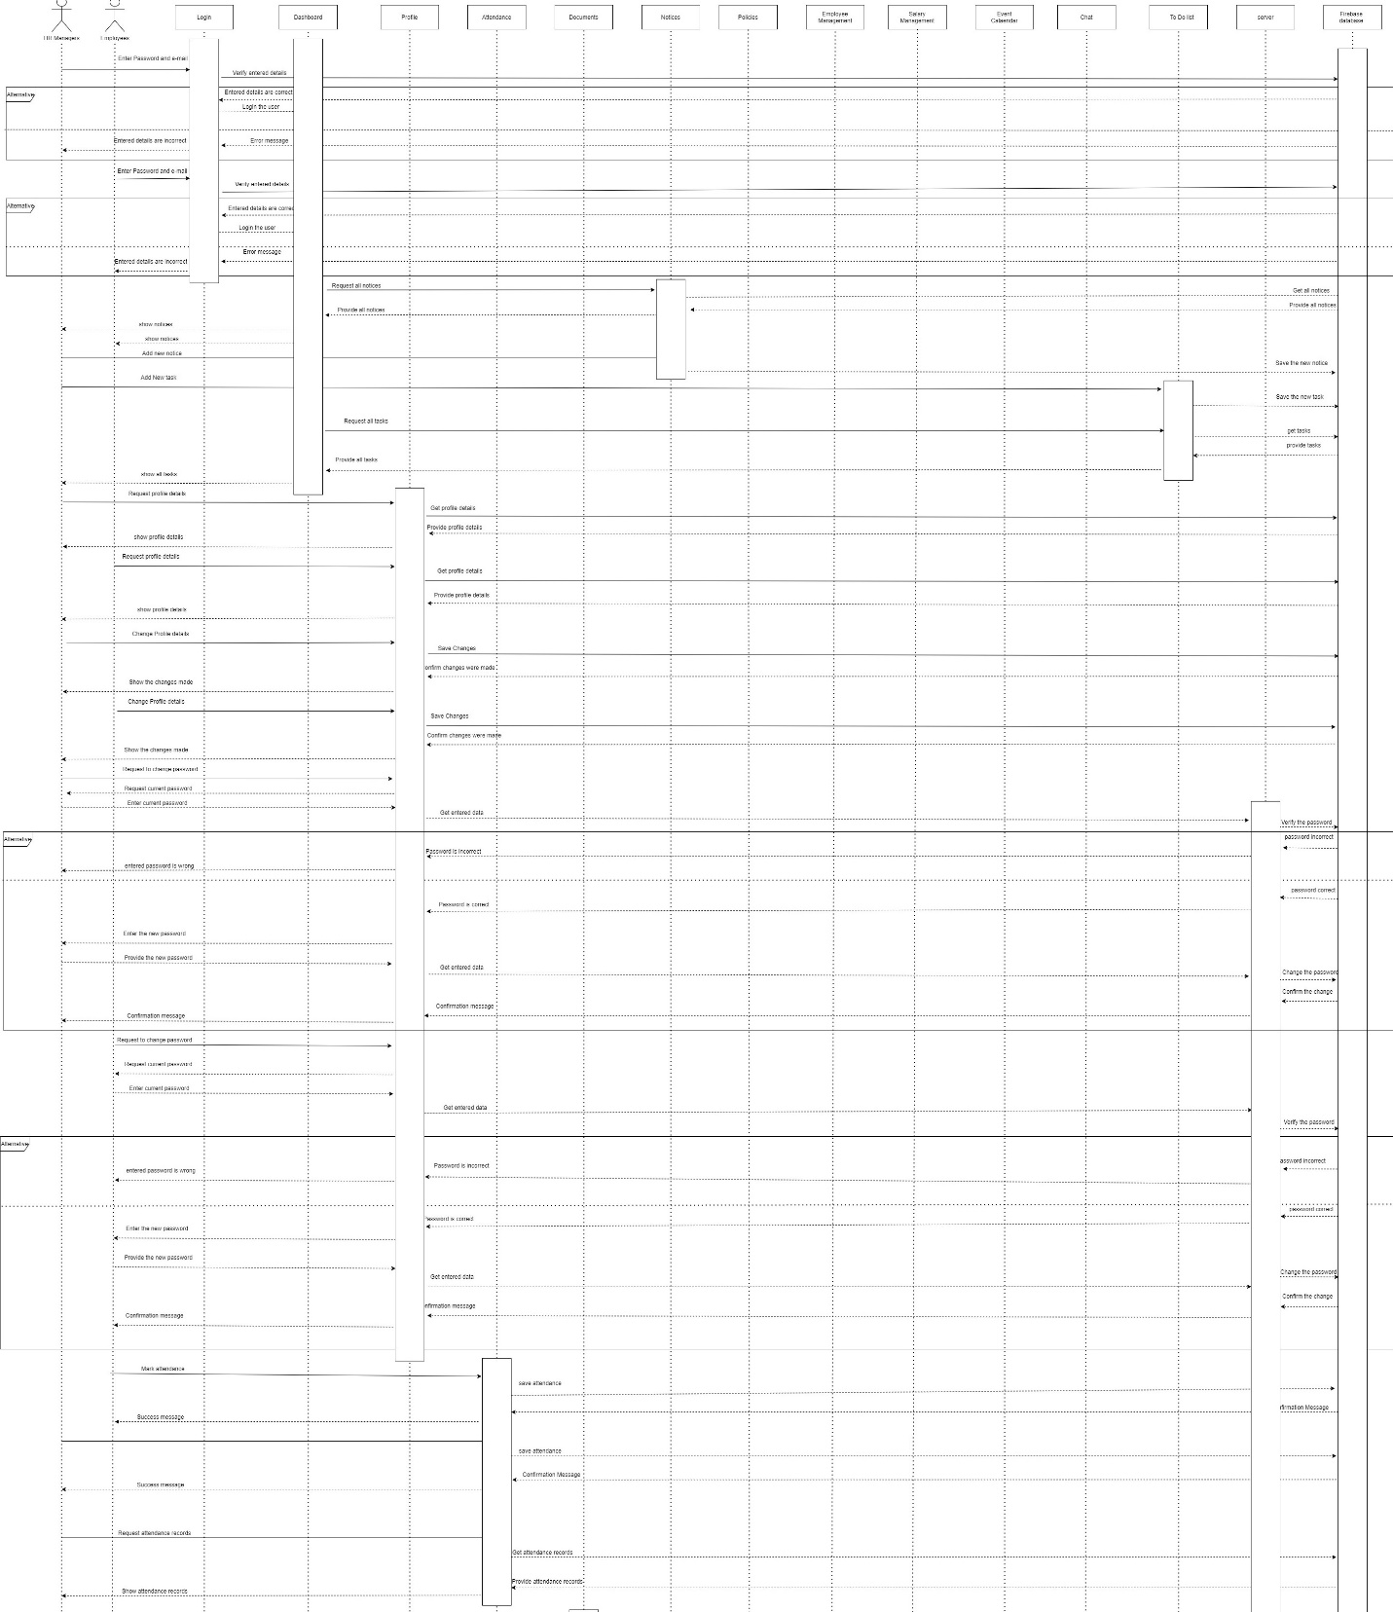

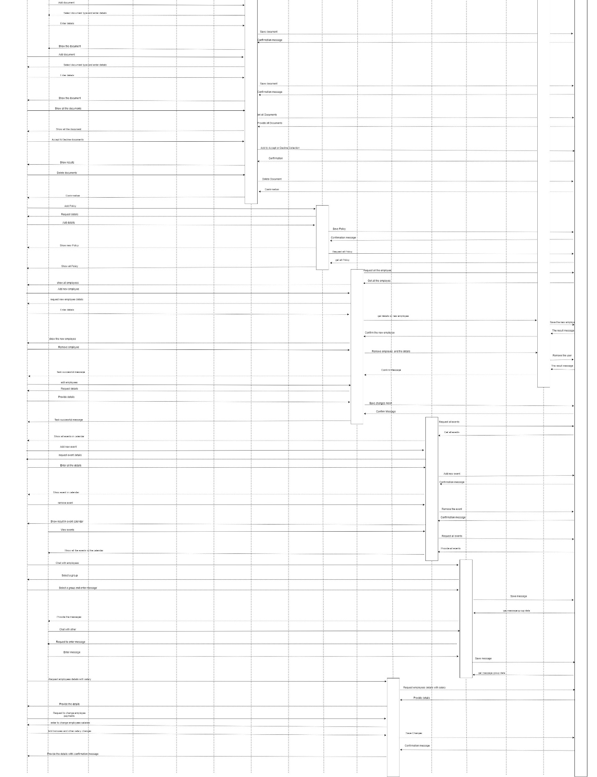

Figure 8.4: Sequence Diagram

## 8.5 Tree representation of hierarchical modal of firebase database

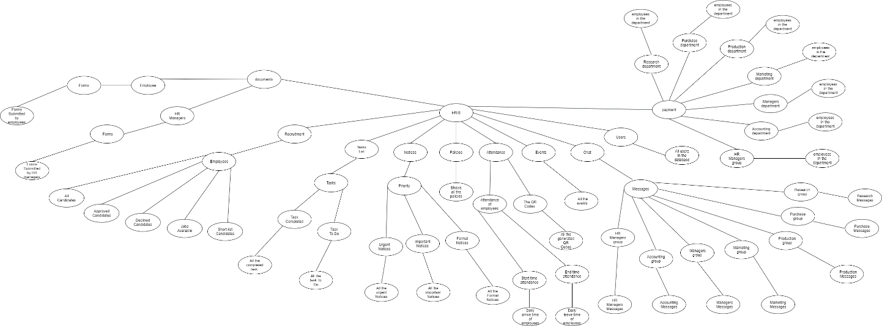

Figure 8.5 Hierarchical modal tree representation

When developing the hierarchical modal for the Firestore database some key instructions were followed because these were the rules set by firebase and While others were the rules followed by NoSQL databases. One of the main one was that there should be a collection and then the document which contains the fields and data. So, the way multiple collections could be made was by either having a collection then a document and repeating the process or by having a collection then a document then a collection within a document and then multiple documents.

# **9. Project status**

## 9.1 Initial Progress

The initial planning stage started began even before the project was assigned and during that time research was being done on the languages that is best suitable for the project and what are the existing human resource information management system that are available in the market and what their functionalities were. The development of the project initially began in November of 2020. The development began as soon as the research was completed to meet the strict time schedule met by me.

## 9.2 In the First Interim

### 9.2.1 Progress

During this time certain number of tasks were completed. In the month of November almost 35% of the development was completed and was going in track according to the initial project plan mentioned in the project initiation document. But in December due to certain risk that affected the project such as schedule over run only 5% of the development work was able to be completed. Currently some of the functionalities that have been completed from the system includes authentication of users, notices, chat system and the event calendar which will be displayed in the video submitted.

## 9.3 In the Second Interim

### 9.3.1 Progress

During this time certain key task were completed. And I was able to complete almost 20% of the project within a time span of one month. Initially before the first interim report I had only completed about 40% of the overall project and now I have completed about 60% of the entire project and is in track according to the updated project plan. Some of the task that was completed before the second interim report was the attendance, some components in dashboard, profile, uploading images to Firestore in the database, some backend components and much more.

### 9.3.2 Progress Tracker

#### 9.3.2.1 Brief

The table below shows the progress of my entire project, but the project is broken down into small tasks to identify what the progression of each task is, this table will allow me to make assessments on which task should I focus on the most and to identify whether I can complete all the tasks before the deadline. The table below clearly shows how much percentage of each task is completed before the first and second interim report and how much percentage is left for me to work on before the final deadline of the project.

#### 9.3.2.2 Progression of each task

|  |  |  |  |
| --- | --- | --- | --- |
| **Task** | **Description** | **Completed percentage before first interim report** | **Completed percentage before second interim report** |
| Design all the HR mangers pages | This includes identifying and designing all the pages for Human resource managers. | 80% | 100% |
| Design all the employee’s pages | This includes identifying and designing all the pages for employees. | 60% | 100% |
| Implement Authentication for the application | This includes all the authentication parts such as login and routing part of the application | 90% | 100% |
| Design the architecture and create a database | This includes identifying all the fields that are required then designing the architecture and finally creating all those collections in firebase. | 100% | 100% |
| Complete Managers user pages | This includes all the functionalities and pages that is available for human resource managers. | 63% | 80% |
| Complete employee’s user pages | This includes all the functionalities and pages that is available for employees. | 10% | 40% |
| Complete the machine learning functionalities | This task includes the machine learning part of the application. | 0% | 10% |
| Testing process of the application | This task includes the testing progress of the entire application and bug fixes in the application. | 35% | 48% |

Table 9.1: Progression table

### 9.3.3 Testing and Quality

The testing has been completely done for the 48% of the development that has been completed and during this testing multiple bugs and errors were found and resolved. The quality is ensured in the completed part of the project because I was able to get opinions from couple undergraduates who are studding Human resource management, according to their response they find the functionalities useful and easy to use.

### 9.3.4 Future Development

The project development being only 60% completed and there is 40% more to be done within the timespan of one and half month according to my updated project plan. Among the functionalities that is yet to be developed machine learning would be the one that word take the most amount of time and will be hard to implement so it will be done last after building the core functionalities of the system. Some of the main functionalities that is yet to be completed are graphs, employee management, and salary management.

## 9.4 Final Progress

### 9.4.1 Progress

The project is complete and is a success, at this time everything except one that is mentioned in the scope is complete along with some improvements. But the functionality that has not been added is the machine learning section for the analytics part of HR Managers. The Main reason to this was time limitation. Even though I had a substantial amount of learning done to do machine learning was not enough to do the functionalities that I was aiming to achieve so I had to make choice and remove the machine learning section from the current plan and add it to future improvements. Other than that, all the functionalities are implemented and both the mobile and the web app is working perfectly.

### 9.4.2 Testing of application

Since incremental approach was followed Testing was done after each increment this reduced the overall time taken for testing. During the final days of development there were some issues and bugs that I ran into, but I was able to fix these issues. Currently the application runs perfectly in mobile and web with any app crashing issues or any other bugs.

#### 9.4.2.1 Test Cases

To ensure testing was done properly and affectively the following test cases were maintained at the final stage of testing and was used to fix the bugs that occurred in the application. In addition, all the test case issues, and other bugs were resolved to make the application run smoothly.

|  |  |  |  |  |  |
| --- | --- | --- | --- | --- | --- |
| **Case Name** | **Details** | **Expected Outcome** | **Actual Outcome** | **Result** | **Solution** |
| Authentication of multiple users | Login as HR manager and try to access employee pages | The manager gets redirected to their dashboard | The manager got access to employee pages | Failed | Add an auth guard service class for each of the routing pages |
| Scan QR code | Scan the QR code using the device camera/webcam | Attendance of the employee is recorded | Attendance of the employee is recorded | Passed | No solution needed |
| Presence functionality | Automatically change in the database | The database value changes automatically from away, online, and offline | The database value changes automatically from away, online, and offline | Passed | No solution needed |
| Employee reviews | Change employees overall review | Can change the users rating | Can change the users rating | Passed | No solution needed |
| Graph’s display | Show the users the data as graphs | The different graphs are shown from the values from database | The different graphs are shown from the values from database | Passed | No solution needed |
| Salary & bonus calculation | Show and calculate the bonuses and salary of each employee | The salary of each employee is shown and then bonuses could be added on o he salary | The salary data is not obtained  From database and show it as an empty field | Failed | Created an entire new method for logic, called the data in a separate service class and did the calculation again |

Table 9.2: Test cases

### 9.4.3 Quality of application

To Ensure that the quality is maintained throughout the project I got the application reviewed from multiple individuals. The main person being my project supervisor, Where I showed him, he current progress, how the functionality work’s and improved the functionalities according to his suggestions. Some of the other people I got the application reviewed by were students who graduated with a degree in HR Management. With all these reviews and suggestion, I was able to increase quality of the application and provide a proper human resource information system.

# **10.The Application**

## 10.1 Screen shots & explanation of the application

### 10.1.1 HR Managers User Interface in Web View

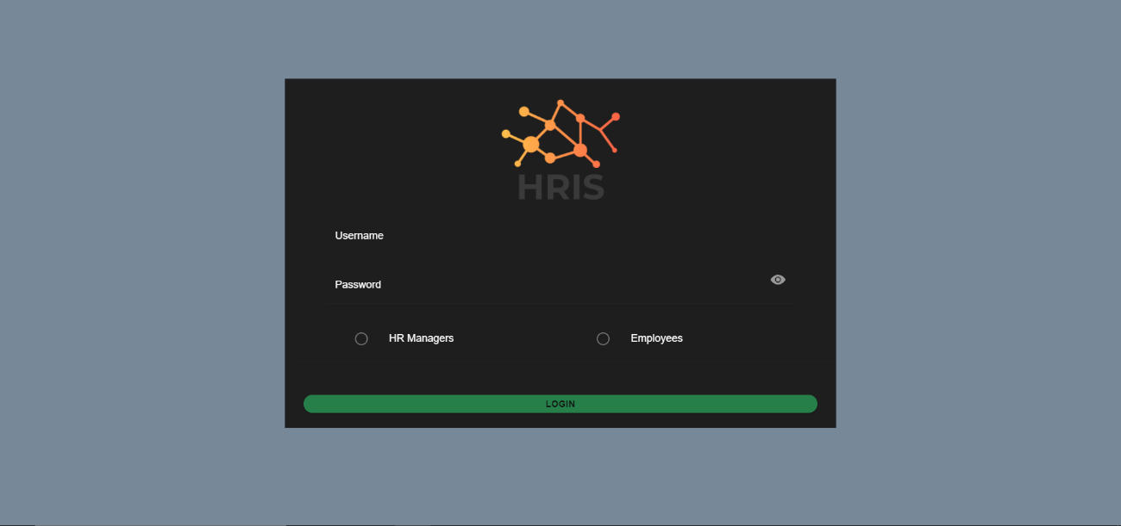

Figure 10.1: Login page

This is the login page and the first page that will be displayed to the users here they have to enter their details to login to the system. In the login page the way the managers and employees are identified is by their email and according to that they will be routed to their specific dashboard.

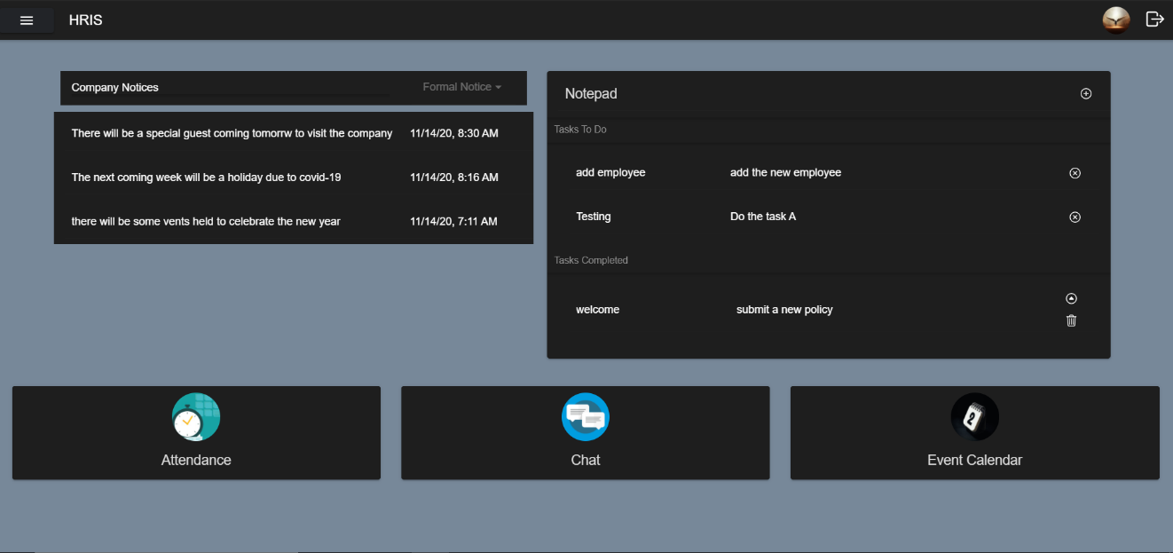

Figure 10.2: Dashboard

This is the managers dashboard page once the HR managers login through the login page they will be routed here and, in the dashboard, it provides buttons to some of the most used functionalities and also provide information.

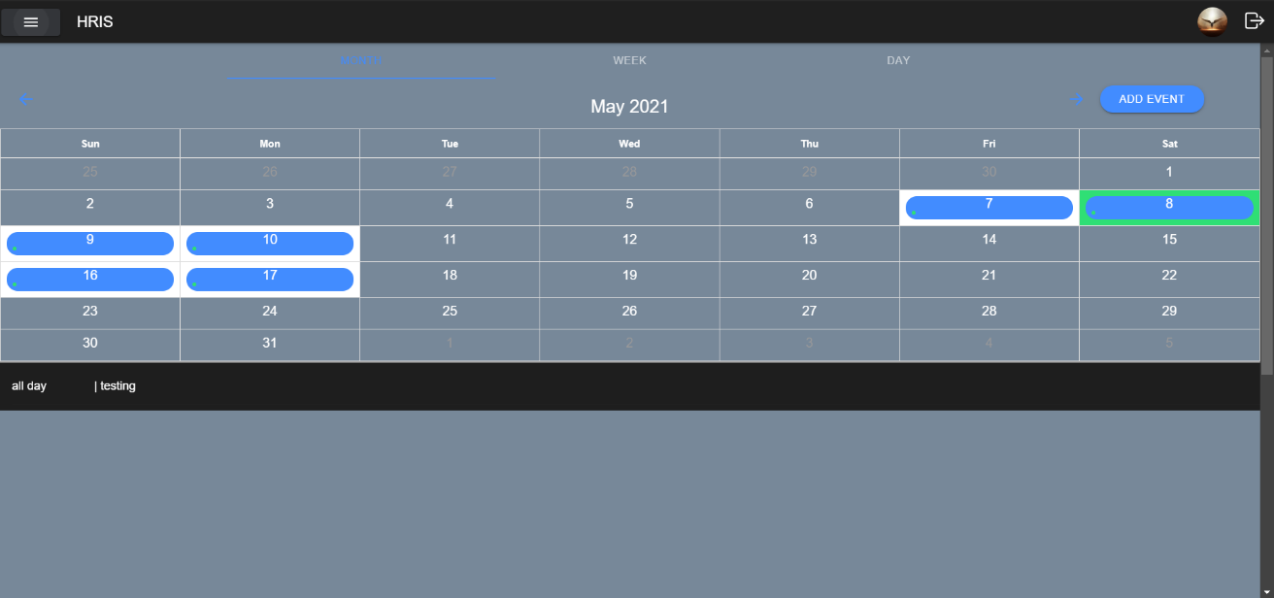

Figure 10.3: Event Calendar

This is the managers event calendar page here it shows the calendar, and the manager can view it in any form they want, they can see it from month, week, and day view. It shows all the events that are added to the event calendar along with the start time, end time and the small description of the event. The human resource managers can also add events by clicking the add events button.

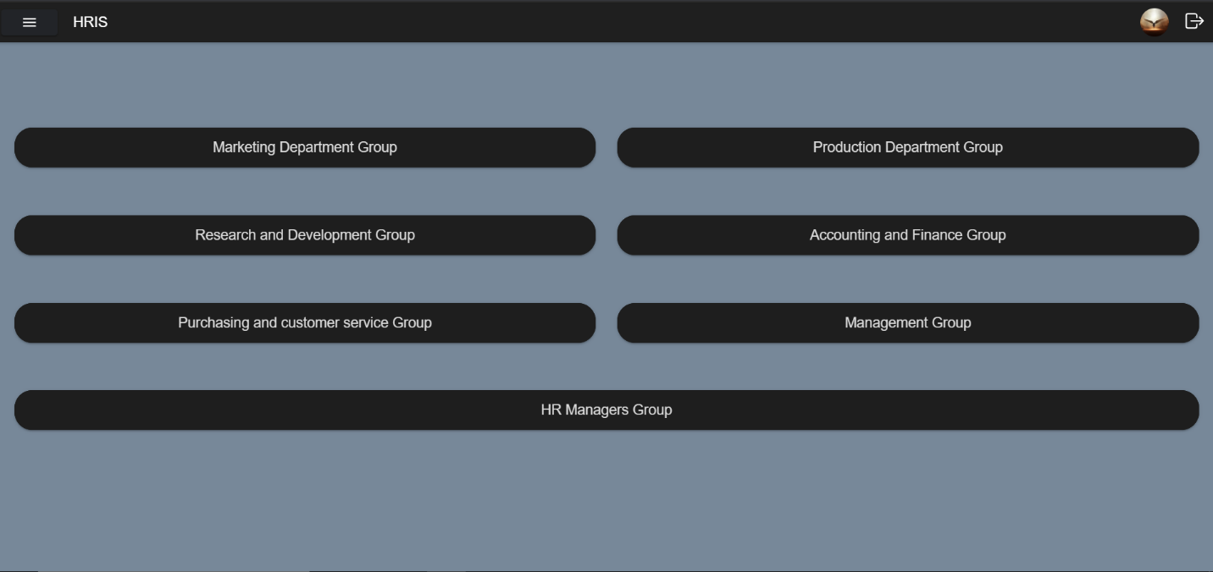

Figure 10.4: Chat lobby

When the human resource manager clicks on the chat from the menu or from dashboard they will be routed to this page, here it shows all the departments available in the organization and all the employees in the organization will be categorized under one of this departments, then the human resource manager can select a department and message to the employees who are in that specific department.

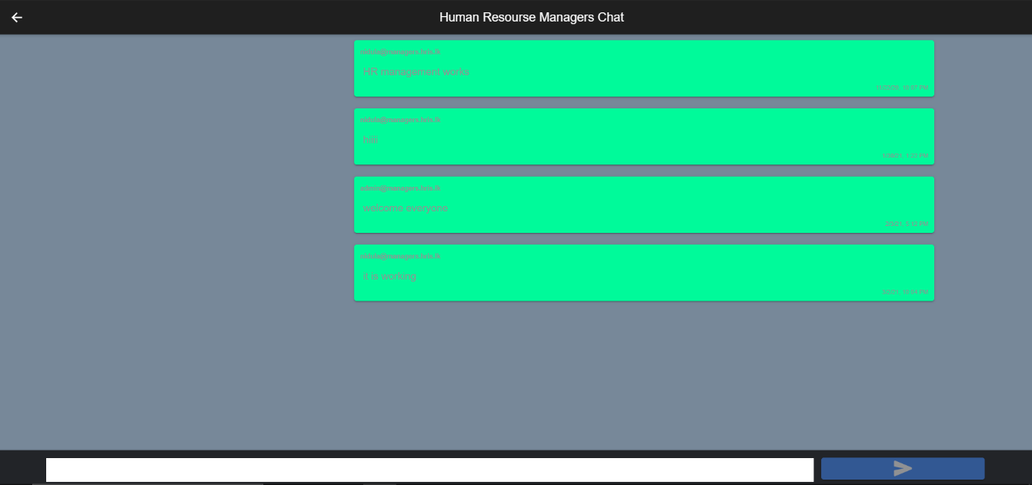

Figure 10.5: Chat group for HR Managers

This is the messaging area for human resource managers. once the human resource managers have selected a department then can send messages from here, when a message is sent it shows the message, the senders e-mail, the time the message was send and the date on when the message was sent.

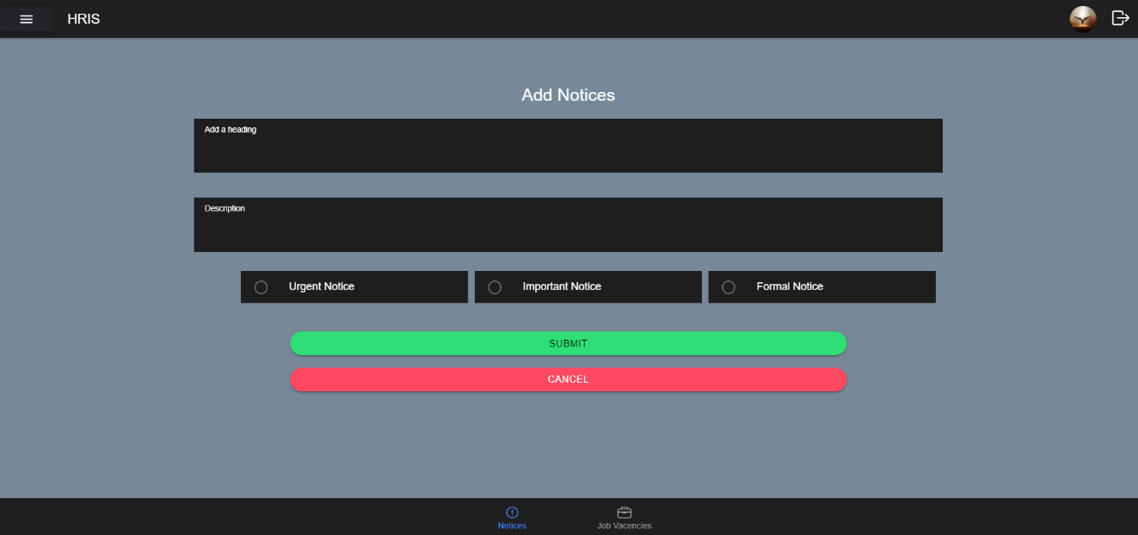

Figure 10.6: Add Notices

This is the notices page, and this is the page where managers use to add notices in the application which will be displayed in the dashboard of the user. There are three types of notices urgent notices, Important notices and formal notices and the user can add one of these 3 types of notices to the application.

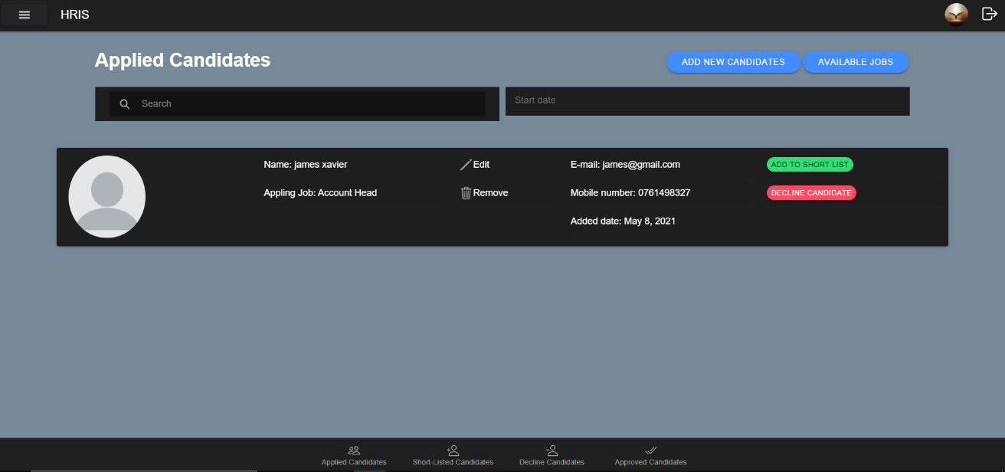

Figure 10.7: Recruitment

This is the recruitment section and here the human resource managers can add all the applicants who have send their CV and done the interview process. From here they can either decline the applicant or add them as an employee to the business. From here the HR manager can also see the Jobs that are available in the business.

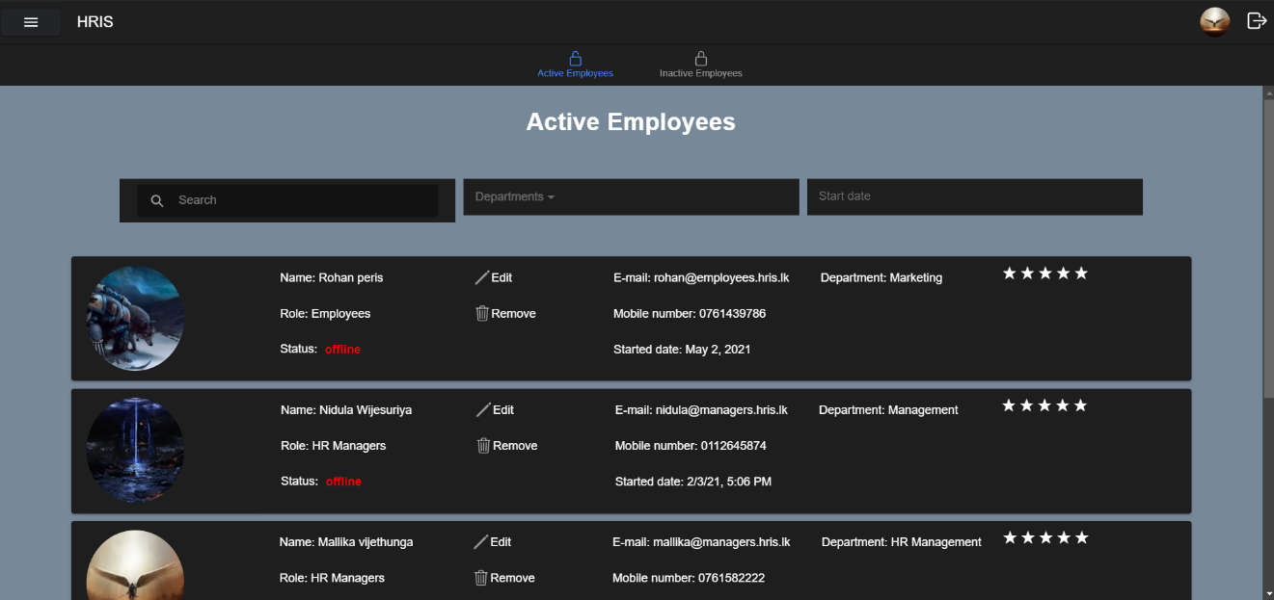

Figure 10.8: Employee Management

This is the employee management section of the application and here the human resource managers can manage all the employees in the business and also see who are the employees that are online and also rate the employees based on how they are working in the organization.

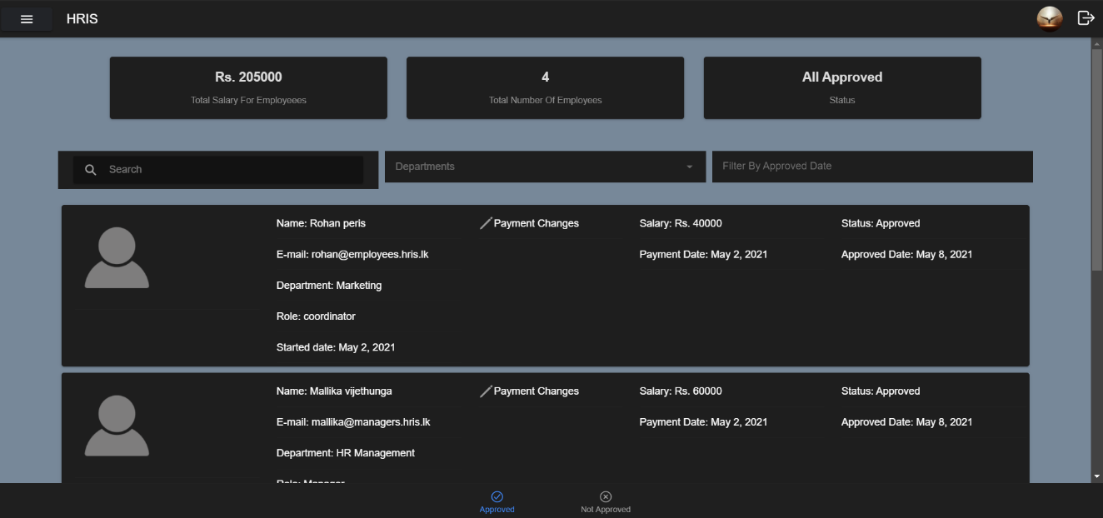

Figure 10.9: Salary Management

This is the salary management section of the application, and from here the HR managers can approve the salary for new employees and add bonuses, add promotion, change employee bank details, and also increase a employees salary based on the reviews an employee has. They can also see the total number of employees alone with the total salaries the business is paying.

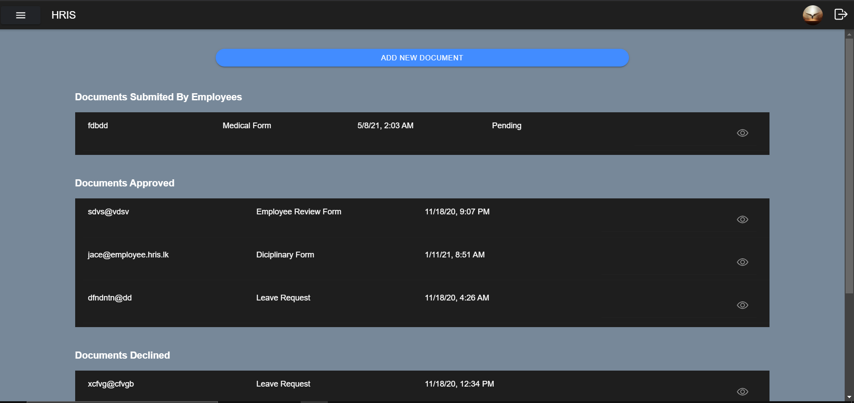

Figure 10.10: Document’s page

This is the document page here it shows all the documents and request forms submitted by human resource managers and by employees, human resource managers can view the submitted documents and then they can either refuse the document or accept it. They can also approve a denied document or just permanently delete the denied document.

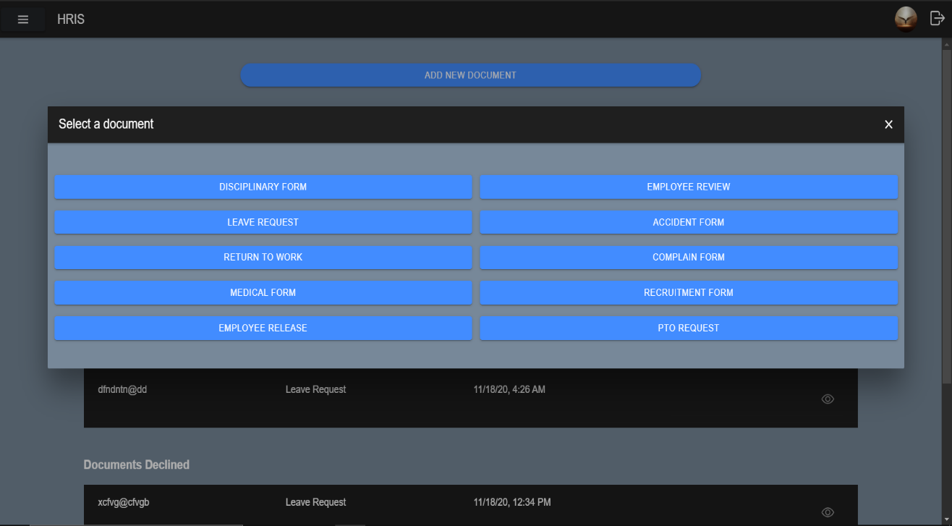

Figure 10.11: Add documents

When the user clicks add document button the following modal pops up and it shows all the different types of documents they can add and once a user clicks a document, they will be taken to that form to add the document to the document page where it later gets accepted or denied. Since there like documents all those documents will not being show on the report, but each document is different from the other and has specific fields which the user should fill to submit the document.

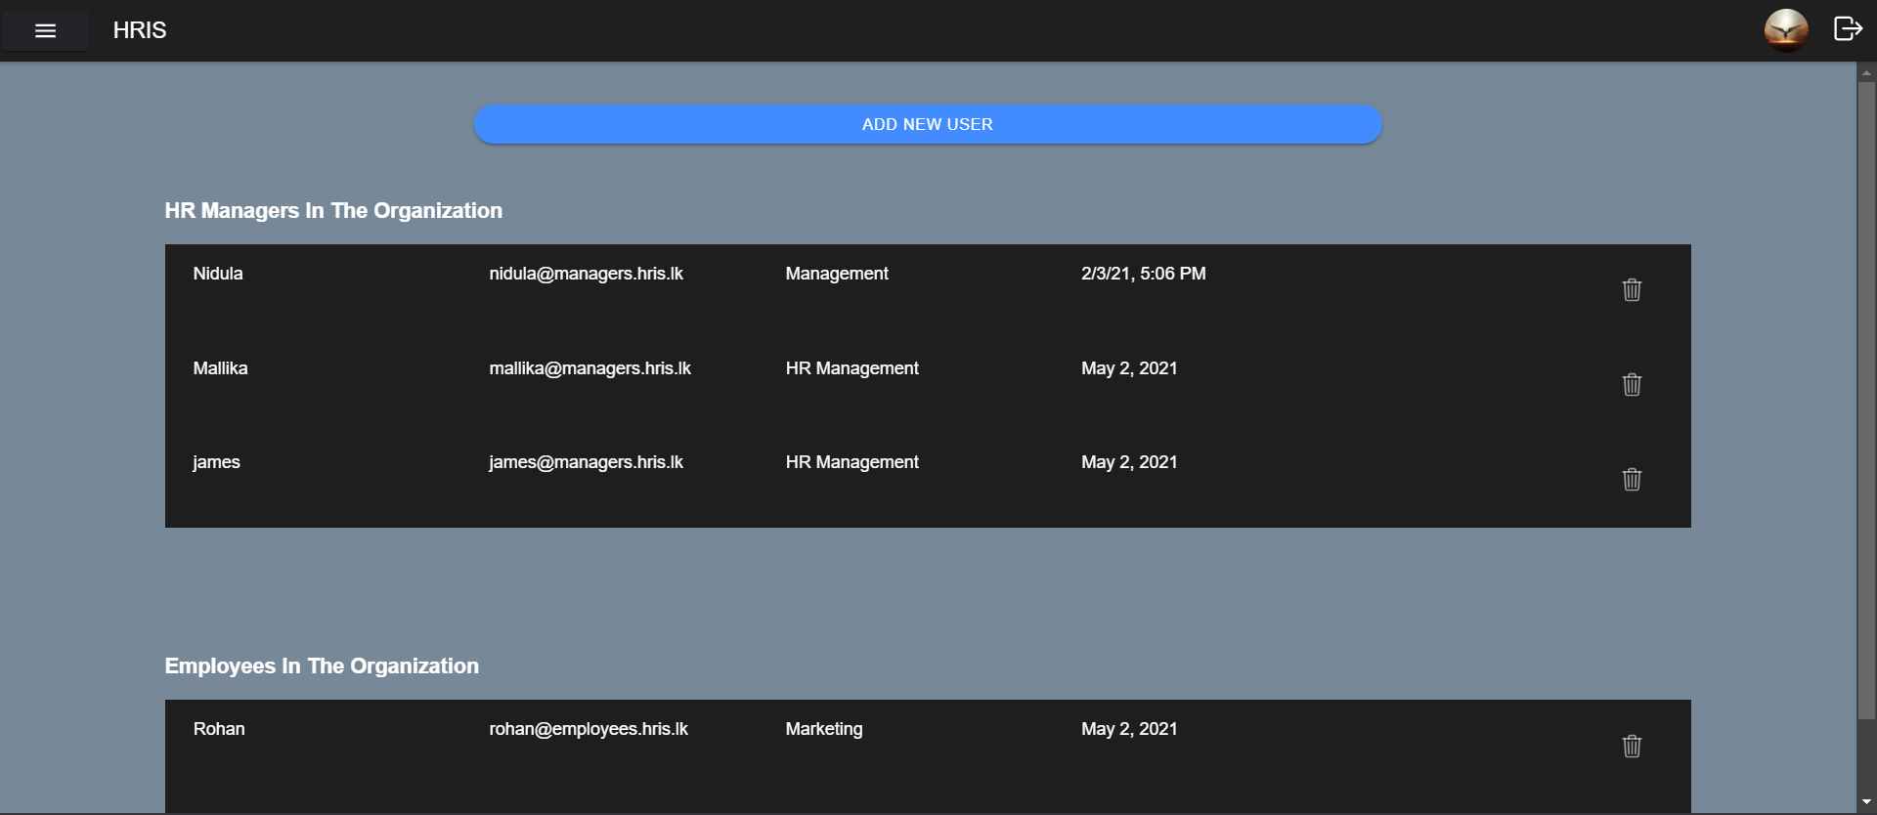

Figure 10.12: Users Page

This is the add new user page here it shows all the employees and human resource managers in the system. From this page the human resource managers can remove existing managers and human resource managers from this system. They can create new users by clicking the add new user button.

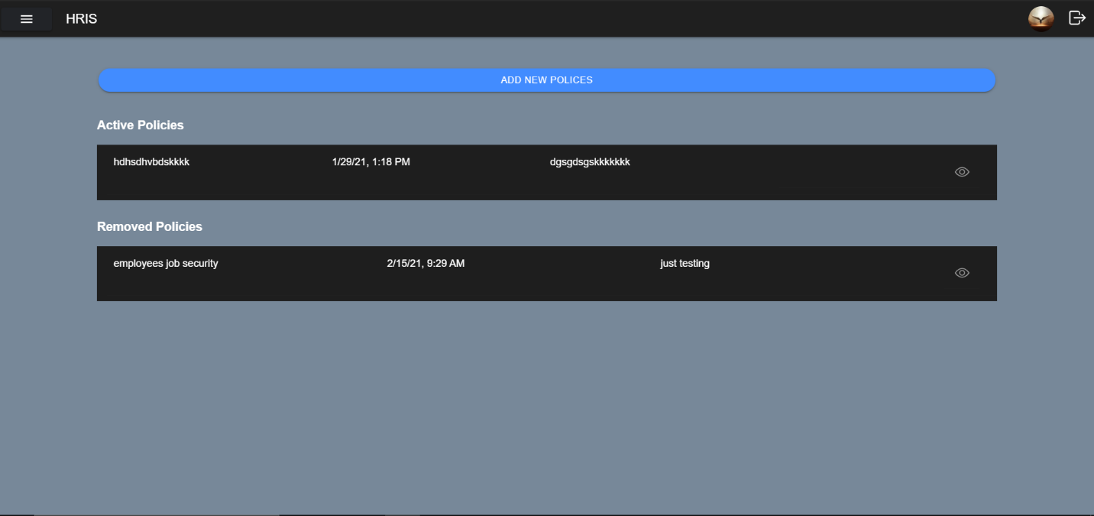

Figure 10.13: Add Policies

Policies is an important part of the organization because it defines the rules of the organization and these policies change overtime, and new policies will be added to the organization overtime and it’s the task of human resource managers to add them, so in this page the human resource managers can add new policies and also edit existing policies and these policies will be displayed to the employees.

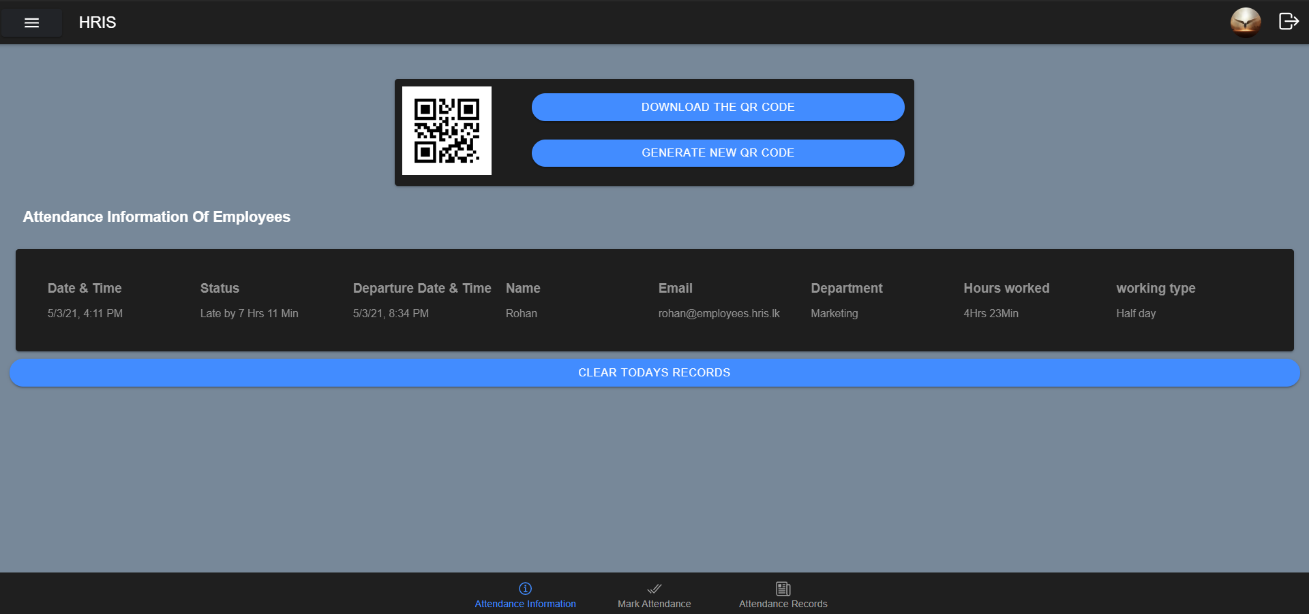

Figure 10.14: Attendance

In the page shown above the human resource managers can create new QR Code and delete old QR Code and whatever the QR code created by the HR managers should be used by the employees to mark attendance for the day, once the employees mark attendance it will be shown to the human resource managers in the above table with the user’s company email address and the time and date the employee scanned the QR Code.

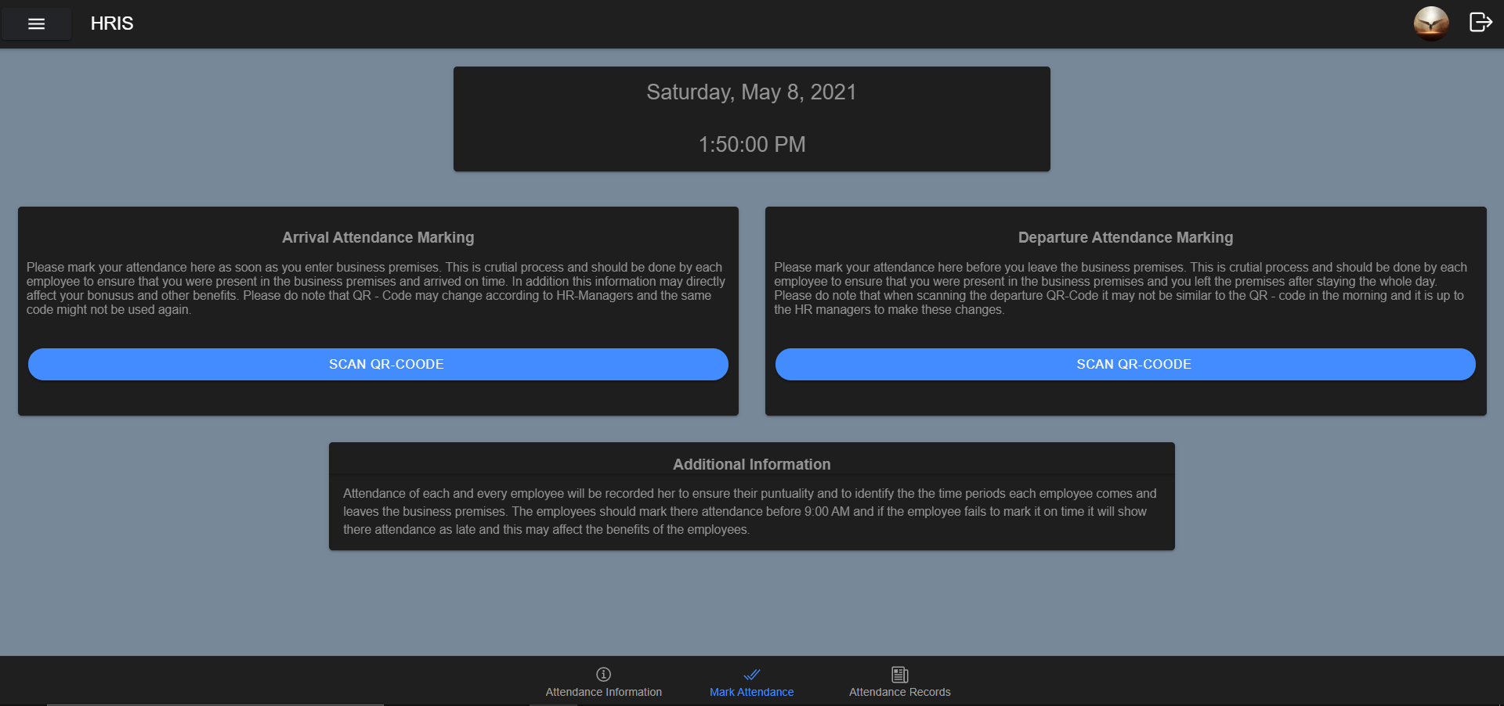

Figure 10.15: Mark Attendance

From this page the user can use this application to scan the QR Code by clicking the mark attendance tab which contains an inbuild QR- code scanner. Once the user scans and the QR Code and the scanned QR Code matches with QR – Code created by HR manager, then the user must enter the password to mark the attendance. The employee must mark the attendance when they enter the business premises and also when they are leaving. And this is used to calculate variety of things, such as hours worked, the arrival and departure time and more.

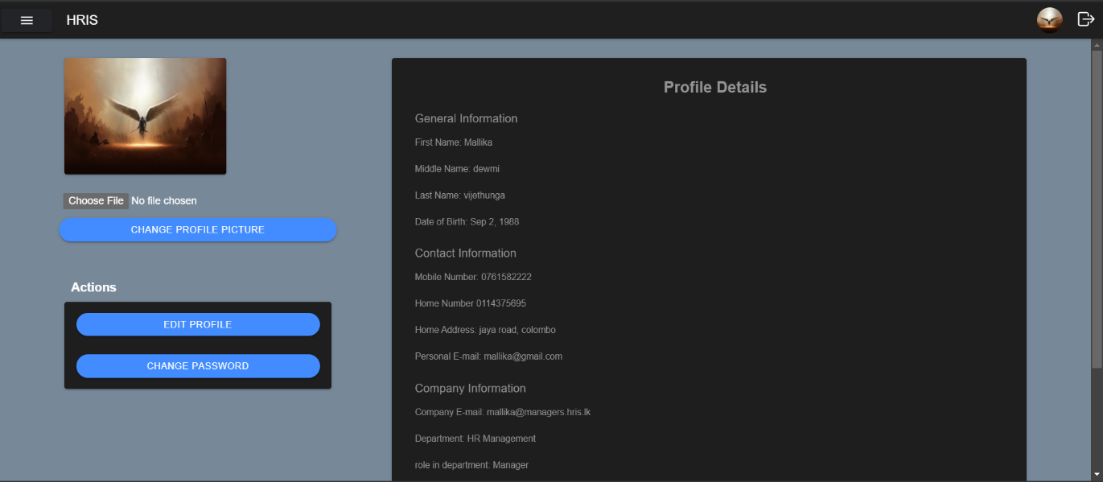

Figure 10.16: User profile

This is the profile page and here it shows the user all their account details and the profile picture. The users can change certain amount personal details by clicking the edit profile button and, they can also change the password by clicking change password which will open a modal but to ensure security within the system the user must enter the old password to change the password. The user can also change their profile by clicking change profile picture and the new picture they put will be stored in firebase storage and updated in in Firestore to display it in the profile page.

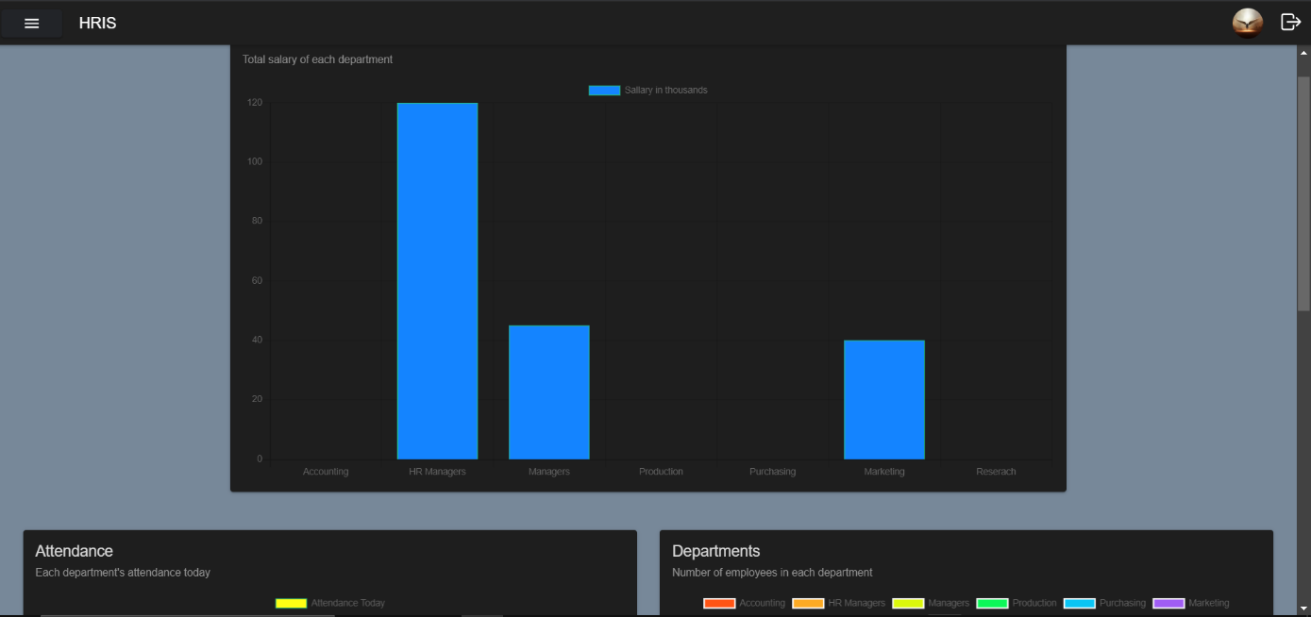

Figure 10.17: Graph Data

This page is only accessible by the HR Managers and here it shows them some useful data in the graph format for them to analyze and make some crucial decisions in the business. Some of the graphs that are displayed here are the: Salary of each department, Attendance of each department, total employees of each department and more.

### 10.1.2 Employees User Interface in Mobile View

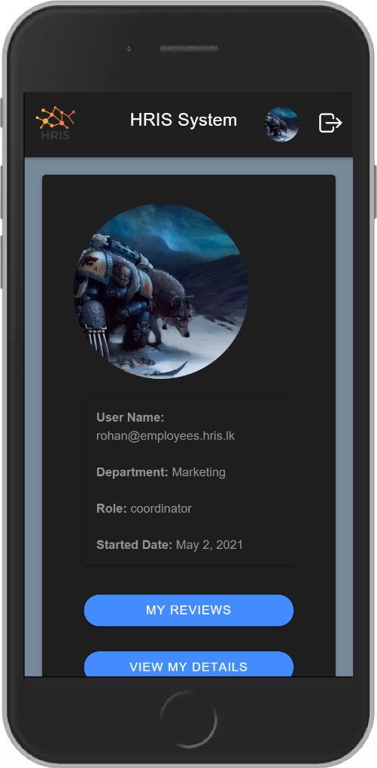 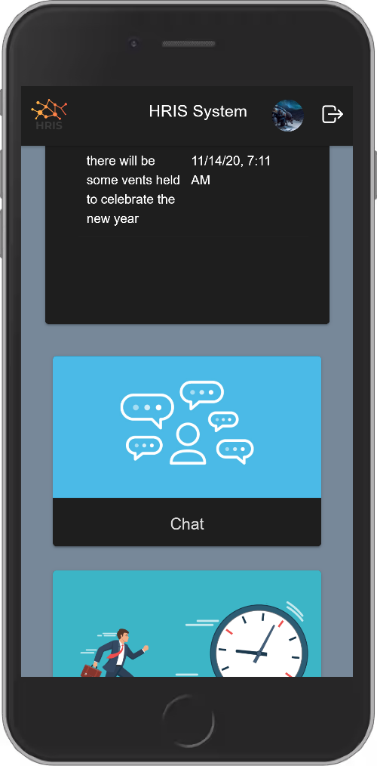

Figure 10.18: Employee Dashboard

This is the employee dashboard, when the employee login using the company email and password they will be redirected here. Only employees can access this page. Here it shows if the employee has marked the attendance for today and if he or she has not then it shows here as a red notification but if they have marked then it shows as green. All the functionalities the employee user has can be accessed from there dashboard.

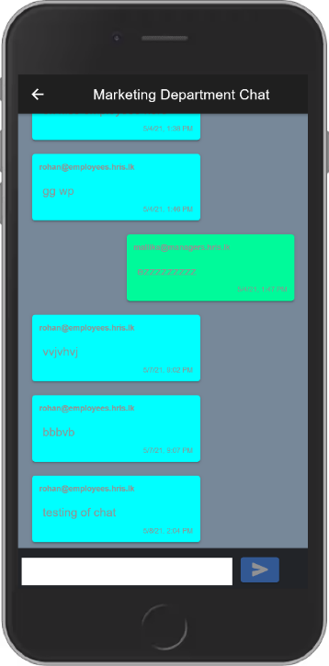

Figure 10.19: Employee Chat

This is the chat area for the employees, and unlike the human resource managers the employees can chat in every group, they can only talk in their department. So, the screenshot taken for the report was from employee in the marketing department and hence he can only talk in the marketing department.

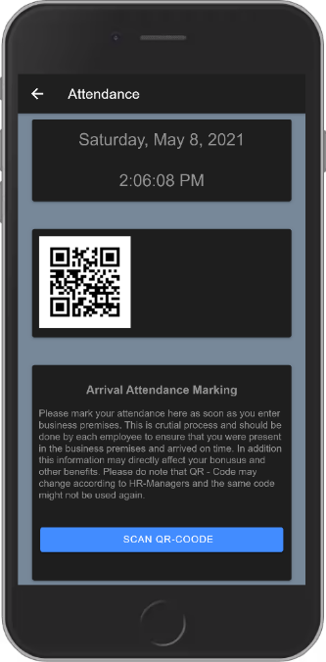

Figure 10.20: Employee Attendance

This is the attendance marking section of the employee here it shows the current time and date alone with the QR-code the employees must use to scan for them to mark the attendance for the day and this QR-code can be changed by the human resource managers any time.

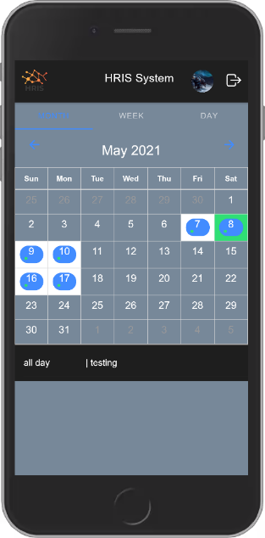

Figure 10.21: Employee event Calendar

This is the employee event calendar that is developed for the employees, here it shows the employees the calendar in month, week, and day form alone with each of the events happening in the organization. The events are shown in the calendar with the start time and end time of the events along with a small description on what the event is so that employees know what’s happening in the organization.

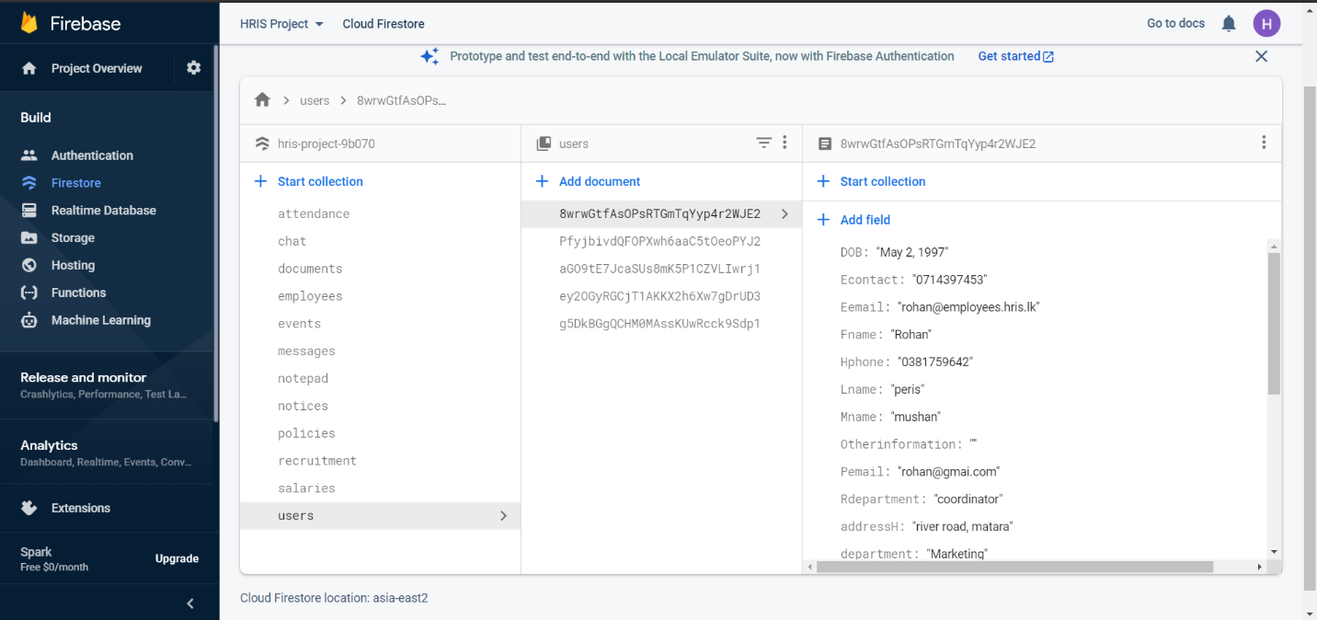

Figure 10.22: Firebase Firestore database

This is the firebase database used for this project and when developing this database, the hierarchical modal was used to ensure that this database is developed in a proper easy to access manner.

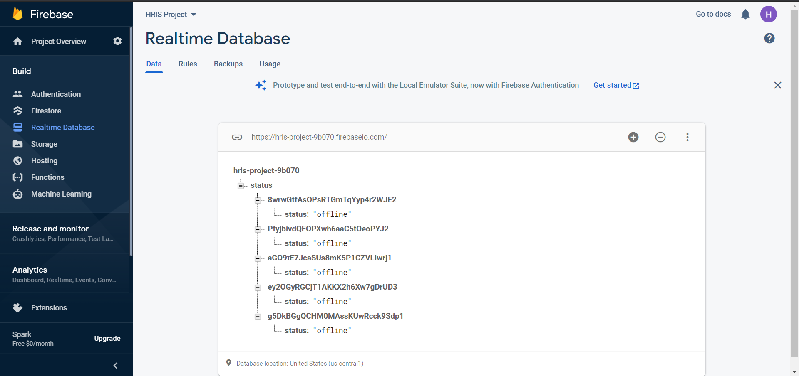

Figure 10.23: Firebase Real-Time Database

The firebase real time database and is used for the presence system in the employee management section in order to update the HR managers on the employee status real time. It stores the user id alone with the status of each user.

### 10.1.3 Extra Information

In addition to the screenshots of the system that is shown above there are much more pages and modals within the developed system those include different types of forms and sub-pages. What is displayed above are the main pages along with a small description on how each of these page’s function. The screenshots of the pages above are from both the users which are human resource managers and the employees.

## 10.2 Code Snippets from the application

### 10.2.1 Brief

The section below shows some screenshots of code snippets and contain a small description on what each of them does. The entire code base will not be added to the report because then it will turn it to a massive report and would not be an affective report, so instead some of the code snippets will be shown under the sections below which are separated into two sections called the front-end code snippets which contain front end code and back-end code snippets which will contain back-end code.

### 10.2.2 Front-end code snippets

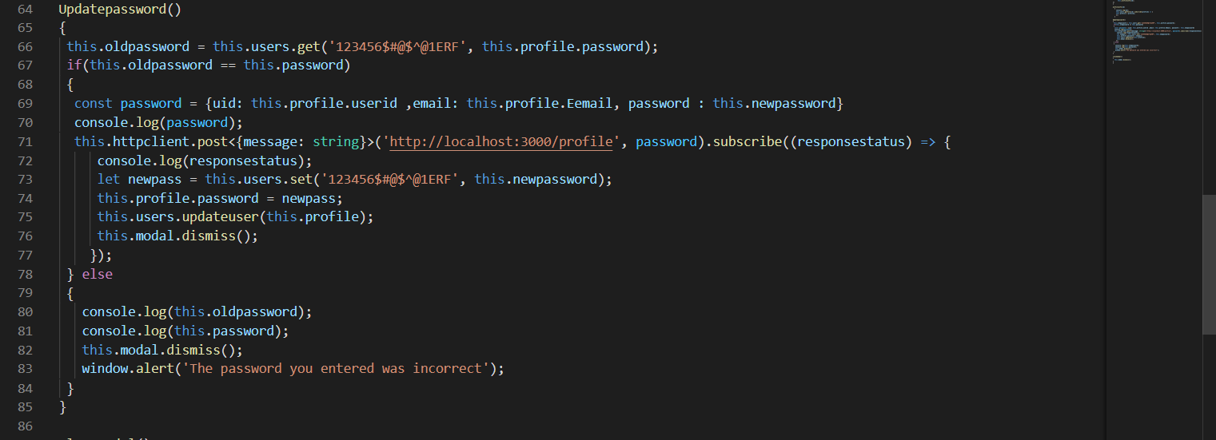

Figure 10.24: Update profile function

What the above code is used is for changing the password of the user. The way it works is that it takes the gets the old password from the database and decrypts it and then when the user enters the old password it checks whether the user entered old password is similar to the password in database and if the passwords are similar then the user entered new password is sent to the backend to change the password and the user is alerted with a message and if the old password entered by user does not match the password of the database then an error message is show to the user.

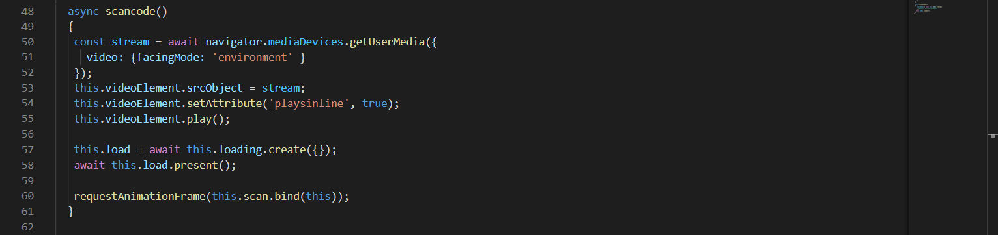

Figure 10.25: QR-code scanner

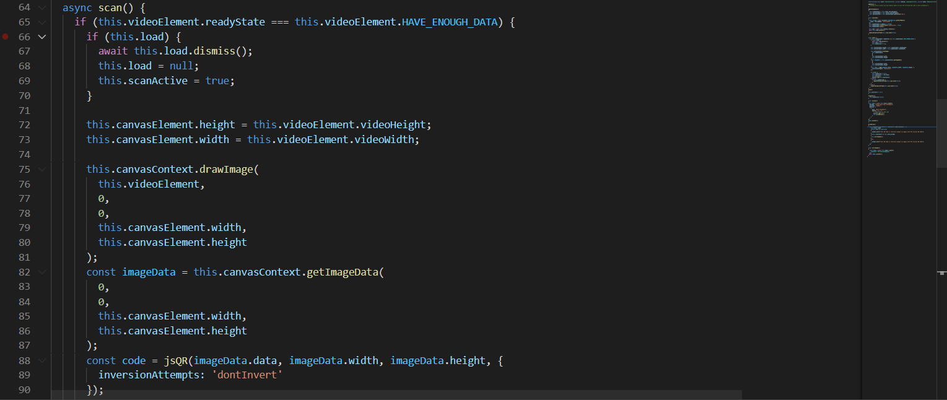

Figure 10.26: QR-code scanner

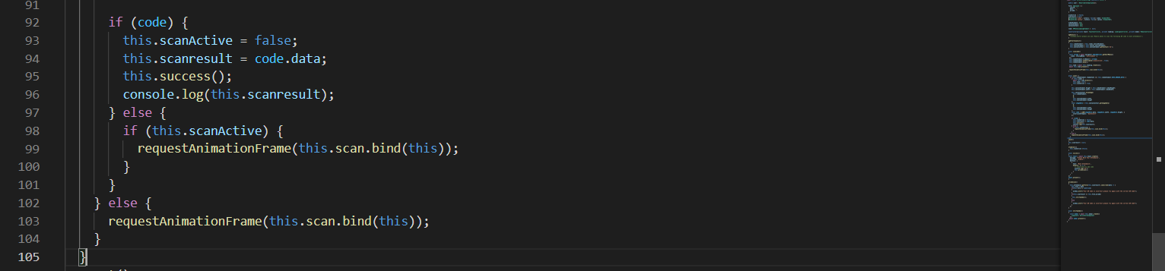

Figure 10.27: QR-code scanner

The three images above show how the QR- code scanner works. The QR- code scanner is used by the employees and the managers to scan the QR code and if the scan is successful the attendance of the user will be recorded. The way it works is that at first, we access the camera of the device this can be the web cam of the computer or the camera of the phone and then we show the user the live video of what the camera sees so that the user can point to a QR Code and once a QR code is detected by the camera it scans the QR code and gives us the result. The QR Code is detected by using the package @ionic-native/barcode-scanner which is available in ionic and should be installed using npm install. So, getting the result is not enough so what I did was I check the result taken from QR code and check where it matches to the QR-code generated by the manger which is there in the database and if the QR codes are similar then the attendance is recorded else it shows an error message to the user.

### 10.2.3 Back-end code Snippets

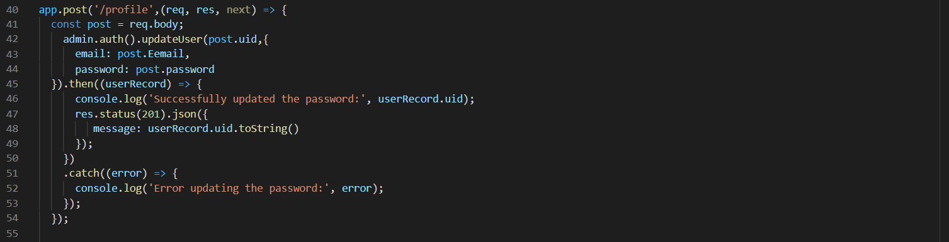

Figure 10.28: Update profile function

What the above code does is it gets the data from the front end and then uses the user id of the employee to find his records and then updates the user details with the details received by the front end. And if the task is successful, it sends a success message to the front end and consoles it in the terminal and if it fails the same thing happens but sends a failure message along with the reason why it might have failed

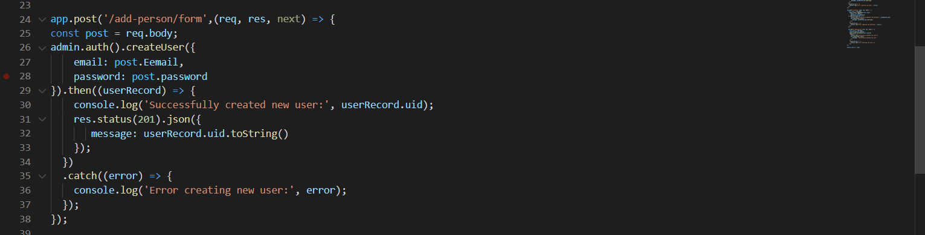

Figure 10.29: Add person function

What the above code does is it allows the human resource managers to add new users to the system. The way it works is similar to the above code snippet it gets the data from the front end and creates a new user with a unique user id and then if the task is successful sends a message to the front end and also consoles it and if it fails it sends an error message to the front end alone with what the error is and also consoles the result in the terminal.

# **11 Security & ethics of the application**

## 11.1 Security Of the application

The security of the application was one of the key things that was taken into consideration during the development of the application, Because the human resource managers can do sensitive functionalities in the application and have sensitive information about the employees, So the users needed to be validated and only the human resource managers should be able to do he managerial tasks and only the employees should be able to do the employees task. This was accomplished by using authgaurds in angular which allows me to detect and redirect the user using their company email which either have ‘@managers’ or ‘@employees’.

Another main security functionality that was implemented was the encryption of passwords in the database. The user’s password was saved in the database for the applications use in order for it to do a set of tasks. So, the password that is saved in the database is encrypted and can only be decrypted by the key the application uses so even if a person accesses the database, they want be able to get the users login credentials for the organizations application.

## 11.2 Ethics followed for the application

Human resource managers collect and process numerous sensitive information that should not be accessible by the employees due to variety of reasons, so this needed to be identified and considered when developing the application. Some of the ethics that was followed during development was that employees can’t see what the other employees salary and the bonus they get per year, they also can’t see the personal details and other sort of documents submitted to the human resource managers, they also can only see how other employees in the department rated them not who rated and how much each of them rated. These are just some of the rules that was followed there are much more rules that was followed to make this application ethical for the business.

# **12. Risks**

## 12.1 Risk plan

|  |  |  |
| --- | --- | --- |
| **Risk Plan** | | |
| **Risk** | **Probability of Occurrence** | **Management Strategy** |
| Schedule overrun | High | To avoid running into this issue a clear plan is made when each stage of the incremental approach should be completed, and I plan to discuss with my supervisor to let him know my progress and get his option whether I could manage the work with the current project scope. |
| Acts of God | Low | In the case of an event as such then the development of the application would not be affected because it will be backed up and so the development could continue from where I left off. |
| Technical difficulties | Moderate | To avoid the entire project been lost due to technical failures a GitHub repository will be created and maintained so that each time a change is made to the project it can be updated to the GitHub. |
| Trouble learning required development technologies | Low | To avoid this a proper research was done during the planning phase and determined whether it was capable doing the project with the suggested technologies and checked whether there is enough documentation and tutorial if I run into any issue during the project. |
| Scope creep | High | To avoid the project scope from growing after the project plan a strict project scope will be followed to avoid getting sidetracked from the initial project scope. |
| User acceptance | Low | User acceptance is one of the most important things and to make sure that human resource managers will like the product a questioner will be made to check what they need, and the systems user friendliness. In addition, I will get my supervisors opinion on the application. |

Table 12.2: Risk Plan

## 12.2 Risk Encountered

During the development of the project two main risk impacted the project but since those risks were identified and a plan was made on the project initiation document, they did not have a huge impact on the project. The risks that impacted and how they affected the project is mentioned below.

The first risk that occurred and impacted the highest was schedule over run. Even though I created the project plan giving time for the other projects and submissions. I did not correctly anticipate the time it would take to complete the other projects and the other reason was I came across some major bugs in the system which took a large time to identify and fix. So due to these reasons my scheduled was overrunned by work and I missed certain deadlines I kept for myself within this project and due to this I had to create a new project plan that puts the project completion data a little behind than the initial plan.

The second and last risk that occurred was technical issues, even though this could have been a major issue but since I identified it and managed this issue by using version control software like GitHub it did not affect a lot because I uploaded to GitHub at least twice a week once I complete any part of the project due to this, I didn’t lose any part of the project and was able to get back to work once my device was fixed.

During the end of the project, I ran into a risk that I previously encountered and dealt with but this time it was more serious, it was schedule over run. As mentioned in the project scope machine learning was to be added to the system and a intense amount of research and learning was done but due to a compact schedule and some bugs in the application I had to emit that technology from the system for the time begin. And focused on the other areas of the application and fixing the bugs caused in the system in order to provide a functioning and quality application.

## 12.3 Difficulties Faced During The Project

There were multiple difficulties that I had to face and overcome during the development of this project. One of these difficulties was the global pandemic which had a huge impact on research and the quality management if the project. If the pandemic did not occur, then I could have done interviews with HR managers which would have given me more information about them, their tasks, and their mundane tasks. The quality was affected because due to the pandemic I could not visit the university, So I could not show and get a review from my supervisor as often I wanted. Another main difficulty I faced was schedule overrun initially I had planned of implementing machine learning to the application and left it as the last increment of the incremental process but when developing the application the other increments took longer than expected due some bug in the code, and even though I learned about tensorflow.js I was not able to implement I into the application because of the time constrains and had to add that machine learning functionality to the future improvements of the application. These were the main difficulties that I had to face which took more time and effort to overcome.

# **13. Quality Plan**

## 13.1 Brief

When developing a project quality is one of the essentials things that should be considered because it is one of the main things that a customer looks for in a product and due to poor quality, the customer may even reject the entire application. So, to ensure that this project provides a good quality HRIS system the following quality checks will be done, and these strategies will be used to do these checks, so if these quality checks are done in a proper way, then the quality of the system can be ensured.

## 13.2 Quality Plan

|  |  |
| --- | --- |
| **Quality Plan** | |
| **Quality check** | **Strategy** |
| Major deliverables | To ensure that the major deliverables are met a plan is made on the work process so it is not rushed this will also ensure that the system has the functionalities mentioned and nothing will be missed. |
| Quality control activities throughout the project | To ensure the quality I will get a review from my supervisor after each increment of the project and during the testing period of the system |
| Sub system usability and validation | This will be done after each increment to ensure quality is maintained in the project |
| Quality assurance activities | To ensure that the quality of the application is maintained I will get the review of the quality from my supervisor after each stage. |
| Feasibility study | A feasibility study will be done on the project to ensure that the project is worth the time and effort and to show how it will benefit the business. |
| System validation and user acceptance | To ensure that the human resource managers accept the product and is also helpful to them a questioner was conducted of what they need and what they want from a human resource information system. So, it could be delivered to them. In addition, I will also get the option of my supervisor. |

Table 13.1: Quality Management Plan

## 13.3 Changes Made Based On reviews

During the development of the project, I got reviews of the application from multiple people, mainly from my project supervisor, fellow batch mates and from few working human resource managers and they all gave me valuable suggestions on how to improve he application. All these suggestions were taken into consideration and changes were made during the development of the application.

One of the main changes based on reviews was that initially the attendance was only taken when a user enters the business premises, Then my supervisor suggested me to take the time when an employee enter the premises and also leaves the premises and so this was implemented in the application and this change allowed me to add much more functionality to the application like allowing me to calculate numerous things like over-time bonuses, to calculate he holidays left for each employee and finally to identify whether the employee worked for a full day or half day. This improvement also improved the enterprise aspect of the application. Another change that was done based on reviews was for the chat system available in the application. A fellow batchmate suggested me to change the interface of the chat system to make it more user friendly to the users allowing them to easily communicate with each other. So, with this suggestion the entire chat system user interface was changed, and this change improved the way the application looked and also improved the user experience of the application. There is much more scenarios where the application was changed based on a review and the ones mentioned here are just some changes made from the variety of reviews and changes made on the application.

# **14. Project Plan**

## 14.1 Brief

The project plan was initially created during the planning stage of the project and was added to the project imitation document. But when the project began one of the risks mentioned in the risk list occurred and caused a delay and due to that following the old project plan was not feasible anymore. So, a new project plan was created and with it the project was continued without any complications.

## 14.2 Initial Project Plan

|  |  |  |
| --- | --- | --- |
| **Project Plan** | | |
| **Stage** | **End date** | **Products/deliverables / outcome** |
| Project Initiation | 03/11/2020 | Project initiation document |
| Research on the development area | 05/11/2020 | A clear understanding of what human resource managers need and the short comings of the current HRIS systems |
| High Level designs of the system | 10/11/2020 | Design documents that are needed for the project and graphical user interface layouts |
| Increment 1 | 01/12/2020 | Development of the functionalities for human resource managers in the web and mobile application |
| Increment 2 | 20/12/2020 | Development of the functionalities for employees in the web and mobile application |
| Increment 3 | 31/01/2021 | Integration of machine learning and some of the other functionalities |
| System testing | 12/02/2021 | Testing the entire system using the component testing method |
| completion of final report | 15/03/2021 | Final report of the project |

Table 14.1: Initial project plan

## 14.3 Finalized Project plan

|  |  |  |
| --- | --- | --- |
| **Project Plan** | | |
| **Stage** | **End date** | **Products/deliverables / outcome** |
| Project Initiation | 03/11/2020 | Project initiation document |
| Research on the development area | 05/11/2020 | A clear understanding of what human resource managers need and the short comings of the current HRIS systems |
| High Level designs of the system | 10/11/2020 | Design documents that are needed for the project and graphical user interface layouts |
| Increment 1 | 10/02/2021 | Development of the functionalities for human resource managers in the web and mobile application |
| Increment 2 | 31/02/2021 | Development of the functionalities for employees in the web and mobile application |
| Increment 3 | 15/03/2021 | Integration of machine learning and some of the other functionalities |
| System testing | 23/03/2021 | Testing the entire system |

Table 14. 2: Finalized project plan

# **15. Documentation Guide**

## 15.1 Technical Documentation

In this section I will tell you how to run the application in the web and how to install it and run in a mobile application or in an emulator. This technical documentation is provided for local hosting because currently the application is only hosted locally. This section will not be valid if the application hosted in a hosting server in the future.

### 15.1.1 Web App

If the application is taken from GitHub or from the folder submitted to the DLE it will not contain the node modules file because the node modules files are quite large. So, it must be installed and then it could be ran using the ionic server command since this is an ionic application. Here now I will explain each step you need to do after getting the file to run the application.

Step 1:

To run this application, you need to have Angular and node.js along with ionic installed in your computer and this is a must to run the application. You can see guides on how to install the above there from these websites:

* Angular: <https://angular.io/guide/setup-local>
* Node.js: <https://nodejs.org/en/>
* Ionic: <https://ionicframework.com/docs/intro/cli>

Step 2:

After Angular, Ionic and Node.js is installed you can open the folder in an IDE I recommend visual studio code. After the folder is open you need to install the node packages required for the application. You can do this by navigating to the application folder using a terminal and then typing the **npm install** command.

Step 3:

After all the required node modules are installed then you can run the command **ionic serve** and what this will do is compile the entire project and run it in the browser. This compilation process may take a couple of minutes depend on your device capabilities.

Step 4:

After you run that you also need to run the backend Node.js server. So, to do that you need to navigate to the project folder again using a terminal and type the command **node server.js** and this will get your backend server started.

Step 5:

After all the above steps is followed and done correctly then you should be able to use the web application properly without running into any errors.

### 15.1.2 Android Mobile App

There are two ways in which you can run the mobile app after the APK is released in deployment. The first way is using an emulator in your computer and the other way is installing the application in your mobile app using android, both these ways could be done only if the APK is released. But currently the APK is not released since the app is not yet deployed so if you want run the mobile app you need to enter a set of commands which are mentioned below and need to have android studios installed.

#### 15.1.2.1 Before APK is Released

First you need to build the ionic project by typing the following command **ionic build.** And then after that you need to type the following command **npx cap copy** in the CMD to save the ionic build changes to android folder. Then you need to run the following command **ionic capacitor update** for ionic capacitor to update and do note if this command is not entered then an error might occur during compilation. And then you can finally run the following command **npx cap open android** which will open android studios and build the app which you can then run.

#### 15.1.2.2 After APK is Released

Emulator method

For this method you do not need android studios but if u do not have an emulator in your device, you could install android studios and hen use the emulators provided by them.

If you are using an emulator in your device all you must do is go the APK file of the application and click on it and then it checks for an emulator in your device and install it automatically. The APK file can be found in the following path: android app release

If you do not have an emulator, then you must install android studios and then open the folder in android studio and run the application using an emulator provided by the android studios.

Mobile Method

To do it this way you need to install android studio, but you do not need to install an emulator from them instead you should take your mobile device and unlock developer option on it and then enable the USB debugging setting. After enabling it you should connect it to your computer using a cable and then run the android studios. If the USB debugging is enabled, then the android studio will detect it So after that all you must do is run the project in android studios and the HRIS app will be installed in your mobile phone for you to use.

# **16. Future Improvements**

The application that is currently developed is substantially good but there is always room for improvements, so during the initial development of the project there were not enough time to do some of these improvements So these improvements could be added in the future as updates.

One of the main improvements that could be done is add machine learning to the analytics section of the application. Currently it is called graphs because it contains some valuable information in the form of a graph that shows the user in presentable way. But this could be improved by adding machine learning to predict what the result will be in the coming weeks so then the HR Managers can make crucial decisions in the business.

Another improvement that could improve the application is by adding facial recognition to the application to mark attendance of the employees. Currently it makes use of QR codes to mark the attendance of the employee, even though this is good way it could be improved by adding facial recognition to the application because it will be easier for the employees because then they do not have to physically mark the attendance.

There are much more improvements that could be done by adding multiple advanced concepts and technologies in the future. But for now, the application runs perfectly without any bugs or any other issues.

# **17. Conclusion**

In the initial stages of the project this was just merely a plan but now, I have a completely functioning application that is effective and easy to use. I am genuinely proud of the Human Resource Information system that I have developed, and I would say it is a great success and provides a solution to the problem I initially identified during the research of the project. During the development of this project, I ran into numerous issues some of these issues benefited me allowing me to improve the application while others caused delays in the completion of the increments which resulted in a delay of completing the project. But even with these issues I was able to overcome them and manage the project and complete it successfully while learning new technologies, architectures, and languages.

The application currently is ready for enterprise use and can be deployed without any major changes to the application. So, it could be used in organizations to improve communication, effectiveness, and decision-making process of the organization.

# **18. Appendices**

## 18.1 References

* Balyuk, A., 2020. 7 Benefits of Managing People In The Company - Epicflow. [online] Epicflow. Available at: <https://www.epicflow.com/blog/7-benefits-of-managing-people-in-the-company/> [Accessed 28 October 2020].
* Angular.io. 2021. Angular. [online] Available at: https://angular.io/guide/architecture [Accessed 14 February 2021].
* Tutorialspoint.com. 2021. Node.js - Introduction - Tutorialspoint. [online] Available at: https://www.tutorialspoint.com/nodejs/nodejs_introduction.htm [Accessed 14 February 2021].

## 18.2 Proposal

**Human Resource information Management System**

**(HRIS)**

**Proposer**

Name: Nidula Nuran Wijesuriya

Index Number: 10674049

**Proposed supervisor**

Dr. Rasika Ranaweera

**Project description**

The proposed project is a human resource information management system, the human resource department is one of the crucial parts of a business because they manage the people in the organization and having an effective human resource department can have a direct positive impact on the employees which would make it a good working environment for employees and result in profit for the business. The human resource information management system or the HRIS is developed to make the tasks of human resource managers easier and make them more effective in an organization for them to make important decision for the business. There is different type of HRIS systems out there in the market, but the problem is most of them either does not provide easy to use interface for the human resource managers or does not have enough functionalities for human resource managers to make decisions effectively. But with the proposed system I aim to automate some of the task of human resource manager to reduce their workload and to make them more effective to the organization.

This proposed system will have two platforms and they will a web and mobile application and will be using the progressive web app technology to develop this proposed HRIS system, this application will be developed using ionic and angular with firebase as the database. The application will have all the things that is required to manage employees in a business and will be a user-friendly application. This HRIS system will have functionalities like time & attendance, chat capabilities, performance management, employee self-service and finally a payroll system that uses machine learning to find who should receive raises and who gets overtime payment. This system will contain these main functionalities and a few other functionalities that will make this Human Resource Information Management System different from the current HRIS systems that are currently available in the market. The main objective of the proposed system is to make the tasks of human resource managers easier and to make it a self-service system for employees while aiming to achieve the data, information, and knowledge factors that a HRIM system should have in order for it be a good human resource information management system.

**Project keywords**

Human resource managers, machine learning, Web application, mobile application, progressive web app, angular, ionic, firebase

**Requirements**

Learn ionic and angular frameworks

Learn concepts and implementations of machine learning

Learn node.js

**Finance**

None

**External organizations**

None

**Other staff**

None

## 18.3 Project Initiation Document (PID)

### 1. Introduction

#### 1.1 About us

The Project is a Human Recourse information system which is a system that is developed for the human resource managers to provide them with information and at the same time make the task of human resource managers easier and make them more effective in the business. This HRIS system is not specified to a business but can be used by any business to manage their employees, to do their HR tasks and make their human resource department effective.

#### 1.2 Introduction

The management of the human factor of an organization has been one of the main goals of a business and to do so human resource managers are hired and they have the task of training employees, performance management, organization development, safety, wellness, benefits, employee motivation and more. These tasks can be time consuming and hard to manage so the Human Recourse Information systems or also known as HRIS systems were introduced to the human resource managers. A research done by (Hussain, Wallace and Cornelius, 2020) states that the HRIS systems are used by human resource professionals to make strategic decisions no matter the size of the business and says that this has added value to the company and increased the status of the human resource profession. These HRIS systems are used to make the task of human resource managers easier and manageable. In addition, some HRIS systems have automated some of the tasks done by the human resource managers so that they could be more effective and focus on decision making for the betterment of the business.

### 2. Business case

#### 2.1 Business needs

There are several factors that affect the business it may be in a positive way or else a negative way but what decides this outcome depends on how the business manages these factors. The employees of the business are one of the main factors that can have a huge impact on the organization, so the business needs to manage it in a proper manner. According to (Balyuk, 2020) Management of employees is important because the company is made up of people with different ages, customs and profiles and managing them is crucial to the success of the business and she also states that if they are managed in a proper manner it could provide benefits like good working environment, employee development, Increased productivity, and motivation and finally business objective alignment. So, what the business needs is a user friendly HRIS system that has the functionalities required for management of employees and reduce the mundane tasks of human resource managers. A good HRIS does not just help the business and HR managers it also helps the employees working in the organization making them more motivated and provide them a good working environment and this will have a positive impact on the business and may result in business growth or it becomes more successful.

##### 2.1.1 Identification of the problem

The problem this project is attempting to solve is the management of employees in a business and to make tasks easier for human resource managers by automating them by developing a HRIS system. so that they can be more efficient in the decision-making process. There are multiple HRIS systems in the market but the problem with those systems is either too complicated for user or there are less functionalities so with this project I will attempt to solve this problem by providing a user friendly HRIS system with the functionalities that are required by the HR managers.

##### 2.1.2 Analysis of the problem

To identify what are the main issues that a HR manager have, the task that could be automated and to determine what information would help the human resource managers to make decisions a questionnaire was done. The target people of the questionnaire were the HR managers, students or anyone who has seen or used HRIS systems, I received fifty plus response from all the target people providing me with information on how happy they are with current HRIS systems, what functionalities a HRIS system should have, the problems they face as HR managers and more. These responses were not one sided but one main thing that all recipients agreed was that Human resources information management systems will improve the effectiveness of Human resource managers and benefit employees. In addition, provide a good performance culture in the business.

#### 2.2 Business objectives

The business may have multiple goals but one of the main goals of the business would be to have an effective human resource management department that manages employees to provide a good performance culture within the business. And To achieve this business goal the following business objectives should be accomplished.

* Automate some of the tasks done by employees to make them more efficient
* Provide human resource managers with analytic data to make important decisions for the betterment of the business
* To manage staff more efficiently and in an easy way
* To have a good communication between management and employees
* To motivate employees and provide a good working environment
* To ensure that organization resources are used efficiently
* To have accurate data within the organization

### 3. Project Objectives

At the end of this project, my goal is to provide a working user-friendly human resources information system that has the functionalities required to help the human resource managers and the objectives of this project are:

1. Identify what are the functionalities that the human managers need to manage task easily.
2. Identify what are the tasks done human resource managers that could be automated.
3. To provide a way to improve the communication between the employees and the management.
4. Create a good working environment for the employees with less arguments and fights within the organization.
5. To make the decision-making process of human resource managers easier using analytic data.
6. To keep the employees up to date on what is happening in the business and when it is happening.
7. To provide a way to manage employees effectively within the business.
8. To Provide self-service capabilities for employees in the business.

### 4. Initial scope

1. Identify what are the human recourses information systems in the current market and find what are the positives and negatives of these systems
2. Identify the human resource process what the human resource managers need to make decisions using questioners
3. The proposed system will allow:
   1. HR managers to get the attendance of each employee and find out the days the employee did not come
   2. HR managers to make decisions effectively by using analytic and statistic data
   3. HR managers to manage and change details about the current employees
   4. HR managers to add and remove the employees that are currently in the business
   5. HR managers to send notifications to the employee in the organization
   6. HR managers and employees to talk to each other using the chat facilities
   7. Employees to request for a holidays and other requests
   8. Employees to see how many holidays they have left for the year
   9. Employees to change some of their personal details
   10. HR managers to manage the hiring process
   11. Employees to review other employees in the same department
   12. HR managers should be able to add events to the calendar and employees can see them
   13. HR managers will be able to fill and submit different kind of forms
   14. HR managers to add bonuses and increase salary
4. A mobile application will also be developed for the employees and the human resource managers
5. The system will use machine learning and provide a suggestion to human resource managers which employee should receive the raise and when they should receive it.

### 5. Method of approach

The development process of system will take use of the incremental approach, the reason the incremental approach was chosen over the other approaches was because with the incremental approach I will be able to make changes throughout the development process after getting a respond to each iteration and also the errors are easy to find. The incremental approach will have 3 increments. The first increment is the development Human resource manager functionalities for the web and mobile application. The second increment is the development of employee functionality for the web and mobile application. And finally, the third increment is the integration of machine learning and some of the other functionalities.

The web and mobile application will be developed using the above approach but what the technologies that will be used is not yet confirmed but these are some of the possible technologies that will be used, and they are Angular, Ionic, Nodejs and firebase which is a real time database.

### 6. System Design

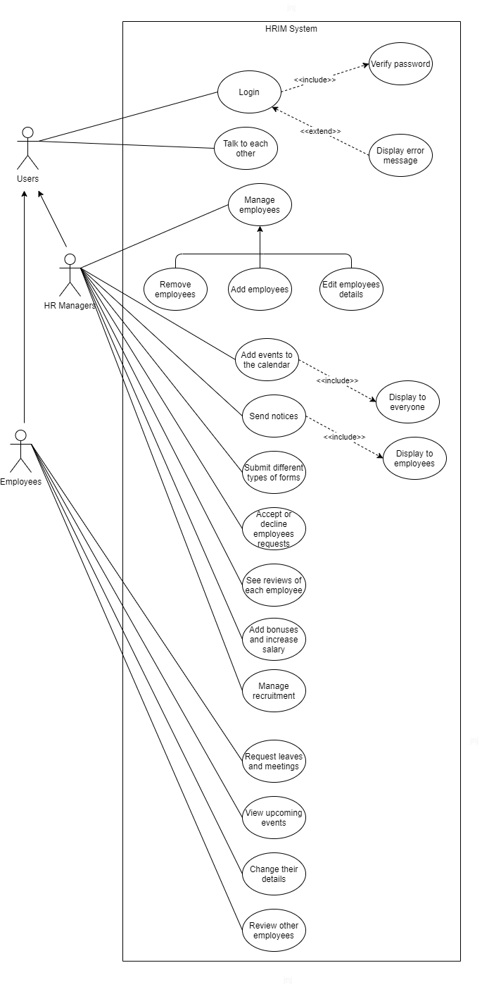

Diagram 1: The use case diagram

### 7. Project plan

|  |  |  |
| --- | --- | --- |
| Project Plan | | |
| Stage | End date | Products/deliverables / outcome |
| Project Initiation | 03/11/2020 | Project initiation document |
| Research on the development area | 05/11/2020 | A clear understanding of what human resource managers need and the short comings of the current HRIS systems |
| High Level designs of the system | 10/11/2020 | Design documents that is needed for the project and graphical user interface layouts |
| Increment 1 | 01/12/2020 | Development of the functionalities for human resource managers in the web and mobile application |
| Increment 2 | 20/12/2020 | Development of the functionalities for employees in the web and mobile application |
| Increment 3 | 31/01/2021 | Integration of machine learning and some of the other functionalities |
| System testing | 12/02/2021 | Testing the entire system using the component testing method |
| completion of final report | 15/03/2021 | Final report of the project |

Table 1: Project Plan

### 8. Stage Management

#### 8.1 control plan

The PRINCE2 techniques will be used to properly control the project so that the required project goal and objectives could be achieved. The PRINCE2 techniques that will be used are the end stage reports after each increment, review of the stage with the supervisor, highlight reports, risk management, quality plan, communication plan and exception reports where they are required.

#### 8.2 communication plan

To maintain a good communication throughout the project there will be multiple supervisor meetings and these meetings will be used to discuss the progression of the project, next stage of the plan, end stage report and feedbacks meetings will be held. In addition to mentioned meetings the necessary meetings will also be held.

### 9. Initial risk list

During the development of a project there are risks that are undertaken or problems that might occur and these risks should be managed during the planning process of the project so that when the particular risk occurs then we know what must be done. And having a risk analysis can sometimes determine the success and failure of a project. During the risk analysis of the project these were the risk that was identified for this project.

|  |  |  |
| --- | --- | --- |
| Risk Plan | | |
| Risk | Probability of Occurrence | Management Strategy |
| Schedule overrun | High | To avoid running into this issue a clear plan is made when each stage of the incremental approach should be completed, and I plan to discuss with my supervisor to let him know my progress and get his option whether I could manage the work with the current project scope. |
| Acts of God | Low | In the case of an event as such then the development of the application would not be affected because it will be backed up and so the development could continue from where I left off. |
| Technical difficulties | Moderate | To avoid the entire project been lost due to technical failures a GitHub repository will be created and maintained so that each time a change is made to the project it can be updated to the GitHub. |
| Trouble learning required development technologies | Low | To avoid this a proper research was done during the planning phase and determined whether it was capable doing the project with the suggested technologies and checked whether there is enough documentation and tutorial if I run into any issue during the project. |
| Scope creep | High | To avoid the project scope from growing after the project plan a strict project scope will be followed to avoid getting sidetracked from the initial project scope. |
| User acceptance | Low | User acceptance is one of the most important things and to make sure that human resource managers will like the product a questioner will be made to check what they need, and the systems user friendliness. In addition, I will get my supervisors opinion on the application. |

Table 2: Risk Management Plan

### 10. Initial quality plans

During the development of a project quality is one of the essentials things that should be considered because it is one of the main things that a customer looks for in a product and due to poor quality, the customer may even reject the entire application. So, to ensure that this project provides a good quality HRIS system the following quality checks will be done, and these strategies will be used to do these checks, so if these quality checks are done in a proper way, then the quality of the system can be ensured.

|  |  |
| --- | --- |
| Quality Plan | |
| Quality check | Strategy |
| Major deliverables | To ensure that the major deliverables are met a plan is made on the work process so it is not rushed this will also ensure that the system has the functionalities mentioned and nothing will be missed. |
| Quality control activities throughout the project | To ensure the quality I will get a review from my supervisor after each increment of the project and during the testing period of the system |
| Sub system usability and validation | This will be done after each increment to ensure quality is maintained in the project |
| Quality assurance activities | To ensure that the quality of the application is maintained I will get the review of the quality from my supervisor after each stage. |
| Feasibility study | A feasibility study will be done on the project to ensure that the project is worth the time and effort and to show how it will benefit the business. |
| System validation and user acceptance | To ensure that the human resource managers accept the product and is also helpful to them a questioner was conducted of what they need and what they want from a human resource information system. So, it could be delivered to them. In addition, I will also get the option of my supervisor. |

Table 3: Quality Management Plan

### 11. References

* Hussain, Z., Wallace, J. and Cornelius, N., 2020. The use and impact of human resource information systems on human resource management professionals. Information & Management, [online] 44(1), pp.74-89. Available at: <https://www-sciencedirect-com.plymouth.idm.oclc.org/science/article/pii/S0378720606001157>

[Accessed 27 October 2020].

* Balyuk, A., 2020. 7 Benefits Of Managing People In The Company - Epicflow. [online] Epicflow. Available at: <https://www.epicflow.com/blog/7-benefits-of-managing-people-in-the-company/> [Accessed 28 October 2020].

### 12. Appendix

#### 1. Questioner

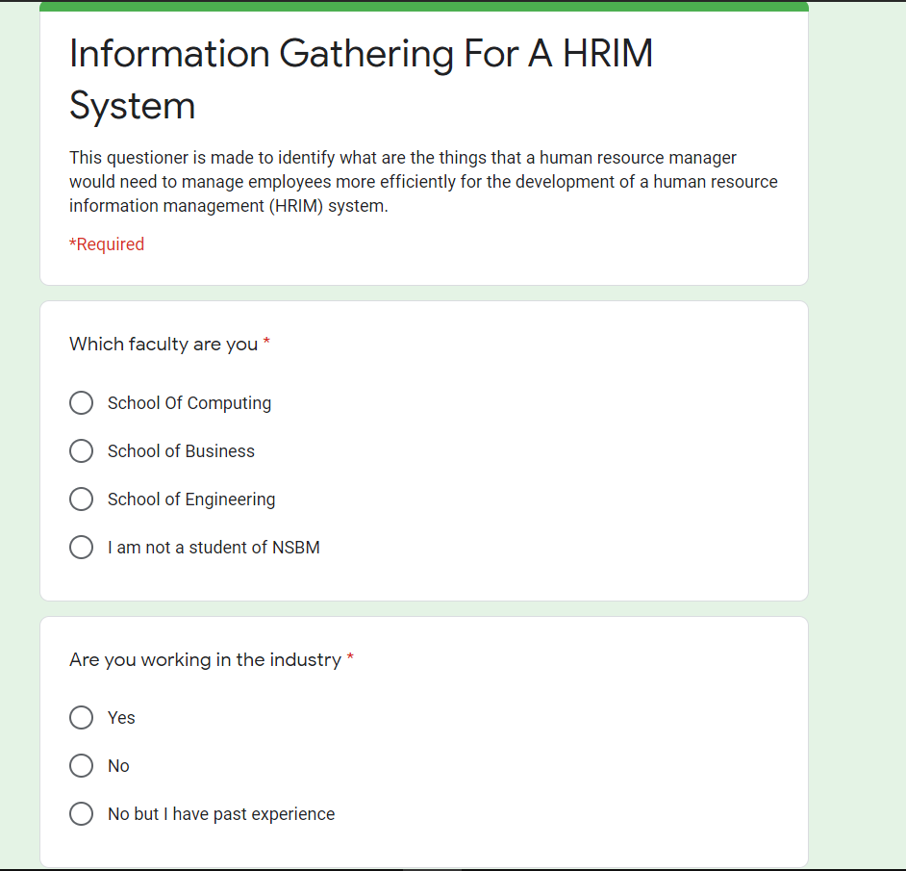

Image 1: Of Questioner

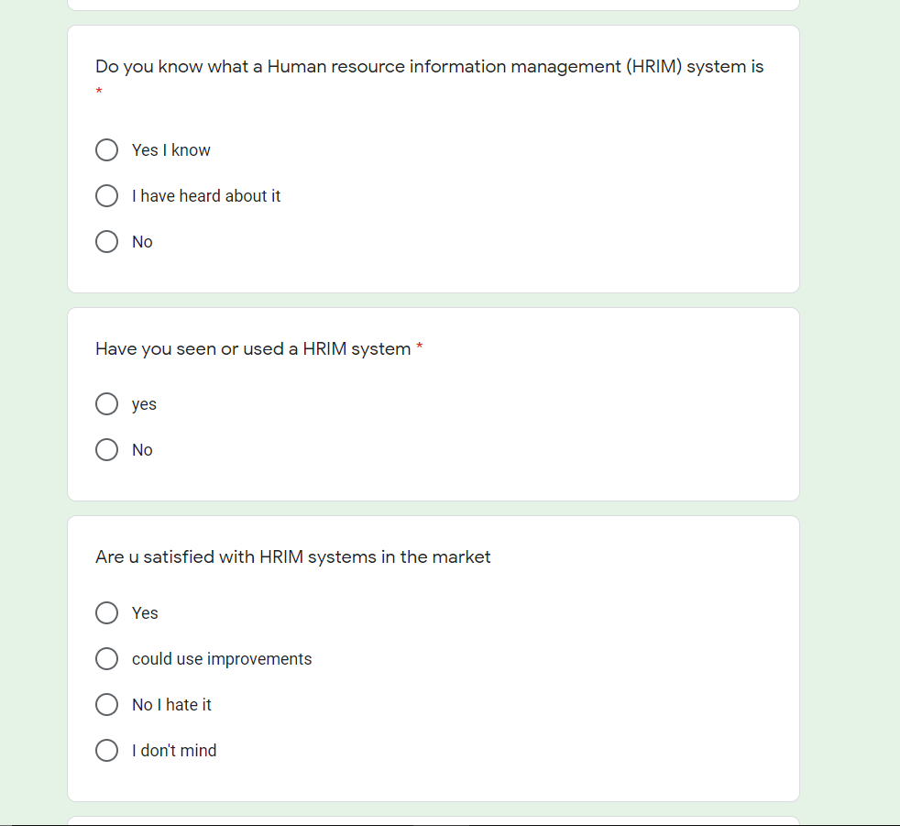

Image 2: Of Questioner

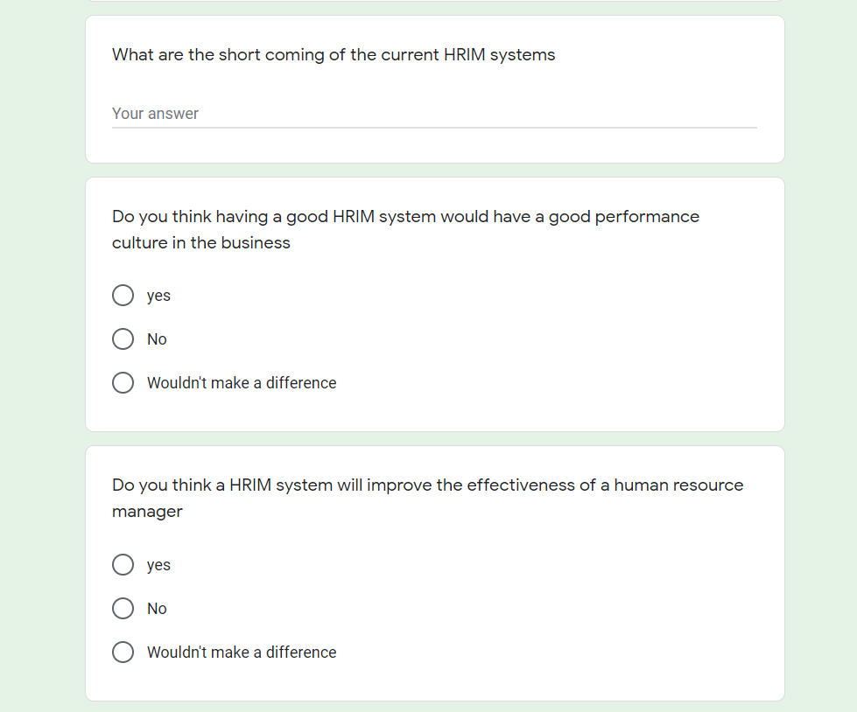

Image 3: Of Questioner

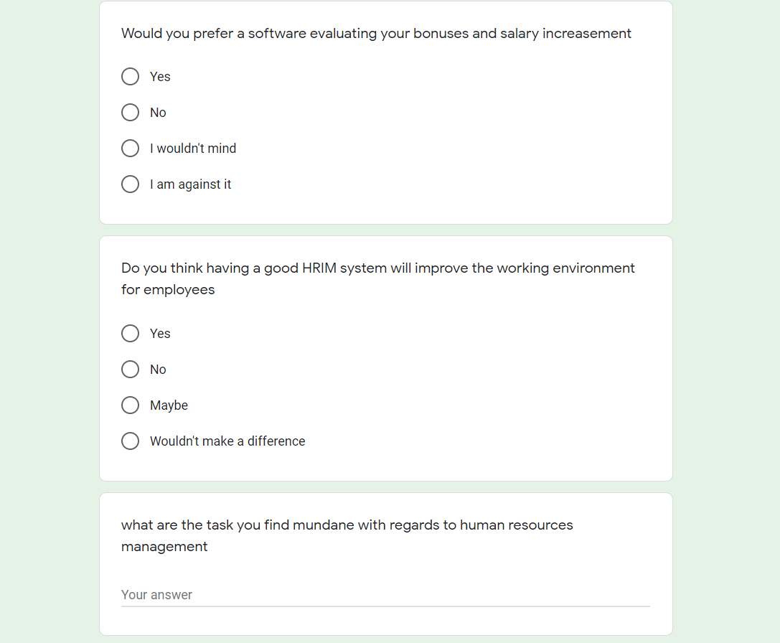

Image 4: Of Questioner

## 18.4 Interim Report 1

### 1. Introduction

The Project is to develop a HRIS system or also known as the Human resource information system, the system will be available as web app and as a mobile app for mobile phones, this is to improve the user experience and making it convenient for users to access the application whether they are in the office or not. This application will be mainly used by Human resource managers to manage the employees in the business in an effective and efficient manner. The HRIS system’s main goal is to make the tasks of human resource manager easier and faster so that they can spend more time making strategic decisions to improve the business. Another main objective of this system is to improve the communication within the business so to do so this system has an employee’s interface of software added which allows employees to submit request forms, chat with others and much more. To develop this project the incremental approach is used because of its ability to allow me to make changes to the development within the increment and because of its other advantage which is the errors are easy to find when compared with the other types of approaches.

### 2. Research Results

#### 2.1 Research of the Project

##### 2.1.1 Brief

Research part of a project is crucial to a project success and its quality. Because of those reason and couple more an extent research was done in this project for over a course of three to four weeks to find each and important factor that may influence the project, to learn about the Human resource management, to identify existing systems and their issues, to identify the functionalities required by human resource managers and to find the perfect technologies and programming languages to be used to do this project. Some of the research methods are mention below along with what I learned with each research type and how they affected the project.

#### 2.1.2 Questioner

One way the research was done was through questioners to identify whether the people know what a HRIS system is and to know whether they think it is useful to the organization. The Questions were aimed for HR mangers or undergraduates who are doing Human resource management, but the questioners were also distributed to the public to understand what they think about HRIS systems. The questioner was a success and received around 52 response and from those response 43 people had past working experience, 6 people were working and 3 had no working experience and due to these various responses, that was received a large amount of valuable information was gathered. One of those interesting results were that almost 31 of those responses said that having a good HRIM system can affect the working environment for employees. And another one was when asked what are things that is wrong with current HRIM systems the majority answers stated that the functionalities were not enough and there is no proper communication between employees and Human resource managers. Much more information such as those were gathered through the questioners.

#### 2.1.3 Interviews

The other method used to gather information on Human resource management and the HRIS systems was using the interviews method. Even though substantial amount of information was gathered from questioner’s I could not ask questions which needed detailed answers so during the interviews this was possible. But an issue I ran into was because of the pandemic situation in the country the universities and business have been closed. so, I was not able to get interviews from industry professionals so the candidates I interviewed was mainly undergraduates who are in the final year and are doing human resource management as their degree. I was able to get 6 interviews done and gained a valuable information that was useful for the development of the application. Some of the main questions that were asked was what were the main documents that are submitted by human resource managers, what are the tasks that Human resource managers find boring or tiering. These were just some of the questions that was asked during the interview, the responses I got from them was greatly beneficial for the research.

#### 2.1.4 Conclusion

Questioners and interviews were not the only methods used to do research on Human resource management and HRIS systems in addition to those methods online articles were also used to do the research for the project. Articles were mainly used to identify the tasks and responsibilities that the human resource managers have, and this was done so that I can understand and determine whether the functionalities specified in the interviews is a need to have functionality or want to have functionality and I then can assess on them. These different techniques of collecting information help me to get to know more about human resource managers responsibilities and to identify the functionalities they need in a human resource information system.

#### 2.2 Research on Existing Systems

There are numerous existing human resource management systems and during my research I came to know their different types of human resources management systems as well and they are HCM which means Human Capital management system, HRMS which means Human Resources management systems and finally the system type developed in this project which is HRIS Systems. HRMS systems only cover the payroll, time and labor and there are numerous systems available for this type and is the most common type of human resource management system used in low level business. Next is the HCM covers everything in HRMS and some additional functionalities like analytics and so on. Finally, HRIS systems cover everything and has additional functionalities. There are numerous HRIS systems and HCM systems but during the questioner and the interview I found out that they do not have enough functionalities to help Human resource managers. Furthermore, during the interviews, a common thing that was mentioned was that some more functionalities could be added to the existing HRIS systems that are used by businesses. In addition, in Sri Lanka only the high-level companies use HRIS systems, but the employees and the human resource managers believe use of HRIS systems can improve the working environment of a business.

#### 2.3 Research Technologies & Languages

##### 2.3.1 Currently used technologies

To build this project Ionic and Angular will be used for the front-end development and for the backend I make use of Node.js and for the database I am using the firebase because it is easier to use and is an effective database. In this project I make use of both Fire store and the firebase real time database to provide a quality system. These languages were chosen after researching about each language and determining the advantages, disadvantages, and limits of them. Up to now around 40% of the project has been developed using these languages.

##### 2.3.2 Technologies that will be used in the future

In the coming days I plan to make use machine learning for this project to increase the functionalities of the system and to satisfy the users. So, to add machine learning I will be using Tensorflow.js which is a JavaScript library that will allow me to develop machine learning models in JavaScript and allow me to either use machine learning directly in the browser or in my back end which is the node.js.

### 3. Learning Undertaken

In this project there was large learning curve mainly due to the fact I did not know the languages that was used in the project because I have not used these languages before. In addition, during the research I found out using these languages were the best way to develop the system I planned for. So, to get the knowledge I had to be learn them from the beginning. In the database I did have some experience in using the fire store and NO SQL databases but not the real time database, so I had to learn about that section also. One of the greatest challenges were learning about machine learning and about how to implement them. Multiple machine learning courses were done in linked in learning and Udemy courses to get the basics of machine learning and understand the concepts. Next, I had to learn how to use machine learning in my project and once I came across tensorflow.js through research I started doing an online course on it as well and I am still doing this course and have completed almost 85% of the course. These were the key thing I had to learn for me to do this project to make it a successful project.

### 4.Architectural Diagrams

#### 4.1 Activity Diagram



Figure 4.3: Activity Diagram

#### 4.2 Use case Diagram



Figure 4.2: Use Case Diagram

#### 4.3 Context Diagram



Figure 4.3: Context Diagram

### 5. Project status

#### 5.1 Progress

The development of the project initially began in November of 2020. The development was begun as soon as the research was completed to meet the strict time schedule met by me and within in the month of November almost 35% of the development was completed and was going in track according to the initial project plan mentioned in the project initiation document. But in December due to certain risk that affected the project such as schedule over run only 5% of the development work was able to be completed. Currently some of the functionalities that have been completed from the system includes authentication of users, notices, chat system and the event calendar which will be displayed in the video submitted.

#### 5.2 Testing and Quality

The testing has been completely done for the 40% of the development that has been completed and during this testing multiple bugs and errors were found and resolved. The quality is ensured in the completed part of the project because I was able to get opinions from couple undergraduates who are studding Human resource management, according to their response they find the functionalities useful and easy to use.

#### 5.3 Future Development

The project development being only 40% completed and there is 60% more to be done within the timespan of one and half month according to my updated project plan. Among the functionalities that is yet to be developed machine learning would be the one that word take the most amount of time and will be hard to implement so it will be done last after building the core functionalities of the system. Some of the main functionalities that is yet to be completed are attendance, employee management, and salary management.

#### 5.4 Screen shots of the project

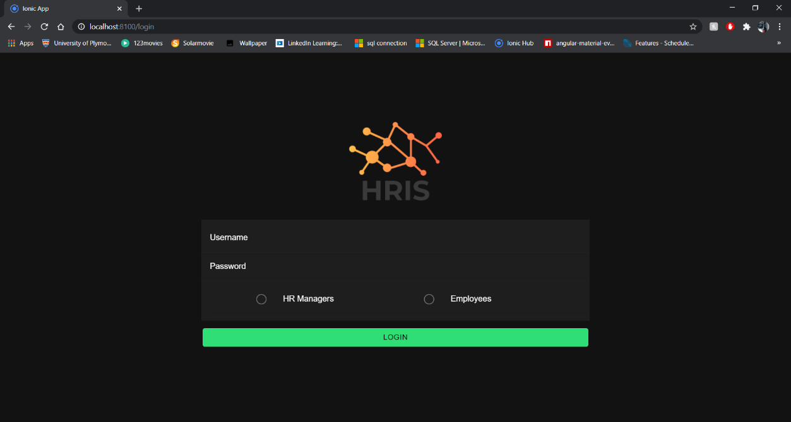

Figure 5.1: Login page

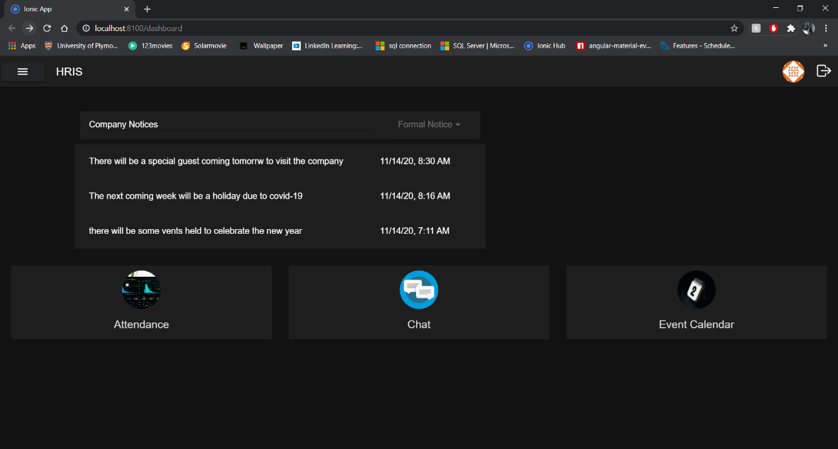

Figure 5.2: Dashboard

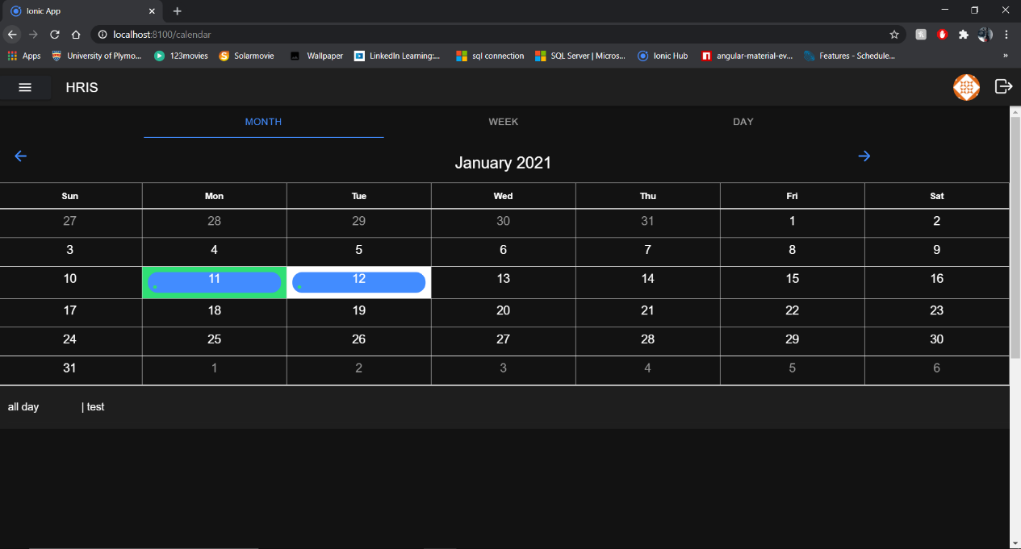

Figure 5.3: Event calendar

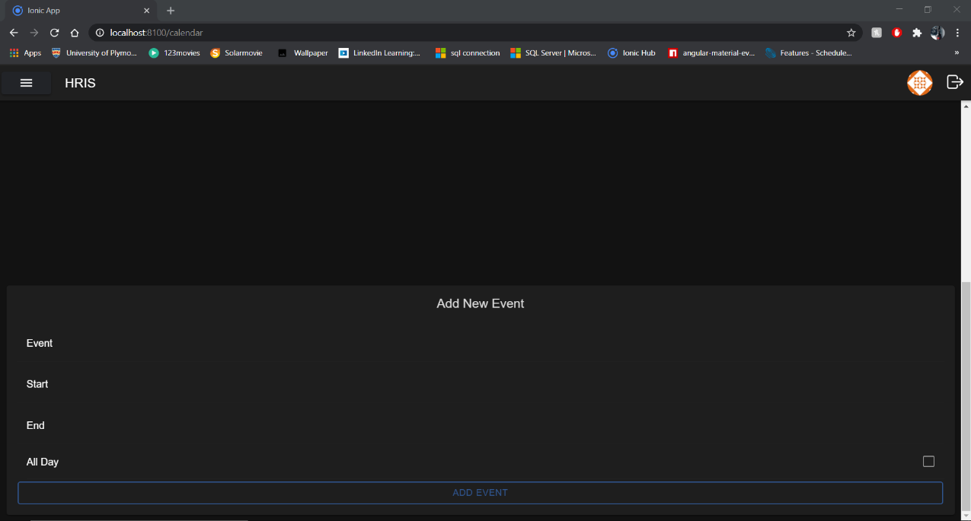

Figure 5.4: Add events

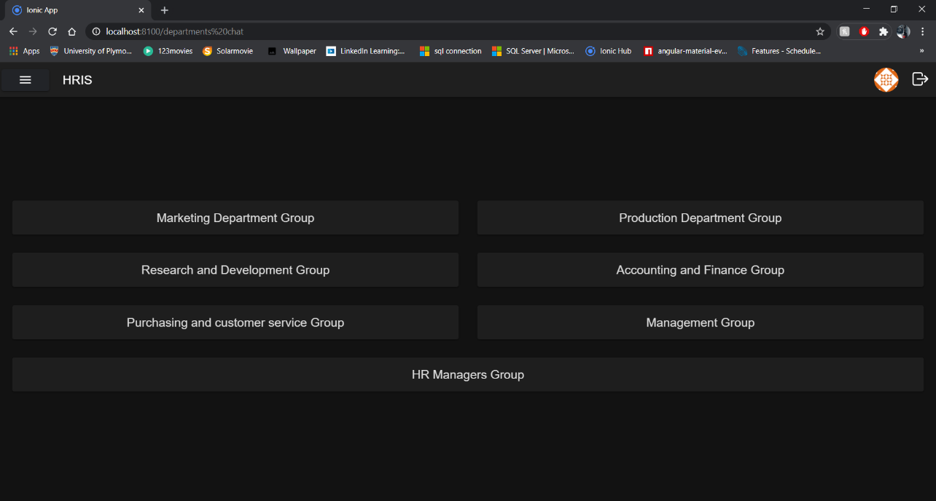

Figure 5.5: Chat lobby

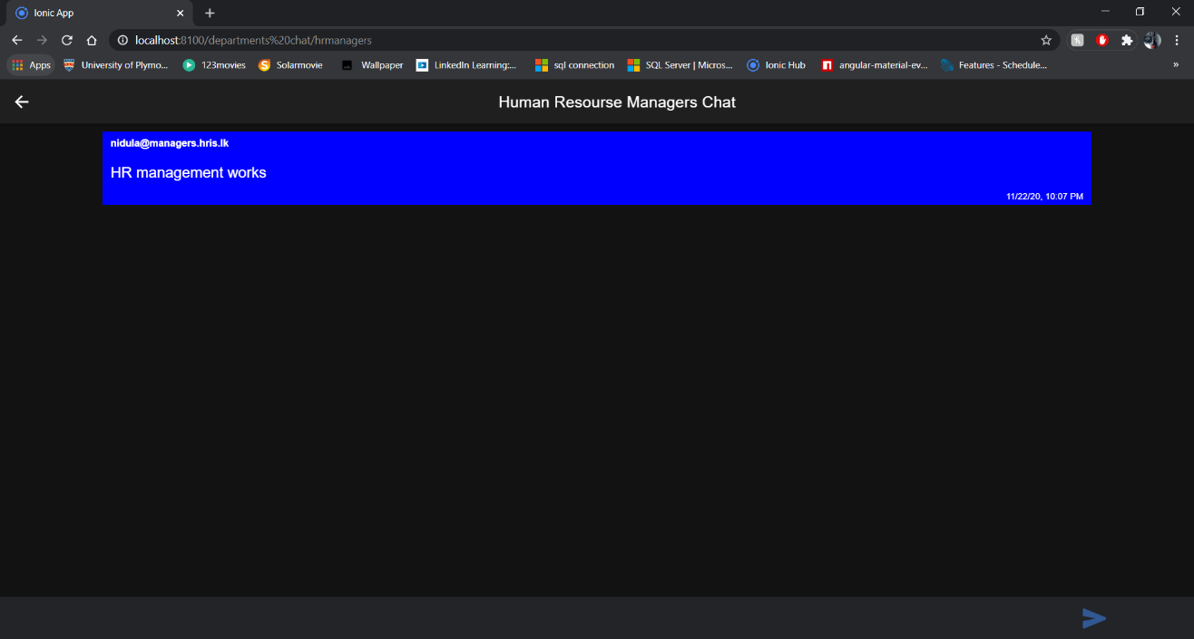

Figure 5.6: Chat group for HR Managers

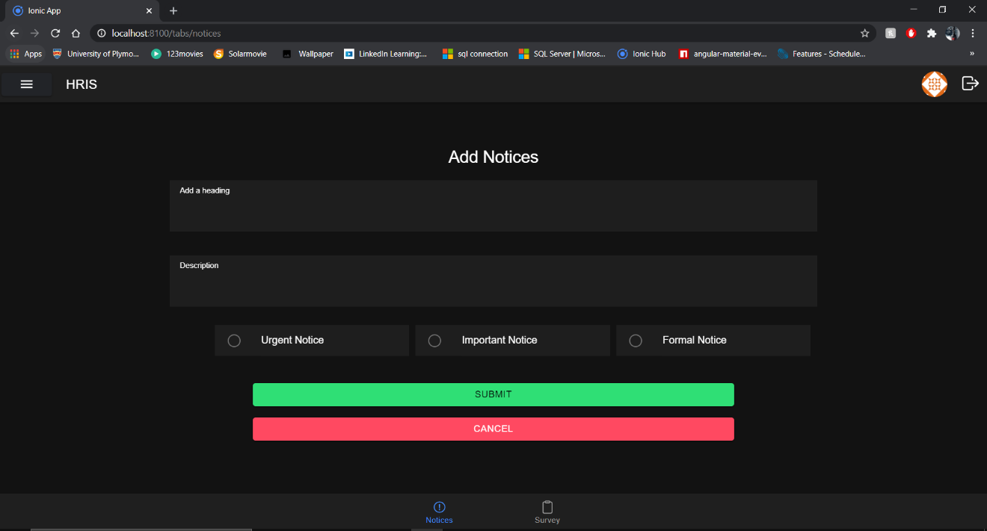

Figure 5.7: Add Notices

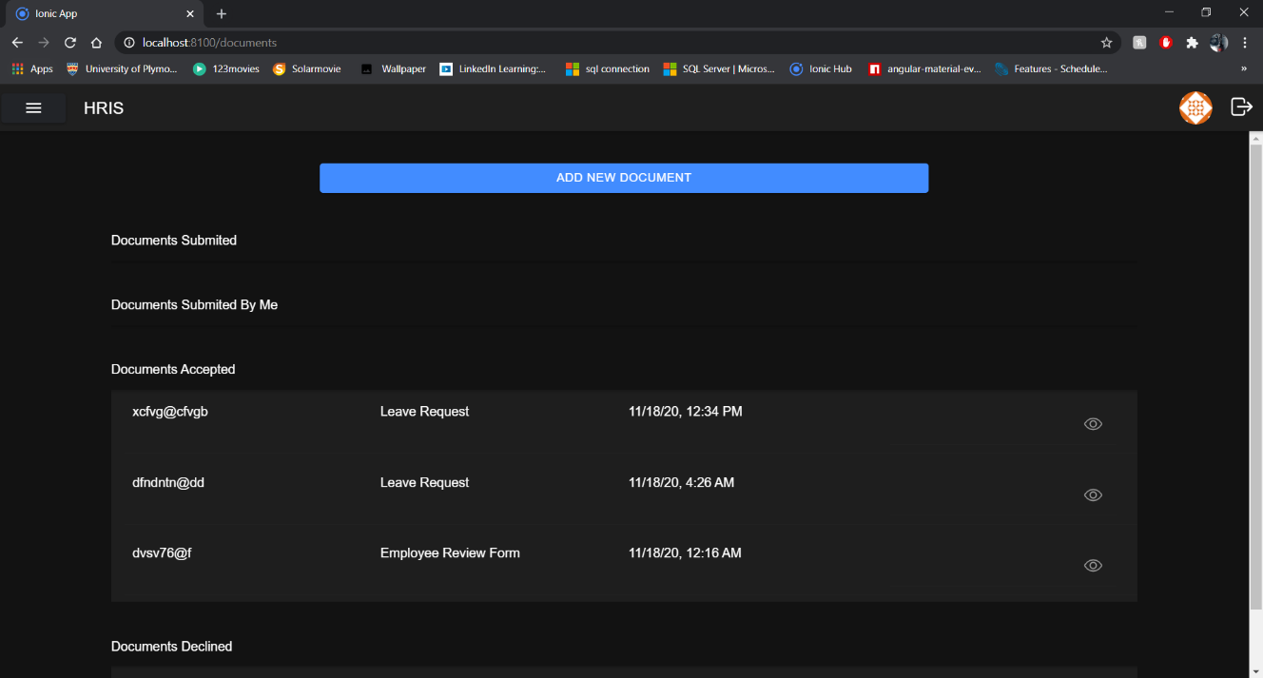

Figure 5.8: Documents page

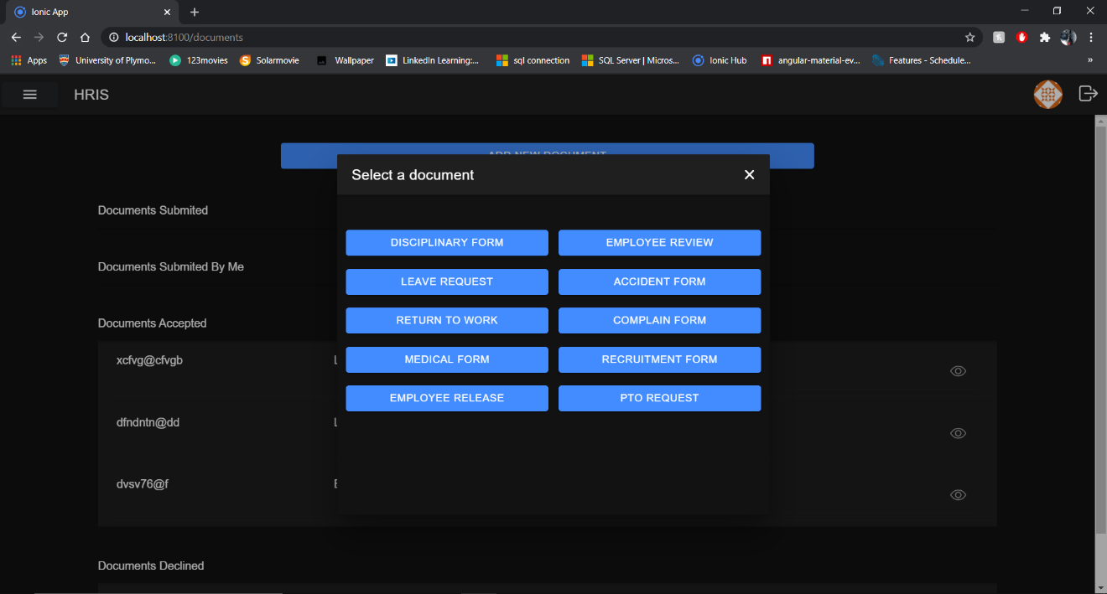

Figure 5.9: Add Documents

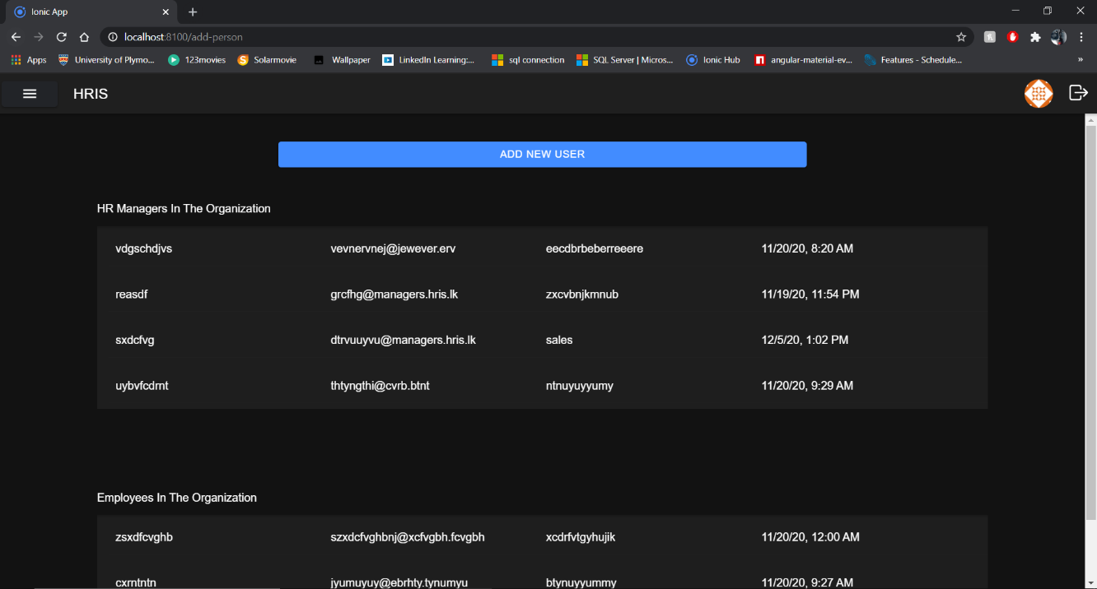

Figure 5.10: Users Page

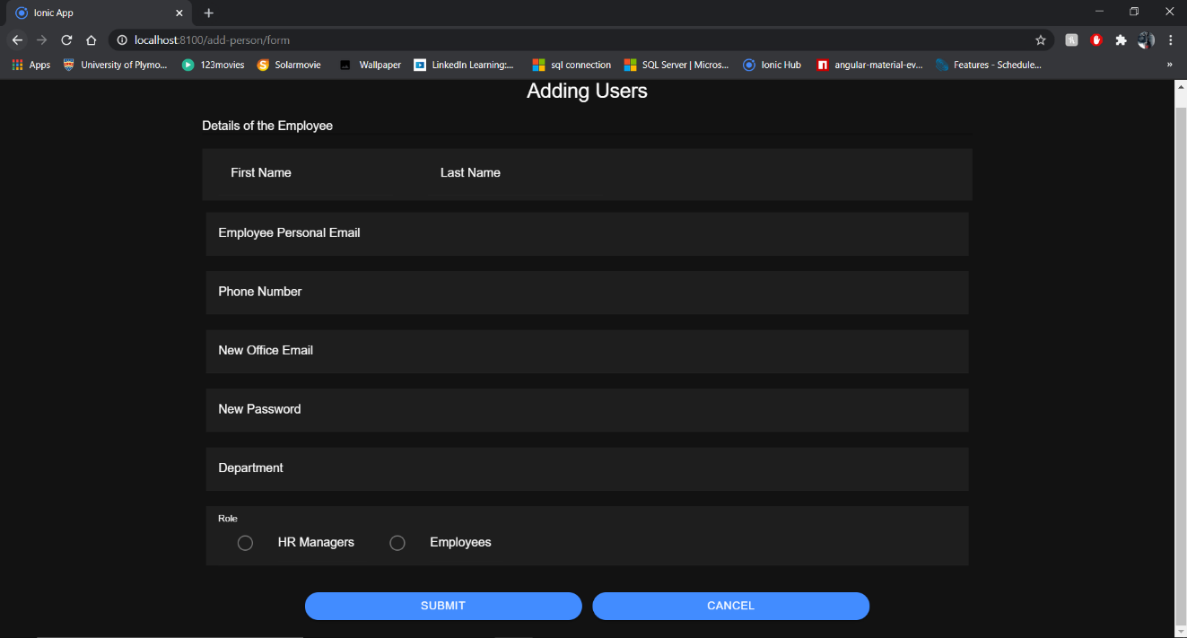

Figure 5.11: Add users

### 6. Risks Encountered

During the development of the project two main risk impacted the project but since those risks were identified and a plan was made on the project initiation document, they did not have a huge impact on the project. The risks that impacted and how they affected the project is mentioned below.

The first risk that occurred and impacted the highest was schedule over run. Even though I created the project plan giving time for the other projects and submissions. I did not correctly anticipate the time it would take to complete the other projects due to this I missed certain deadlines I kept for myself within this project and as a result the plan to finish at least 65% of the development before first interim report was not accomplished and could only do 40% of the development and had to create a new project plan that puts the project completion data a little behind than the initial plan.

The second and last risk that occurred was technical issues, even though this could have been a major issue but since I identified it and managed this issue by using version control software like GitHub it did not affect a lot because I uploaded to GitHub at least twice a week once I complete any part of the project due to this, I didn’t lose any part of the project and was able to get back to work once my device was fixed.

### 7. Changes to the project

#### 7.1 Brief

There are no huge changes to the project. The only change that will be done to the project will be a new project plan because the initial project plan was not feasible due to the risk encountered along the way, so a new project plan is made and with it the project will be able to be completed on time without any complications. The rest of the things mentioned in the project initiation document stays the same including the project scope.

#### 7.2 Finalized Project plan

|  |  |  |
| --- | --- | --- |
| **Project Plan** | | |
| **Stage** | **End date** | **Products/deliverables / outcome** |
| Project Initiation | 03/11/2020 | Project initiation document |
| Research on the development area | 05/11/2020 | A clear understanding of what human resource managers need and the short comings of the current HRIS systems |
| High Level designs of the system | 10/11/2020 | Design documents that are needed for the project and graphical user interface layouts |
| Increment 1 | 10/02/2021 | Development of the functionalities for human resource managers in the web and mobile application |
| Increment 2 | 31/02/2021 | Development of the functionalities for employees in the web and mobile application |
| Increment 3 | 15/03/2021 | Integration of machine learning and some of the other functionalities |
| System testing | 23/03/2021 | Testing the entire system |

Table 7.1: Project Plan

### 8. Conclusion

The current stage of the project is that the research is completely done and have a clear idea of Human resource managers, their responsibilities, and their tasks. In addition, I have a clear understanding of the functionalities that will be provided in this project. I also know and have a clear understanding of the languages and the technologies that I will be using this project and because of this I can now focus fully on the development of this project.

The development status of the project is that only 40% is complete and I have another 60% of the development to work on but do note that the 40% of this development was implemented while I was learning the languages and phasing the risks mentioned above. And now since I have completed the learning process and have a clear understanding of the languages and the technologies that will be used it will be easier for me to implement functions to the project and I will be able to meet the updated project plan and provide a quality functioning human resource information system that will satisfy the Human resource managers and employees needs and wants.

### 9. Appendix

#### 9.1 GitHub Commits

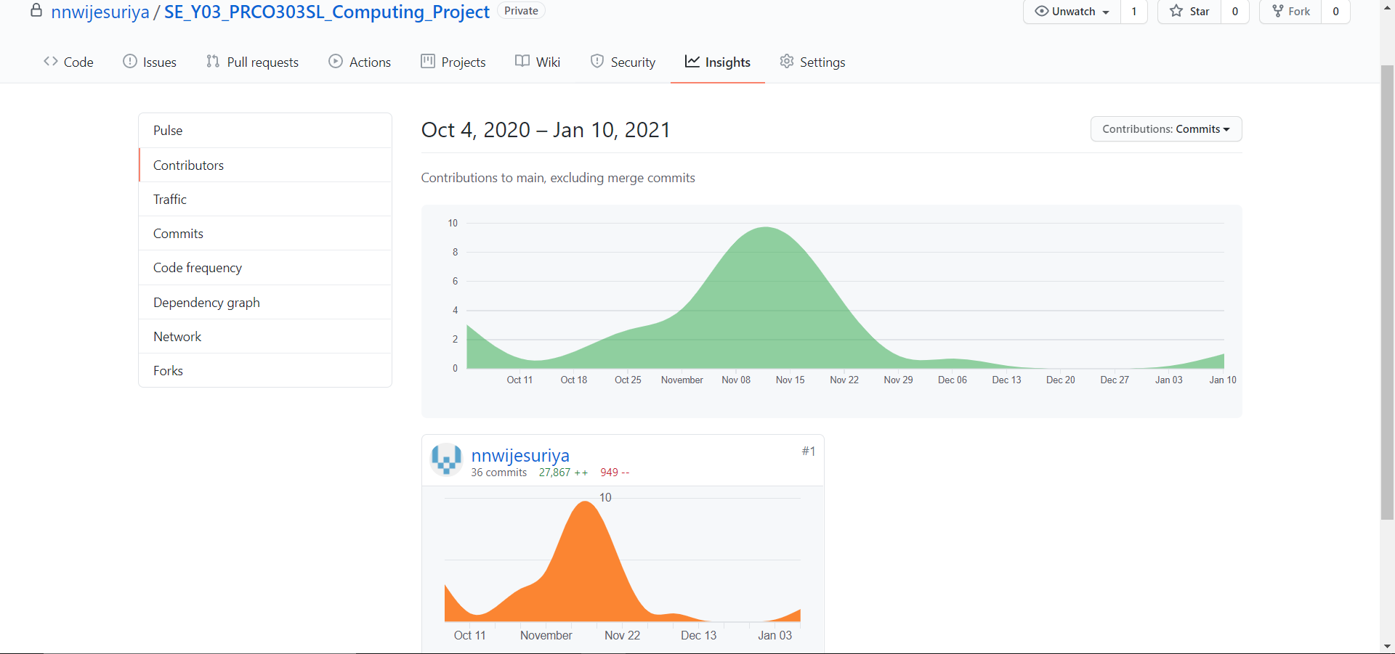

Figure 9.10: The dates on which commits were made to GitHub

## 18.5 Interim Report 2

### 1. Introduction

The management of the human factor of an organization has been one of the main goals of a business and to do so human resource managers are hired and they have the task of recruiting, training employees, performance management, organization development, safety, wellness, benefits, employee motivation and more. These tasks can be time consuming and hard to manage so the Human Recourse Information systems or also known as HRIS systems were introduced to the human resource managers to help them to do the mundane tasks, also to make the human resource department effective and efficient within the organization.

The Project is to develop a HRIS system or also known as the Human resource information system, the application will be available as web app and as a mobile app, this is to improve the user experience and making it convenient for the users to access the application whether they are in the office or not. This application will be mainly used by Human resource managers to manage the employees in the business in an effective and efficient manner. The HRIS systems main goal is to make the tasks of human resource manager easier and faster so that they can spend more time making strategic decisions to improve the business. Another main objective of this application is to improve the communication within the business so to do that this application has an employee’s interface. which allows employees to submit request forms, chat with others and much more. To develop this project the incremental approach is used because of its ability to allow me to make changes to the development within the increment and because of its other advantage. One of those advantage is that the errors are easy to find when compared with the other types of approaches.

### 2. Business Case

#### 2.1 Business needs

There are several factors that affect the business it may be in a positive way or else a negative way but what decides this outcome depends on how the business manages these factors. The employees of the business are one of the main factors that can have a huge impact on the organization, so the business needs to manage it in a proper manner. According to (Balyuk, 2020) Management of employees is important because the company is made up of people with different ages, customs and profiles and managing them is crucial to the success of the business and she also states that if they are managed in a proper manner, it could provide benefits like good working environment, employee development, Increased productivity, motivation and finally business objective alignment. So, what the business needs is a user friendly HRIS system that has the functionalities required for management of employees and reduce the mundane tasks of human resource managers. A good HRIS does not just help the business and human resource managers it also helps the employees that are working in the organization making them more motivated and providing them a good working environment and this will have a positive impact on the business and may result in business growth or it become more successful.

##### 2.1.1 Identification of the problem

The problem this project is attempting to solve is the management of employees in a business and to make tasks easier for human resource managers by automating them by developing a HRIS system. so that they can be more efficient in the decision-making process. There are multiple HRIS systems in the market but the problem with those systems is that either they are too complicated for user or there are less functionalities so with this project I will attempt to solve this problem by providing a user friendly HRIS system with the functionalities that are required by the HR managers.

#### 2.2 Business objectives

The business may have multiple goals but one of the main goals of the business would be to have an effective human resource management department that manages employees to provide a good performance culture within the business. And To achieve this business goal the following business objectives should be accomplished.

* Automate some of the tasks done by employees to make them more efficient
* Provide human resource managers with analytic data to make important decisions for the betterment of the business
* To manage staff more efficiently and in an easy way
* To have a good communication between management and employees
* To motivate employees and provide a good working environment
* To ensure that organization resources are used efficiently
* To have accurate data within the organization

### 3. Project Objectives

At the end of this project, my goal is to provide a working user-friendly human resources information system that has the functionalities required to help the human resource managers and the objectives of this project are:

1. Identify what are the functionalities that the human managers need to manage task easily.
2. Identify what are the tasks done human resource managers that could be automated.
3. To provide a way to improve the communication between the employees and the management.
4. Create a good working environment for the employees with less arguments and fights within the organization.
5. To make the decision-making process of human resource managers easier using analytic data.
6. To keep the employees up to date on what is happening in the business and when it is happening.
7. To provide a way to manage employees effectively within the business.
8. To Provide self-service capabilities for employees in the business.

### 4. Project scope

1. Identify what are the human recourses information systems in the current market and find what are the positives and negatives of these systems
2. Identify the human resource process what the human resource managers need to make decisions using questioners
3. The proposed system will allow:
   1. HR managers to get the attendance of each employee and find out the days the employee did not come.
   2. HR managers and employees should be able to mark attendance using this application
   3. HR managers to make decisions effectively by using the graphs provided by the application.
   4. HR managers to manage and change details about the current employees
   5. HR managers to add and remove the employees that are currently in the system.
   6. HR managers to send notifications to the employee in the organization
   7. HR managers and employees to talk to each other using the chat facilities
   8. Employees to request for a holidays and other requests
   9. Employees to see how many holidays they have left for the year
   10. Employees and HR managers should be able to change some of their personal details and their profile picture.
   11. HR managers to manage the hiring process
   12. Employees to review other employees in the same department
   13. HR managers should be able to add events to the calendar and employees can see them.
   14. HR managers should be able to add task to each other within the human resource management department
   15. HR managers will be able to fill and submit different kind of forms.
   16. HR mangers should be able to add new policies and edit existing policies
   17. HR managers should be able to accept and refuse forms submitted by employees.
   18. HR managers and employees should be able to change the passwords to their account in the system.
   19. HR managers should be able to add bonuses and increase salary of employees.
4. A mobile application will also be developed for the employees and the human resource managers
5. The system will use machine learning and provide a suggestion to human resource managers which employee should receive the raise and when they should receive it.

### 5. Languages and technologies utilized

#### 5.1 Initially planned technologies

In the beginning of the project the plan was to do a human resource management system which will be a desktop application and was planned to use java as the programming language with firebase as the database but after doing some research and getting the plan revised from the supervisor, I came to know that most enterprise applications are web based and has a mobile app to it. So as a result, these technologies was not used to do the human resource management system and this planned was cancelled.

#### 5.2 The final technologies used

When searching for programming languages to do a web and a mobile application I got to know the concept of PWA or also known as progressive web apps where the same code based is used to develop mobile and web applications which met my need to develop the human resource management system. So, the best combination and most recommended of languages to do a progressive web app was by using Angular and ionic framework for the front end and then using node.js and express as the back end and mongoDB for the database which would form the MEAN stack. But I wanted to use firebase for its cloud functions and some of the other key functions. So, for this project I used Angular and ionic for the front end and node.js and express for the backend and finally the firebase database as my database. I also made use of the tensorflow.js library for my machine learning purposes within the project. Because it was one of the best technologies that could be used to add machine learning to the project by using JavaScript programming language.

#### 5.3 Background information on Languages used

* Ionic Framework: Ionic framework is an open-source hybrid mobile development SDK that is used to develop progressive web apps and native apps too. It makes use of typescript and is ideally build on top of angular to provide wonderful progressive web apps.
* Angular Framework: According to (Angular, 2021) Angular is a platform and framework for building single-page client applications using HTML and TypeScript. Angular framework is most known for its Single page application capabilities is one of the main reasons why angular is commonly used. The single page application is the process when only a single page is loaded initially and then the part of these page changes according to the change, we make rather than the entire HTML page been reloaded.
* Node.js: According to (Node.js - Introduction - Tutorialspoint, 2021) Node.js is an open source and a cross-platform runtime environment that is used for developing a server-side and networking applications. In addition, Node.js applications make use of the JavaScript language. Some features of node.js include no buffering and very fast since it is built on Google Chromes JavaScript engine.
* Firebase: Firebase is a platform that can be used for multiple functionalities rather than just the database. This platform is developed by google and provide multiple functionalities some of them include hosting, storage, real-time database and Firestore. But in this project, we will only be using a small amount its functionalities which storage, real-time database and the Firestore. Firebase is preferred by most people is because of its ability to scale and the functions it provides. Firebase also contains a full documentation on each of its functionalities which widely beneficial for software engineers when using firebase as their database or to do any other requirement.

### 6. Research Results

#### 6.1 Research of the Project

##### 6.1.1 Brief

Research part of a project is crucial to a project success and its quality. Because of those reason and couple more an extent research was done in this project for over a course of three to four weeks to find each and important factor that may influence the project, to learn about the Human resource management, to identify existing systems and their issues, to identify the functionalities required by human resource managers and to find the perfect technologies and programming languages to be used to do this project. Some of the research methods are mention below along with what I learned with each research type and how they affected the project.

##### 6.1.2 Questioner

One way the research was done was through questioners to identify whether the people know what a HRIS system is and to know whether they think it is useful to the organization. The Questions were aimed for HR mangers or undergraduates who are doing Human resource management, but the questioners were also distributed to the public to understand what they think about HRIS systems. The questioner was a success and received around 52 response and from those response 43 people had past working experience, 6 people were working and 3 had no working experience and due to these various responses, that was received a large amount of valuable information was gathered. One of those interesting results were that almost 31 of those responses said that having a good HRIM system can affect the working environment for employees. And another one was when asked what are things that is wrong with current HRIM systems the majority answers stated that the functionalities were not enough and there is no proper communication between employees and Human resource managers. Much more information such as those were gathered through the questioners.

##### 6.1.3 Interviews

The other method used to gather information on Human resource management and the HRIS systems was using the interviews method. Even though substantial amount of information was gathered from questioner’s I could not ask questions which needed detailed answers so during the interviews this was possible. But an issue I ran into was because of the pandemic situation in the country the universities and business have been closed. so, I was not able to get interviews from industry professionals so the candidates I interviewed was mainly undergraduates who are in the final year and are doing human resource management as their degree. I was able to get 6 interviews done and gained a valuable information that was useful for the development of the application. Some of the main questions that were asked was what were the main documents that are submitted by human resource managers, what are the tasks that Human resource managers find boring or tiering. These were just some of the questions that was asked during the interview, the responses I got from them was greatly beneficial for the research.

##### 6.1.4 Conclusion

Questioners and interviews were not the only methods used to do research on Human resource management and HRIS systems in addition to those methods online articles were also used to do the research for the project. Articles were mainly used to identify the tasks and responsibilities that the human resource managers have, and this was done so that I can understand and determine whether the functionalities specified in the interviews is a need to have functionality or want to have functionality and I then can assess on them. These different techniques of collecting information help me to get to know more about human resource managers responsibilities and to identify the functionalities they need in a human resource information system.

#### 6.2 Research on Existing Systems

There are numerous existing human resource management systems and during my research I came to know their different types of human resources management systems as well and they are HCM which means Human Capital management system, HRMS which means Human Resources management systems and finally the system type developed in this project which is HRIS Systems. HRMS systems only cover the payroll, time and labor and there are numerous systems available for this type and is the most common type of human resource management system used in low level business. Next is the HCM covers everything in HRMS and some additional functionalities like analytics and so on. Finally, HRIS systems cover everything and has additional functionalities. There are numerous HRIS systems and HCM systems but during the questioner and the interview I found out that they do not have enough functionalities to help Human resource managers. Furthermore, during the interviews, a common thing that was mentioned was that some more functionalities could be added to the existing HRIS systems that are used by businesses. In addition, in Sri Lanka only the high-level companies use HRIS systems, but the employees and the human resource managers believe use of HRIS systems can improve the working environment of a business.

#### 6.3 Research Technologies & Languages

##### 6.3.1 Currently used technologies

Since I will be using ionic and Angular frameworks for the front-end of the project and node.js and express to the backend of the project a thorough research was needed to be done to understand the limits, the advantages and the disadvantages of using these languages. Because I wanted to avoid impactfully surprises during the development of the project which could negatively affect the project. One of the main things that I looked into was the versions document of each framework and identified how much each version changes and what are things that will probably change in the next version of the framework because in the case of a version update my previous code wouldn’t work if that functionality is removed or changed. I did not do that much of a research for firebase because I have used Firestore before and new it was reliable and dramatic changes would not occur. This was done to ensure that project could be carried out smoothly without any issues

##### 6.3.2 Technologies that will be used in the future

In the coming days I plan to make use machine learning for this project to increase the functionalities of the system and to satisfy the users. So, to add machine learning I will be using Tensorflow.js which is a JavaScript library that will allow me to develop machine learning models in JavaScript and allow me to either use machine learning directly in the browser or in my back end which is the node.js.

#### 6.4 Reviews on the developing application

To identify whether my application is user friendly and has the key functions implemented in a manner that will be easy for the users a review session was done. The reviews were obtained from my supervisor, from some of my colleagues and from some human resource managers I personally knew. During these review sessions I was able to get a clear idea of the things they liked and disliked in my application and they even gave ideas on how to improve some functions and I also got to know the functionalities that I missed that should be implemented.

### 7. Learning Undertaken

In this project there was large learning curve mainly due to the fact I did not know some of the languages that was used in the project because I have not used these languages before. During the research I found out using these languages were the best way to develop the system I planned for. So, to get the knowledge I had to be learn them from the beginning. In the database I did have some experience in using the fire store and NO SQL databases but not the real time database, so I had to learn about that section also. One of the greatest challenges were learning about machine learning and about how to implement them. Multiple machine learning courses were done in linked in learning and Udemy courses to get the basics of machine learning and understand the concepts. Next, I had to learn how to use machine learning in my project and once I came across tensorflow.js through research I started doing an online course on it as well.

In addition to that I also had to learn about node.js which was used for the backend. In the begging my plan was to use firebase API to do the backend part as well because since the tensorflow.js could be done in the front end itself and since there was firebase API a backend was not exactly planned. But during the development I learned that to do some firebase functions you need to use firebase admin SDK and the only way to implement admin SDK was by using a backend so because of that reason I had to learn node.js for the backend part of the application. So, like I did for tensorflow.js I followed multiple tutorials to learn about node.js since this would be my first time using it. During this learning process I learned how much node.js would improve my application and the numerous benefits it brings to my application.

These two were the largest and key things I had to learn for me to do this project to make it a successful project. In addition to those two major learning tasks there were minor learning also done one of them being the ionic framework. But since I had experience with angular, I did not have much of a learning curve there since it is kind of make use of the same logic. These were the learning undertaken for the project and learning these key things made the project much better and into a successful project.

### 8.Architectural Diagrams

#### 8.1 Activity Diagram



Figure 8.1: Activity Diagram

#### 8.2 Use case Diagram



Figure 8.2: Use Case Diagram

#### 8.3 Context Diagram



Figure 8.3: Context Diagram

#### 8.4 Sequence Diagram





Figure 8.4: Sequence Diagram

#### 8.5 Tree representation of hierarchical modal of firebase database

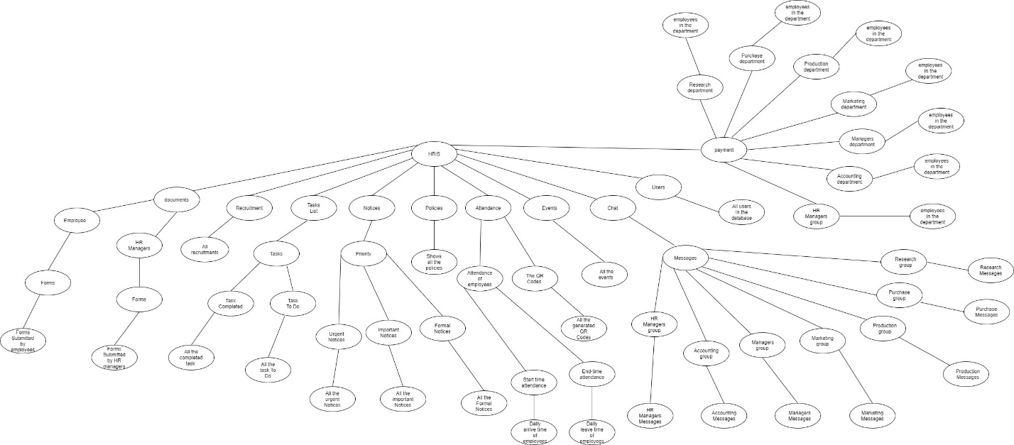

Figure 8.4: Hierarchical modal tree representation

When developing the hierarchical modal for the Firestore database some key instructions were followed because these were the rules set by firebase and While others were the rules followed by NoSQL databases. One of the main one was that there should be a collection and then the document which contains the fields and data. So, the way multiple collections could be made was by either having a collection then a document and repeating the process or by having a collection then a document then a collection within a document and then multiple documents.

### 9. Project status

#### 9.1 Progress

The initial planning stage started began even before the project was assigned and during that time research was being done on the languages that is best suitable for the project and what are the existing human resource information management system that are available in the market and what their functionalities were. The development of the project initially began in November of 2020. The development began as soon as the research was completed to meet the strict time schedule met by me.

##### 9.1.1 Progress before first Interim report

During this time certain number of tasks were completed. In the month of November almost 35% of the development was completed and was going in track according to the initial project plan mentioned in the project initiation document. But in December due to certain risk that affected the project such as schedule over run only 5% of the development work was able to be completed. Currently some of the functionalities that have been completed from the system includes authentication of users, notices, chat system and the event calendar which will be displayed in the video submitted.

##### 9.1.2 Progress before second interim report

During this time certain key task were completed. And I was able to complete almost 20% of the project within a time span of one month. Initially before the first interim report I had only completed about 40% of the overall project and now I have completed about 60% of the entire project and is in track according to the updated project plan. Some of the task that was completed before the second interim report was the attendance, some components in dashboard, profile, uploading images to Firestore in the database, some backend components and much more.

##### 9.1.3 Progress Tracker

###### 9.1.3.1 Brief

The table below shows the progress of my entire project, but the project is broken down into small tasks to identify what the progression of each task is, this table will allow me to make assessments on which task should I focus on the most and to identify whether I can complete all the tasks before the deadline. The table below clearly shows how much percentage of each task is completed before the first and second interim report and how much percentage is left for me to work on before the final deadline of the project.

#### 9.1.3.3 Progression of each task

|  |  |  |  |
| --- | --- | --- | --- |
| Task | Description | Completed percentage before first interim report | Completed percentage before second interim report |
| Design all the HR mangers pages | This includes identifying and designing all the pages for Human resource managers. | 80% | 100% |
| Design all the employee’s pages | This includes identifying and designing all the pages for employees. | 60% | 100% |
| Implement Authentication for the application | This includes all the authentication parts such as login and routing part of the application | 90% | 100% |
| Design the architecture and create a database | This includes identifying all the fields that are required then designing the architecture and finally creating all those collections in firebase. | 100% | 100% |
| Complete Managers user pages | This includes all the functionalities and pages that is available for human resource managers. | 63% | 80% |
| Complete employee’s user pages | This includes all the functionalities and pages that is available for employees. | 10% | 40% |
| Complete the machine learning functionalities | This task includes the machine learning part of the application. | 0% | 10% |
| Testing process of the application | This task includes the testing progress of the entire application and bug fixes in the application. | 35% | 48% |

Table 9.1: Progression Plan

#### 9.2 Testing and Quality

The testing has been completely done for the 48% of the development that has been completed and during this testing multiple bugs and errors were found and resolved. The quality is ensured in the completed part of the project because I was able to get opinions from couple undergraduates who are studding Human resource management, according to their response they find the functionalities useful and easy to use.

#### 9.3 Future Development

The project development being only 60% completed and there is 40% more to be done within the timespan of one and half month according to my updated project plan. Among the functionalities that is yet to be developed machine learning would be the one that word take the most amount of time and will be hard to implement so it will be done last after building the core functionalities of the system. Some of the main functionalities that is yet to be completed are graphs, employee management, and salary management.

### 10.The Application

#### 10.1 Screen shots & explanation of the application



Figure 10.1 Login Page

This is the login page and the first page that will be displayed to the users here they have to enter their details to login to the system. In the login page the way the managers and employees are identified is by their email and according to that they will be routed to their specific dashboard.

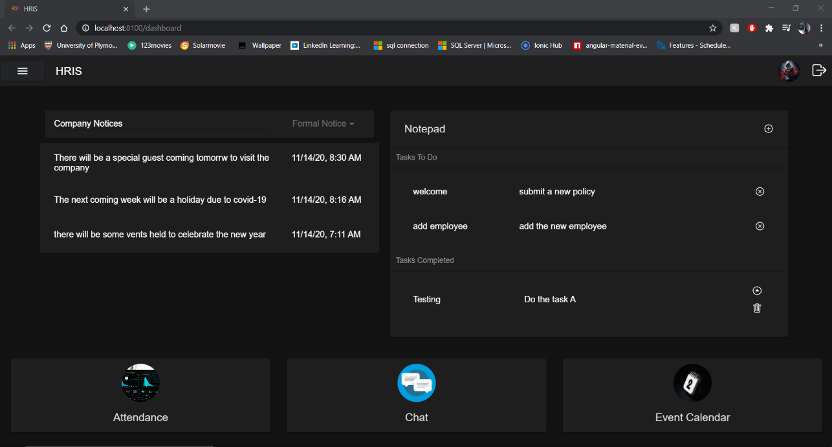

Figure 10.2 Manager dashboard

This is the managers dashboard page once the managers login through the login page they will be routed here and, in the dashboard, it provides buttons to some of the most used functionalities and also provide information.

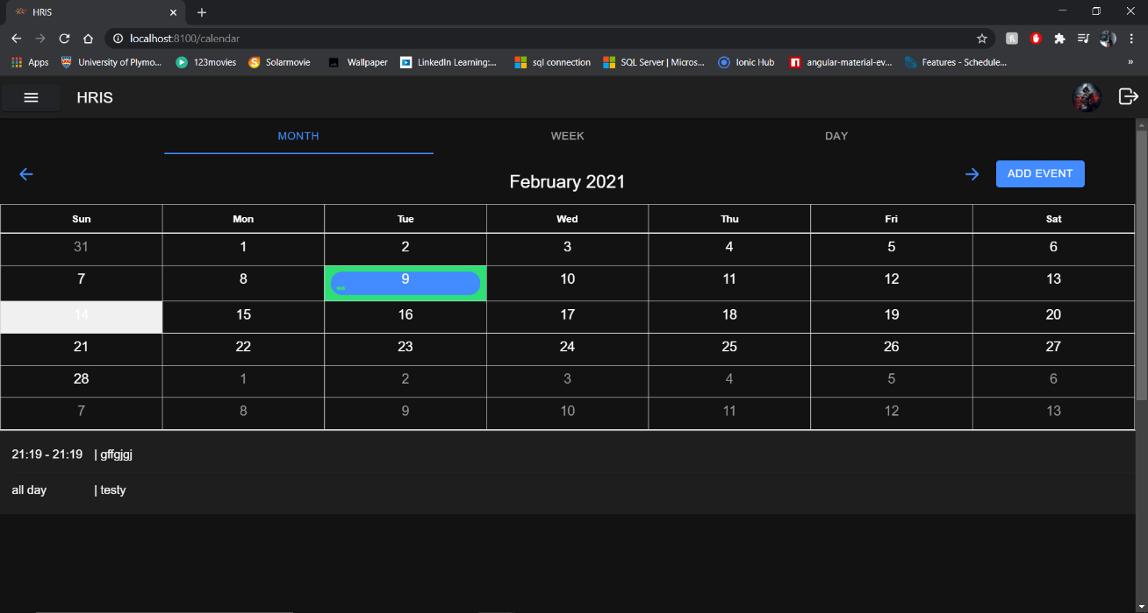

Figure 10.3 Event calendar

This is the managers event calendar page here it shows the calendar, and the manager can view it in any form he wants he can see it from month, week, and day view. It shows all the events that are added to the event calendar along with the start time, end time and the small description of the event.



Figure 10.4 Add events

This part is in the calendar events page and this is where the human resource managers can add events which will be displayed in the above event calenda for employees and the managers to see.



Figure 10.5 Select chat department

When the human resource manager clicks on the chat from the menu or from dashboard they will be routed to this page, here it shows all the departments available in the organization and all the employees in the organization will be categorized under one of this departments, then the human resource manager can select a department and message to the employees who are in that specific department.



Figure 10.6 Human resources chat

This is the messaging area for human resource managers. once the human resource managers have selected a department then can send messages from here, when a message is sent it shows the message, the senders e-mail, the time the message was send and the date on when the message was sent.



Figure 10.7 Add notices

This is the notices page, and this is the page where managers use to add notices in the application which will be displayed in the dashboard of the user. There are three types of notices urgent notices, Important notices and formal notices and the user can add one of these 3 types of notices to the application.



Figure 10.8 Documents page

This is the document page here it shows all the documents and request forms submitted by human resource managers and by employees, human resource managers can view the submitted documents and then they can either refuse the document or accept it. They can also approve a denied document or just permanently delete the denied document.



Figure 10.9 Documents type

When the user clicks add document button the following modal pops up and it shows all the different types of documents they can add and once a user clicks a document, they will be taken to that particular form to add the document to the document page where it later gets accepted or denied. Since there like documents all those documents will not being show on the report, but each document is different from the other and has specific fields which the user should fill to submit the document.

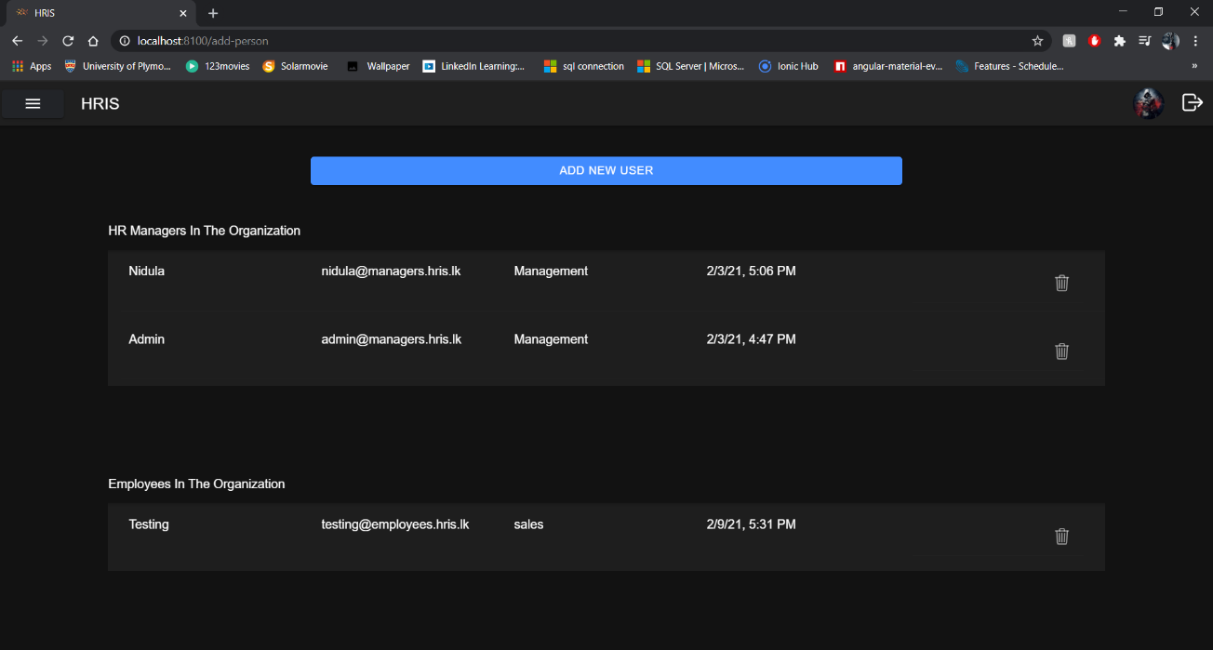

Figure 10.10 All the users

This is the add new user page here it shows all the employees and human resource managers in the system. From this page the human resource managers can remove existing managers and human resource managers from this system. They can create new users by clicking the add new user button.



Figure 10.11 Add new users

The human resource managers can add new users to the system these users can either be employees or newly hired human resource managers that are not in the system. Once they fill this form the user will be created in the system.

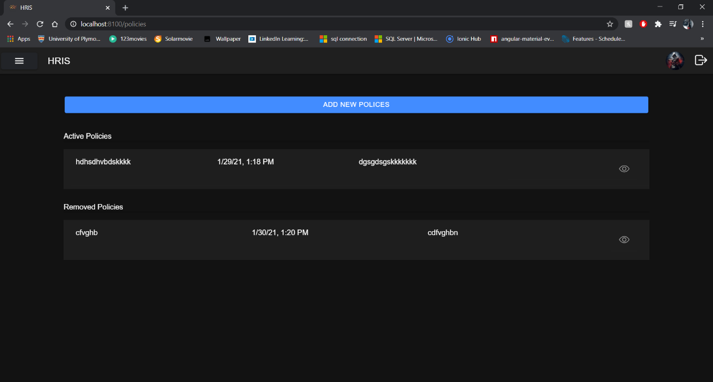

Figure 10.12 Policy page

Policies is an important part of the organization because it defines the rules of the organization and these policies change overtime, and also new policies will be added to the organization overtime and it’s the task of human resource managers to add them, so in this page the human resource managers can add new policies and also edit existing policies and these policies will be displayed to the employees.

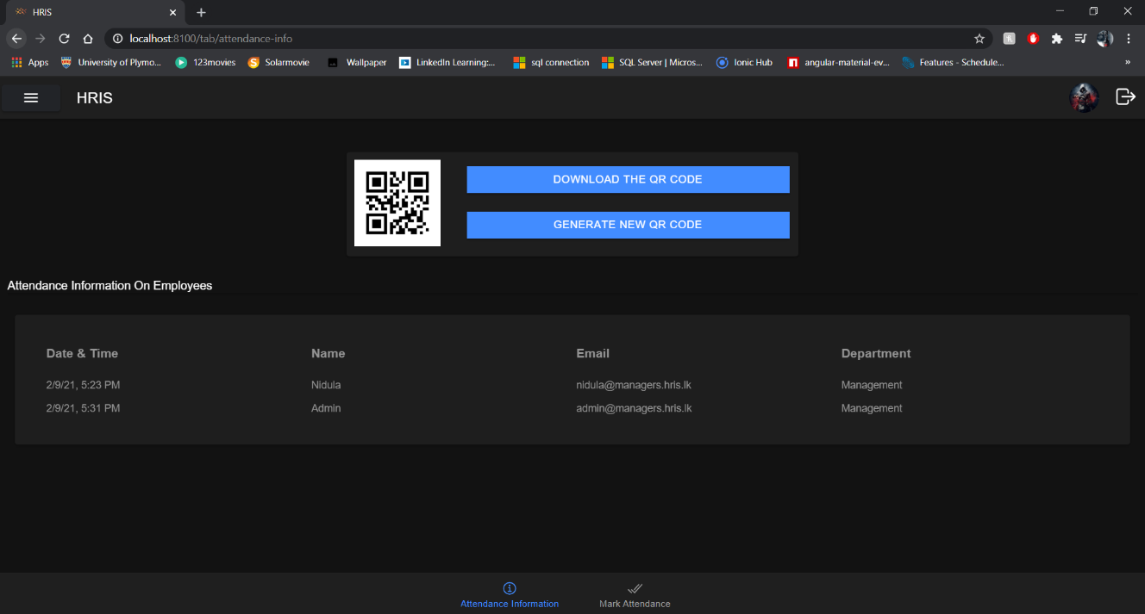

Figure 10.13 Attendance page

In the page shown above the human resource managers can create new QR Code and delete old QR Code and whatever the QR code created by the HR managers should be used by the employees to mark attendance for the day, once the employees mark attendance it will be shown to the human resource managers in the above table with the user’s company email address and the time and date the employee scanned the QR Code. The user can use this application to scan the QR Code by clicking the mark attendance tab which contains an inbuild QR- code scanner. Once the user scans and the QR Code and the scanned QR Code matches with QR – Code created by HR manager, then the user must enter the password to mark the attendance.

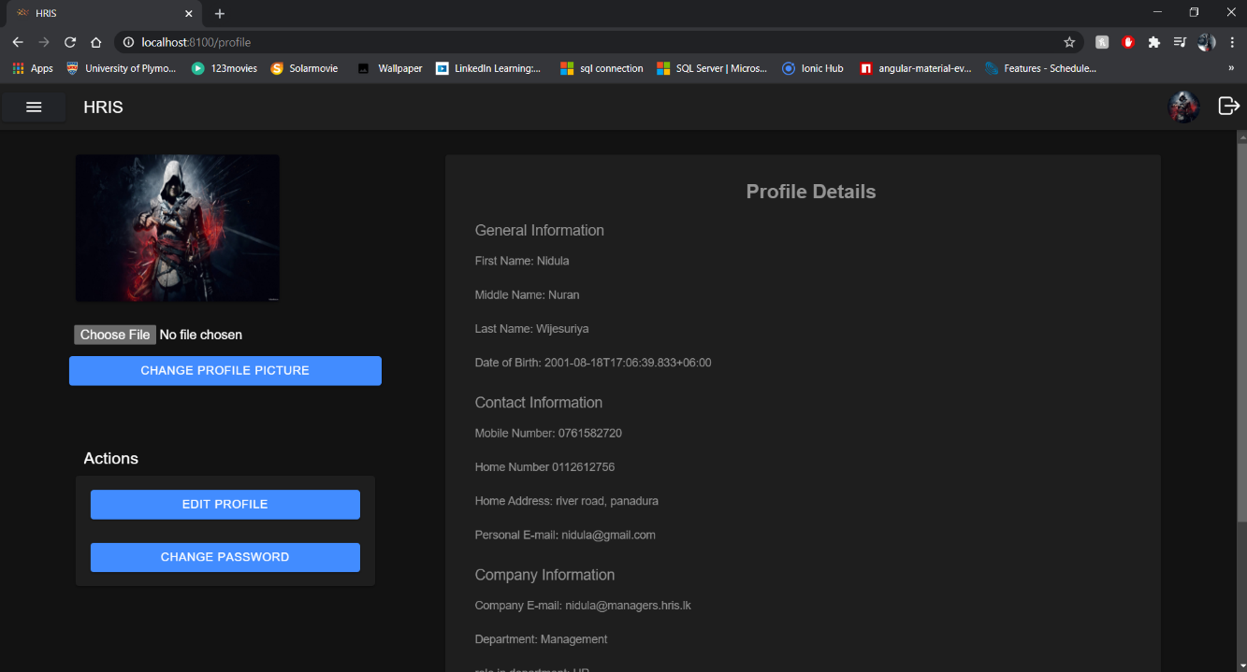

Figure 10.14 User profile

This is the profile page and here it shows the user all their account details and the profile picture. The users can change certain amount personal details by clicking the edit profile button and, they can also change the password by clicking change password which will open a modal but to ensure security within the system the user must enter the old password to change the password. The user can also change their profile by clicking change profile picture and the new picture they put will be stored in firebase storage and updated in in Firestore to display it in the profile page.

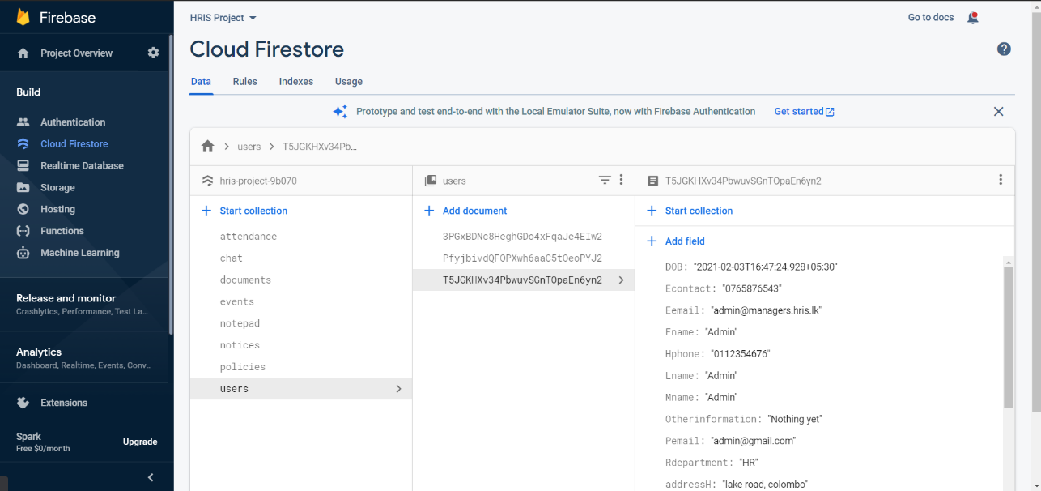

Figure 10.15 Firebase Database

This is the firebase database used for this project and when developing this database, the hierarchical modal was used to ensure that this database is developed I a proper easy to access manner.

##### 10.1.1 Extra Information

In addition to the screenshots of the system that is shown above there are much more pages and modals within the developed system those include different types of forms and sub-pages. What is displayed above are the main pages along with a small description on how each of these page’s function. The screenshots of the pages above are from both the users which are human resource managers and the employees.

### 10.2 Code Snippets from the application

##### 10.2.1 Brief

The section below shows some screenshots of code snippets and contain a small description on what each of them does. The entire code base will not be added to the report because then it will turn it to a massive report and would not be an affective report, so instead some of the code snippets will be shown under the sections below which are separated into two sections called the front-end code snippets which contain front end code and back end code snippets which will contain back end code.

##### 10.2.2 Front-end code snippets



Figure 10.16 update password

What the above code is used is for changing the password of the user. The way it works is that it takes the gets the old password from the database and decrypts it and then when the user enters the old password it checks whether the user entered old password is similar to the password in database and if the passwords are similar then the user entered new password is sent to the backend to change the password and the user is alerted with a message and if the old password entered by user does not match the password of the database then an error message is show to the user.



Figure 10.17: QR-code scanner



Figure 10.18: QR-code scanner



Figure 10.19: QR-code scanner

The three images above show how the QR- code scanner works. The QR- code scanner is used by the employees and the managers to scan the QR code and if the scan is successful the attendance of the user will be recorded. The way it works is that at first, we access the camera of the device this can be the web cam of the computer or the camera of the phone and then we show the user the live video of what the camera sees so that the user can point to a QR Code and once a QR code is detected by the camera it scans the QR code and gives us the result. The QR Code is detected by using the package @ionic-native/barcode-scanner which is available in ionic and should be installed using npm install. So, getting the result is not enough so what I did was I check the result taken from QR code and check where it matches to the QR-code generated by the manger which is there in the database and if the QR codes are similar then the attendance is recorded else it shows an error message to the user.

##### 10.2.3 Back-end code Snippets



Figure 10.20 update password

What the above code does is it gets the data from the front end and then uses the user id of the employee to find his records and then updates the user details with the details received by the front end. And if the task is successful, it sends a success message to the front end and also consoles it in the terminal and if it fails the same thing happens but sends a failure message along with the reason why it might have failed



Figure 10.21 Add new user

What the above code does is it allows the human resource managers to add new users to the system. The way it works is similar to the above code snippet it gets the data from the front end and creates a new user with a unique user id and then if the task is successful sends a message to the front end and also consoles it and if it fails it sends a error message to the front end alone with what the error is and also consoles the result in the terminal.

### 11. Risks

#### 11.1 Risk plan

|  |  |  |
| --- | --- | --- |
| **Risk Plan** | | |
| **Risk** | **Probability of Occurrence** | **Management Strategy** |
| Schedule overrun | High | To avoid running into this issue a clear plan is made when each stage of the incremental approach should be completed, and I plan to discuss with my supervisor to let him know my progress and get his option whether I could manage the work with the current project scope. |
| Acts of God | Low | In the case of an event as such then the development of the application would not be affected because it will be backed up and so the development could continue from where I left off. |
| Technical difficulties | Moderate | To avoid the entire project been lost due to technical failures a GitHub repository will be created and maintained so that each time a change is made to the project it can be updated to the GitHub. |
| Trouble learning required development technologies | Low | To avoid this a proper research was done during the planning phase and determined whether it was capable doing the project with the suggested technologies and checked whether there is enough documentation and tutorial if I run into any issue during the project. |
| Scope creep | High | To avoid the project scope from growing after the project plan a strict project scope will be followed to avoid getting sidetracked from the initial project scope. |
| User acceptance | Low | User acceptance is one of the most important things and to make sure that human resource managers will like the product a questioner will be made to check what they need, and the systems user friendliness. In addition, I will get my supervisors opinion on the application. |

Table 11.1: Risk Management Plan

#### 11.2 Risk Encountered

During the development of the project two main risk impacted the project but since those risks were identified and a plan was made on the project initiation document, they did not have a huge impact on the project. The risks that impacted and how they affected the project is mentioned below.

The first risk that occurred and impacted the highest was schedule over run. Even though I created the project plan giving time for the other projects and submissions. I did not correctly anticipate the time it would take to complete the other projects and the other reason was I came across some major bugs in the system which took a large time to identify and fix. So due to these reasons my scheduled was overrunned by work and I missed certain deadlines I kept for myself within this project and due to this I had to create a new project plan that puts the project completion data a little behind than the initial plan.

The second and last risk that occurred was technical issues, even though this could have been a major issue but since I identified it and managed this issue by using version control software like GitHub it did not affect a lot because I uploaded to GitHub at least twice a week once I complete any part of the project due to this, I didn’t lose any part of the project and was able to get back to work once my device was fixed.

### 12. Quality Plan

When developing a project quality is one of the essentials things that should be considered because it is one of the main things that a customer looks for in a product and due to poor quality, the customer may even reject the entire application. So, to ensure that this project provides a good quality HRIS system the following quality checks will be done, and these strategies will be used to do these checks, so if these quality checks are done in a proper way then the quality of the system can be ensured.

|  |  |
| --- | --- |
| **Quality Plan** | |
| **Quality check** | **Strategy** |
| Major deliverables | To ensure that the major deliverables are met a plan is made on the work process so it is not rushed this will also ensure that the system has the functionalities mentioned and nothing will be missed. |
| Quality control activities throughout the project | To ensure the quality I will get a review from my supervisor after each increment of the project and during the testing period of the system |
| Sub system usability and validation | This will be done after each increment to ensure quality is maintained in the project |
| Quality assurance activities | To ensure that the quality of the application is maintained I will get the review of the quality from my supervisor after each stage. |
| Feasibility study | A feasibility study will be done on the project to ensure that the project is worth the time and effort and to show how it will benefit the business. |
| System validation and user acceptance | To ensure that the human resource managers accept the product and is also helpful to them a questioner was conducted of what they need and what they want from a human resource information system. So, it could be delivered to them. In addition, I will also get the option of my supervisor. |

Table 12.1: Quality Management Plan

### 13. Changes to the project

#### 13.1 Brief

There are no huge changes to the project. The only change that will be done to the project will be a new project plan because the initial project plan was not feasible due to the risk encountered along the way, so a new project plan is made and with it the project will be able to be completed on time without any complications. The rest of the things mentioned in the project initiation document stays the same including the project scope.

#### 13.2 Finalized Project plan

|  |  |  |
| --- | --- | --- |
| **Project Plan** | | |
| **Stage** | **End date** | **Products/deliverables / outcome** |
| Project Initiation | 03/11/2020 | Project initiation document |
| Research on the development area | 05/11/2020 | A clear understanding of what human resource managers need and the short comings of the current HRIS systems |
| High Level designs of the system | 10/11/2020 | Design documents that are needed for the project and graphical user interface layouts |
| Increment 1 | 10/02/2021 | Development of the functionalities for human resource managers in the web and mobile application |
| Increment 2 | 31/02/2021 | Development of the functionalities for employees in the web and mobile application |
| Increment 3 | 15/03/2021 | Integration of machine learning and some of the other functionalities |
| System testing | 23/03/2021 | Testing the entire system |

Table 13.1: Project Plan

### 14. Conclusion

The current stage of the project is that the research is completely done and have a clear idea of Human resource managers, their responsibilities, and their tasks. In addition, I have a clear understanding of the functionalities that will be provided in this project. I also know and have a clear understanding of the languages and the technologies that I will be using this project. The low-fidelity diagrams are completed along with the all the architectural diagrams so now I can fully focus on the development process of the project and have a clear idea of the tasks I am doing.

The development status of the project is that only 60% is complete and I have another 40% of the development work to be done. And I believe I can finish the entire project before the project deadline set my me in the updated project plan because currently, I am on track in the updated project plan and not falling behind. So, if I continue to work in this manner, I will be able to complete the project and provide a quality functioning human resource information system that will satisfy the Human resource managers and employees needs and wants.

### 14. Appendix

#### 14.1 GitHub Commits

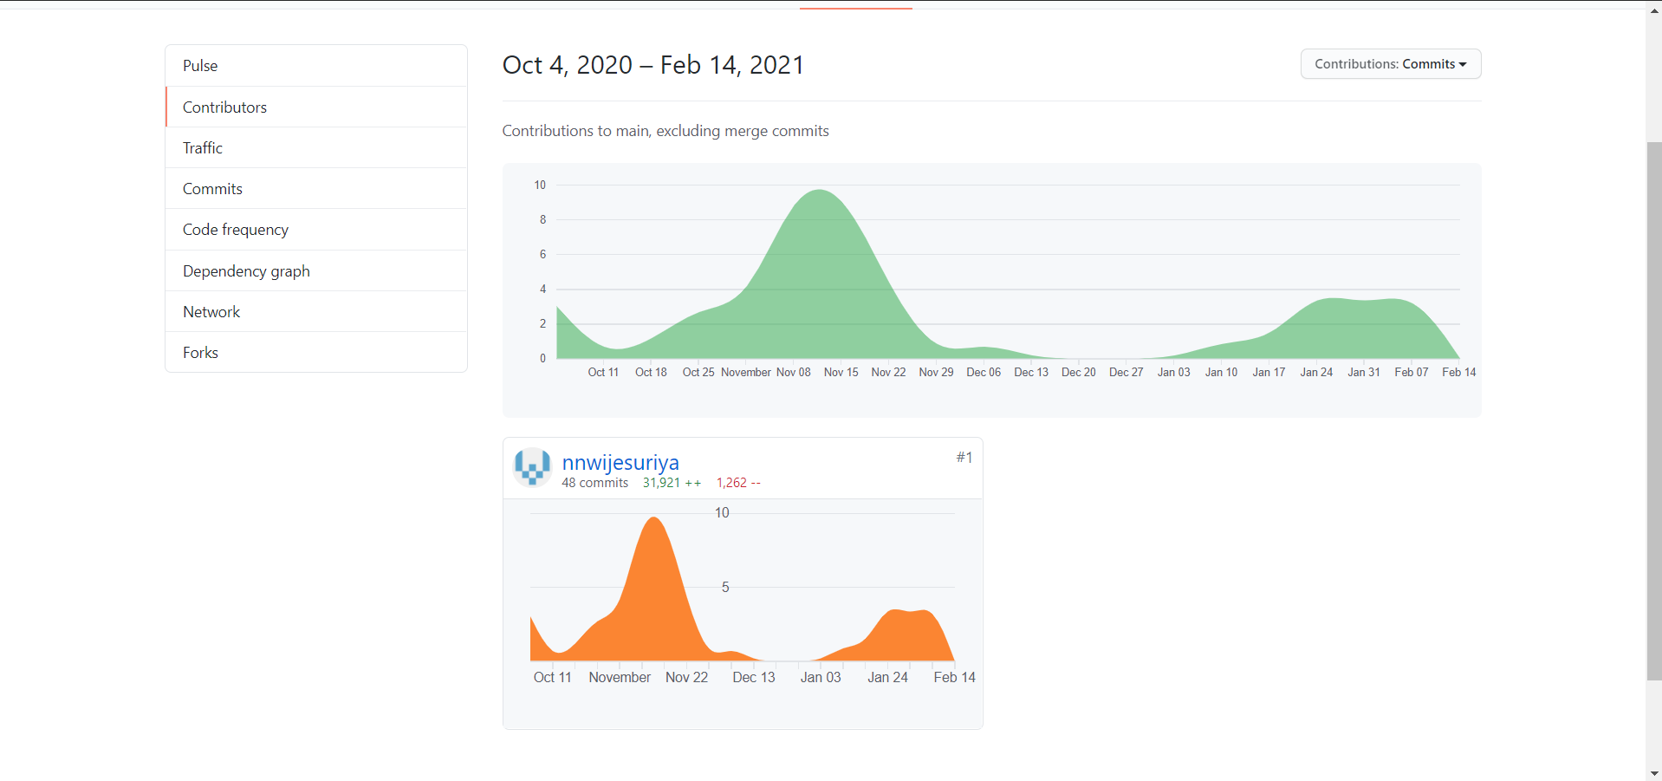

## 18.6 Questioner

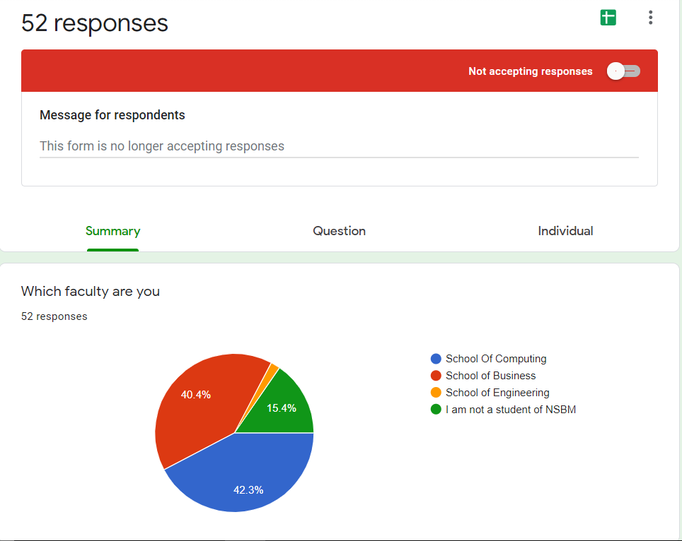

Figure 15.1: Questioner Results

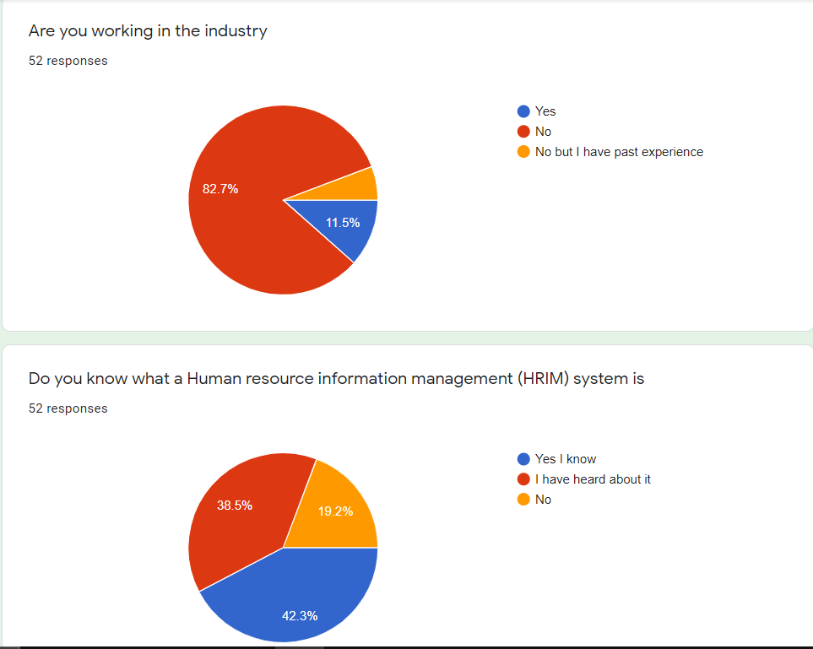

Figure 15.2: Questioner Results

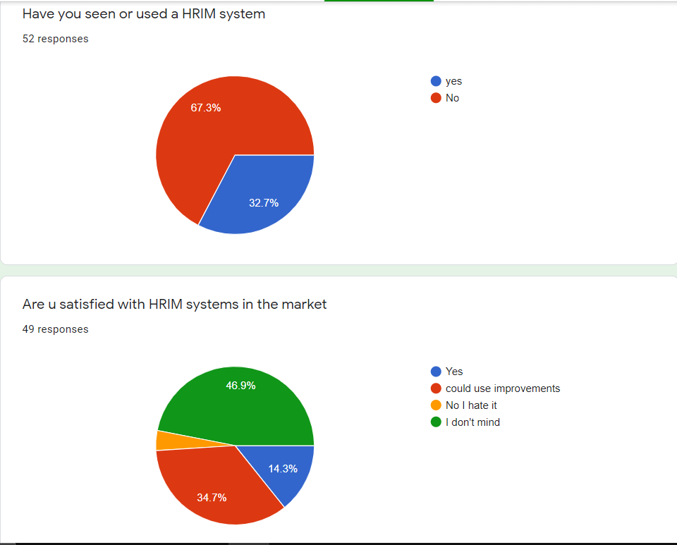

Figure 15.3: Questioner Results

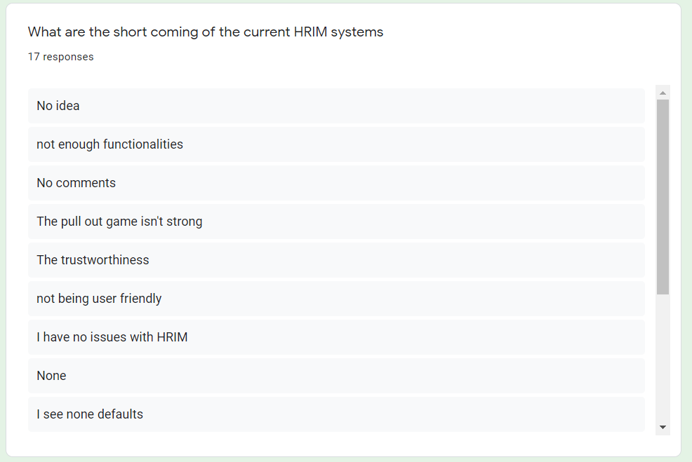

Figure 15.4: Questioner Results

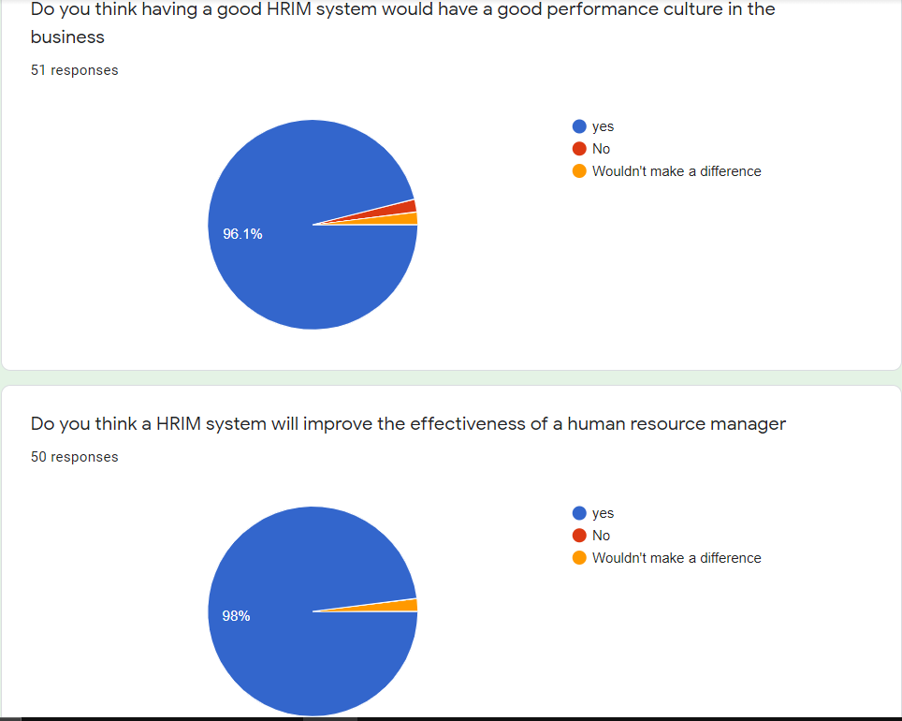

Figure 15.5: Questioner Results

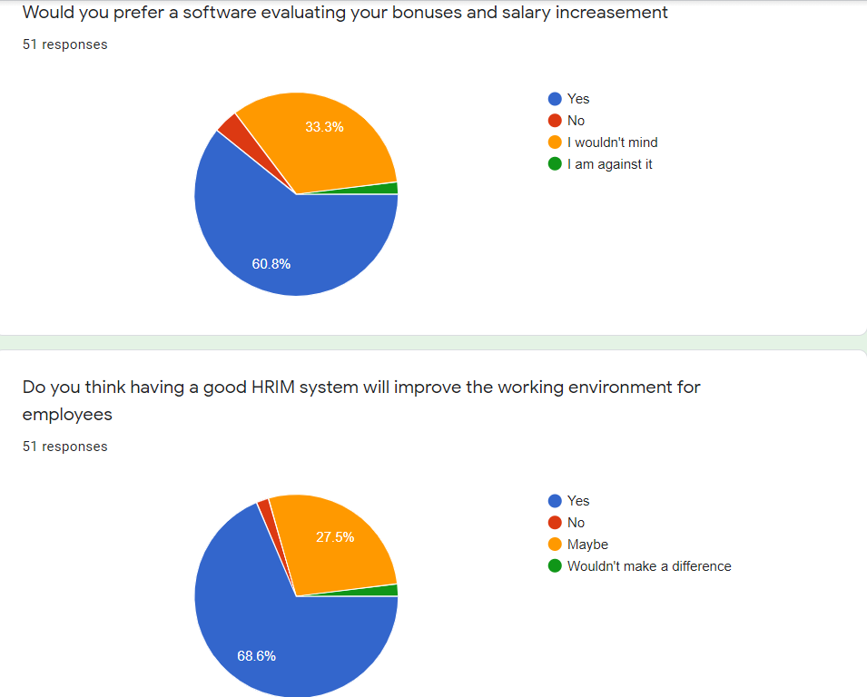

Figure 15.6: Questioner Results

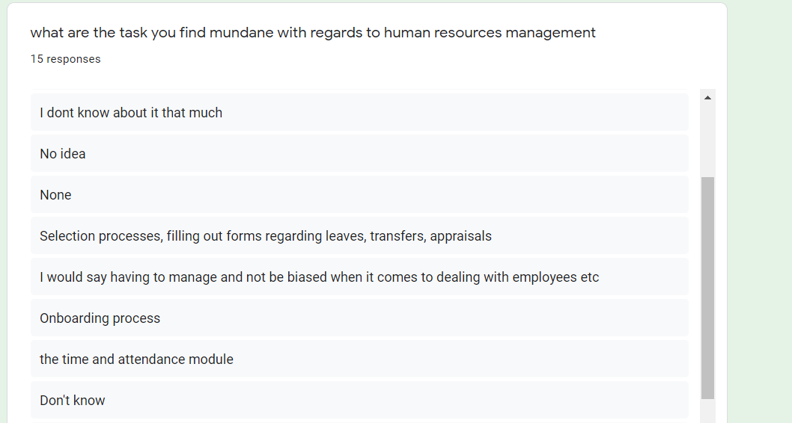

Figure 15.7: Questioner Results

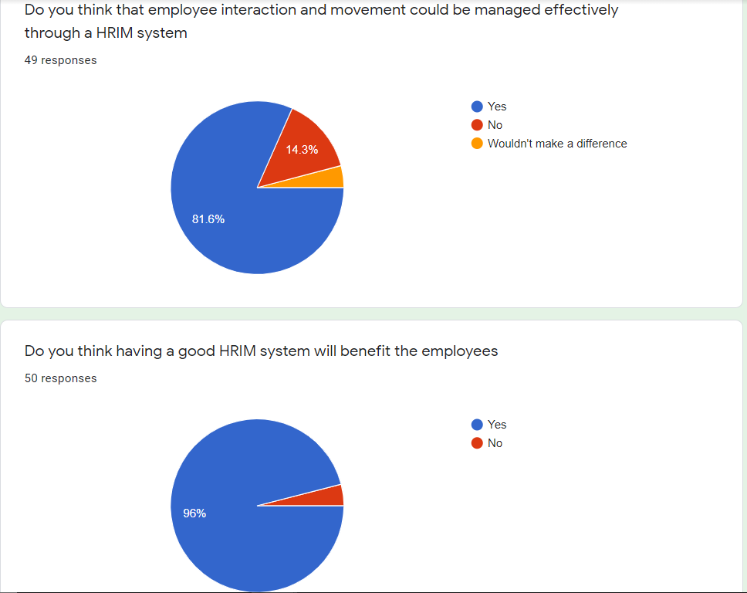

Figure 15.8: Questioner Results

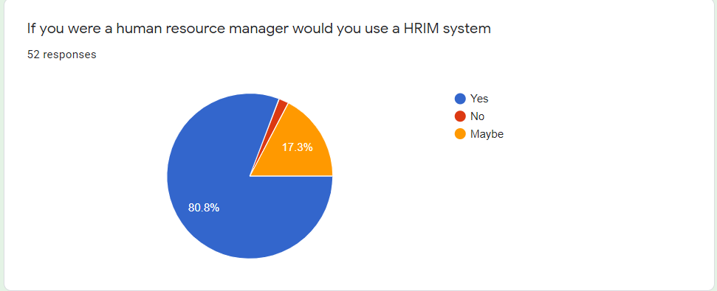

Figure 15.9: Questioner Results

## 18.7 Overall GitHub Commits

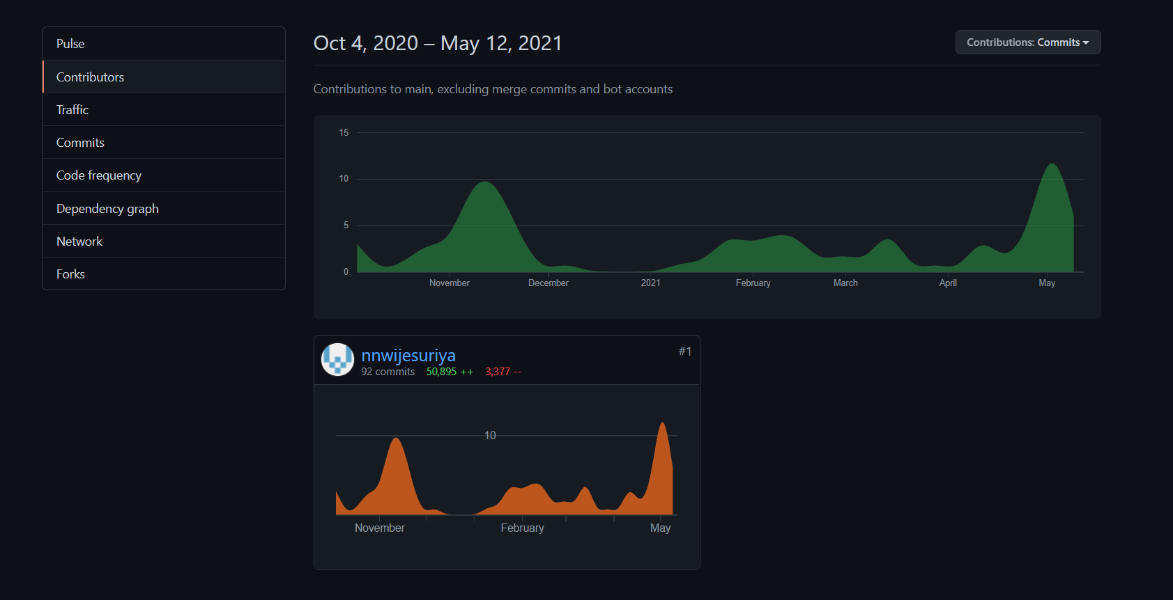

Figure 15.10: The dates on which commits were made to GitHub

## 18.8 LinkedIn Courses Completed

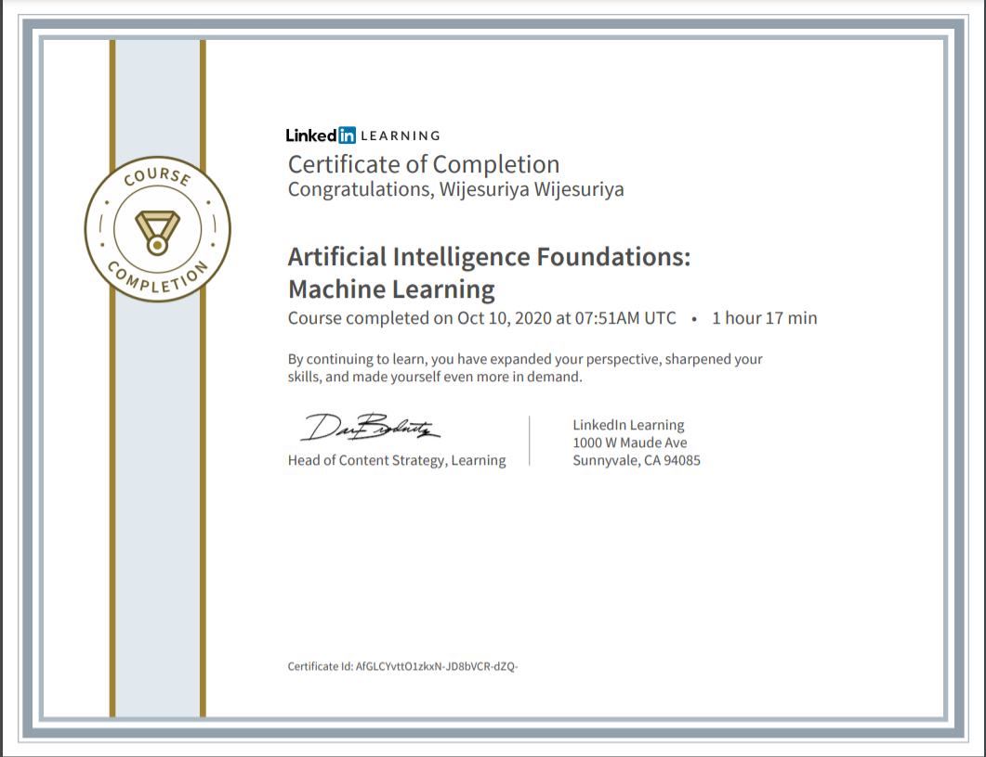

Figure 15.11: Courses completed



Figure 15.12: Courses completed

## 18.9 Supervisor Meetings

